Amington Ward

Existing Polling Districts

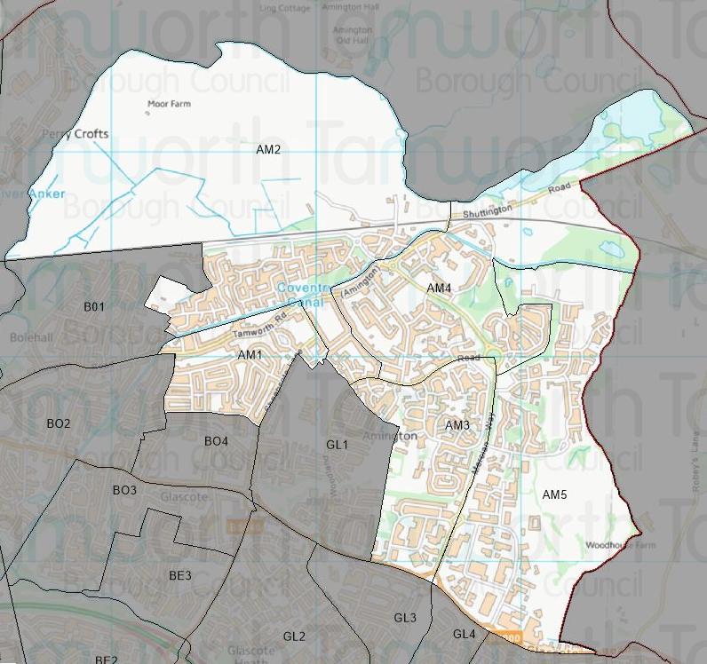

Existing Polling Stations

Polling District | Polling Station | Electorate | Polling Station Electorate | Disabled Access | What3Words Reference
AM1 | Florendine Primary School | 1,209 | 881 | Yes | ///shiny.soaks.critic
AM2 | Florendine Primary School | 1,642 | 1,295 | Yes | ///shiny.soaks.critic
AM3 | Amington Heath Primary School | 1,191 | 1,066 | Yes | ///elbow.motel.watch
AM4 | Amington Band Welfare Centre | 1,491 | 1,202 | Yes | ///fishery.defeat.froze
AM5 | Amington Band Welfare Centre | 1,239 | 1,058 | Yes | ///fishery.defeat.froze

Proposed Changes

Polling District | Polling Station | Recommendations
AM1 | Florendine Primary School | No change.
AM2 | Florendine Primary School | No change.
AM3 | Amington Heath Primary School | No change.
AM4 | Amington Band Social Welfare Centre | No change.
AM5 | Amington Band Social Welfare Centre | Explore the possibility of moving this polling district from its current polling venue to Garden Village Primary School.

There are no proposed changes to the polling districts covered by the Amington Ward. The only change proposed is to look at the possibility of using the newly built Garden Village Primary School as a polling station for the AM5 polling district.

No complaints have been received regarding disabled accessibility to any of the polling stations. An issue was raised regarding parking in the locality of the Amington Band Social Welfare Centre. The relocation of the AM5 polling district to new premises would alleviate some of the parking congestion.

Amington Ward Polling Stations

AM1 & AM2 – Florendine Primary School
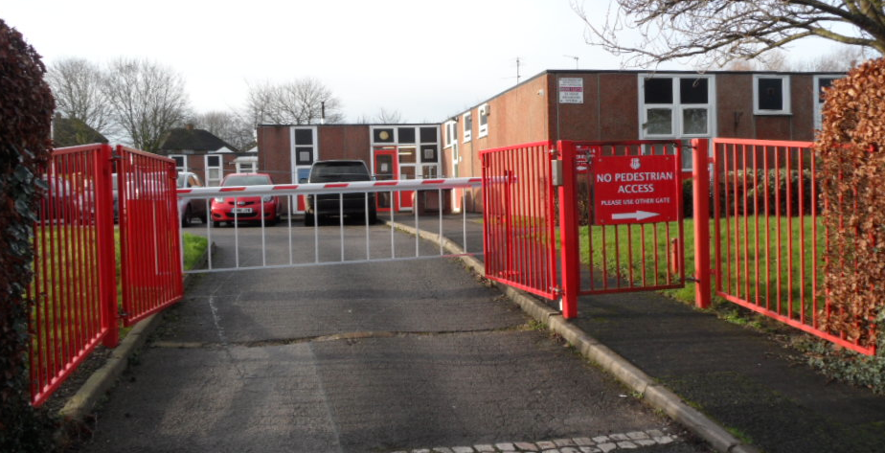

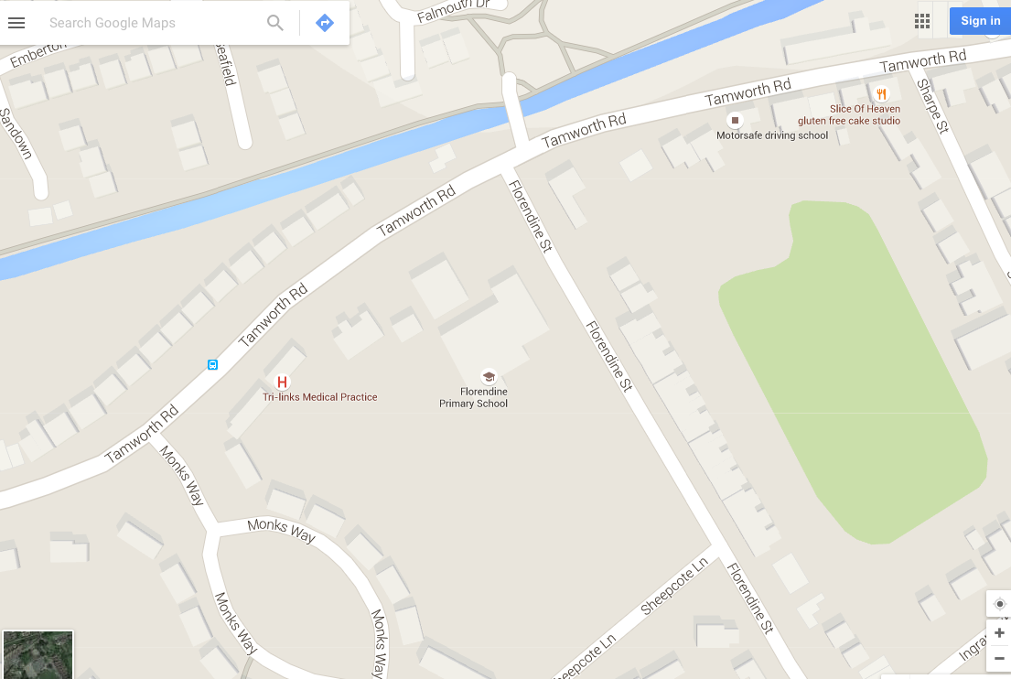

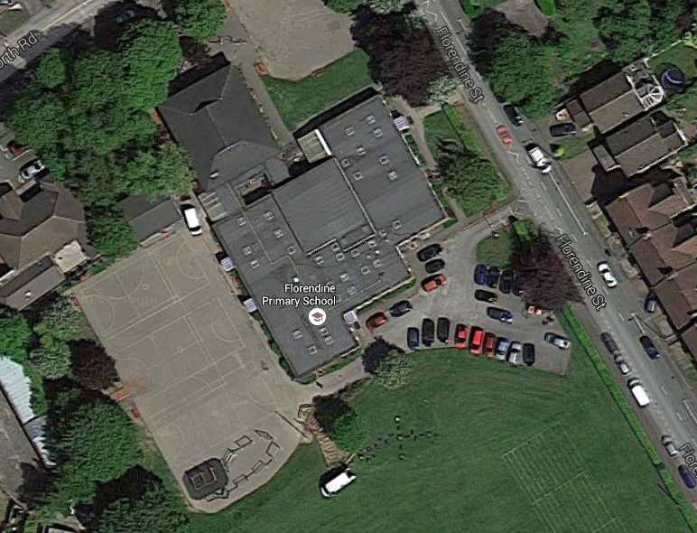
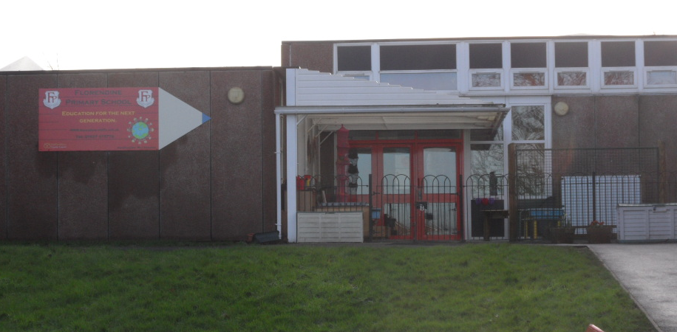

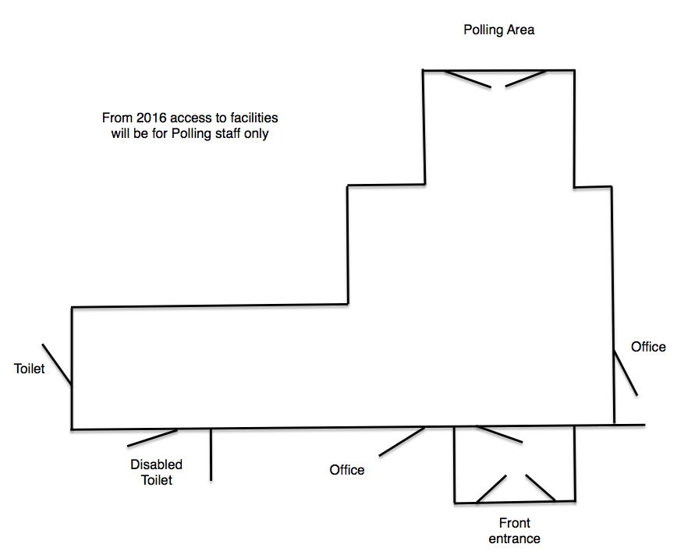
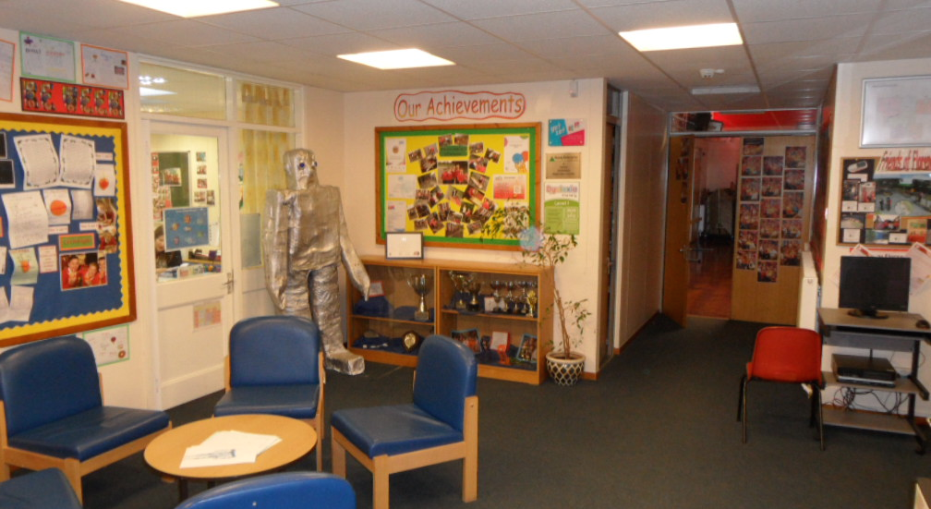

AM3 – Amington Heath Primary School

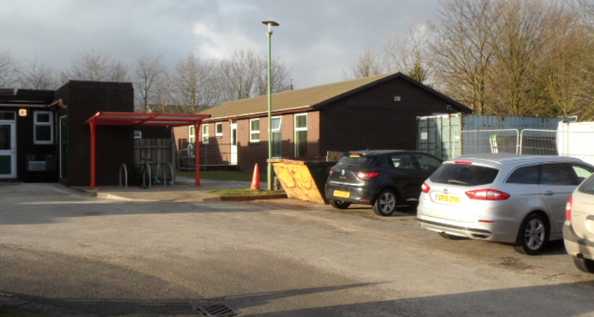

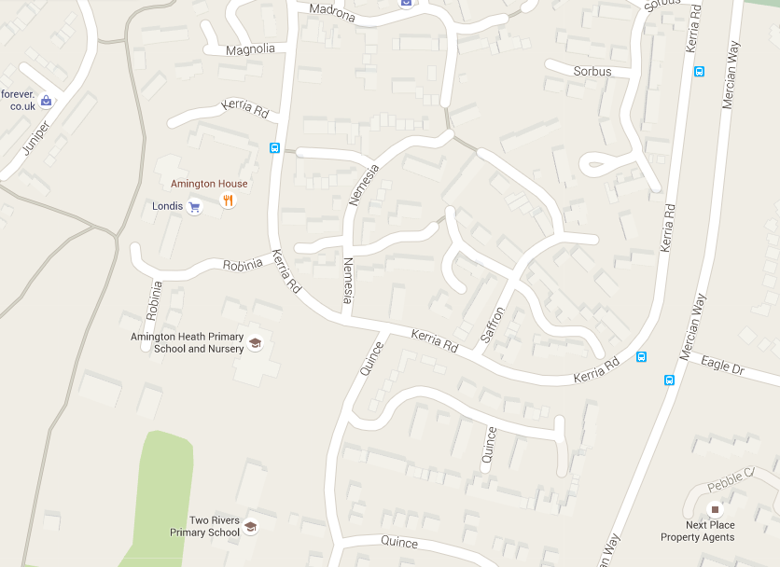

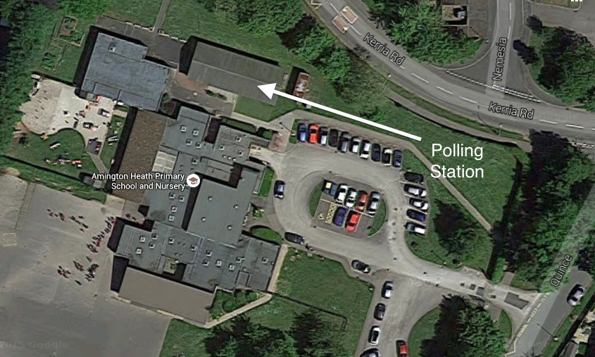

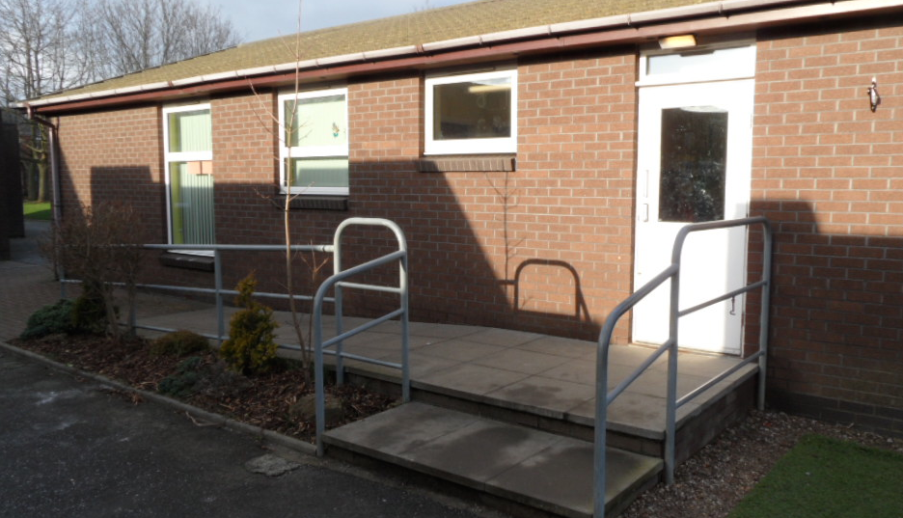

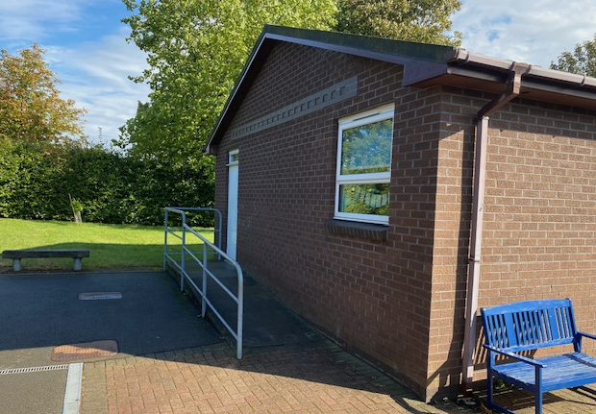
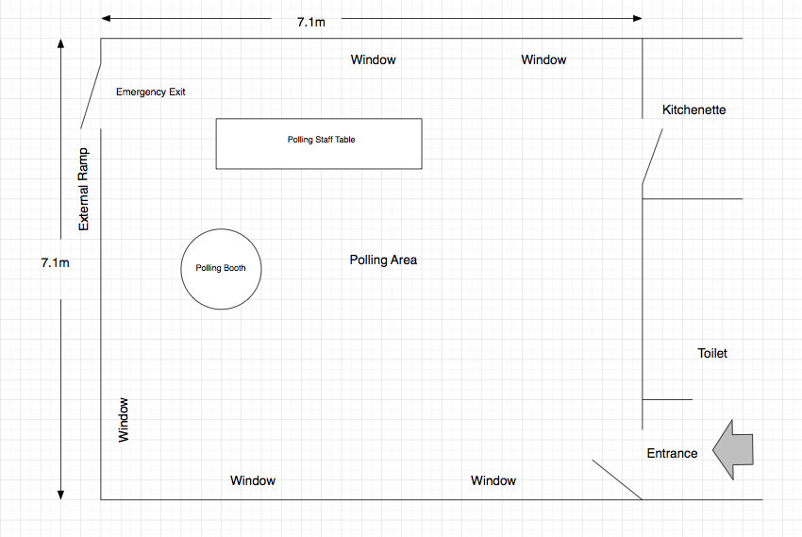

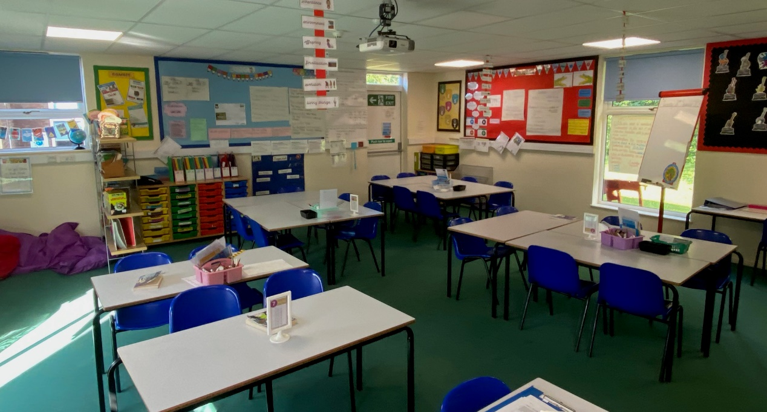

AM4 & AM5 – Amington Band Social Welfare Centre

