Glascote Ward

Existing Polling Districts

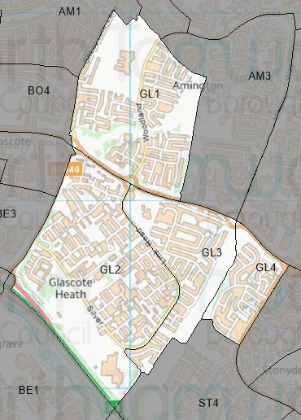

Existing Polling Stations
Polling District | Polling Station | Electorate | Polling Station Electorate | Disabled Access | What3Words Reference
GL1 | Sacred Heart Catholic Church | 1,515 | 1,189 | Yes | ///cans.refers.cross
GL2 | Oakhill Primary School | 2,425 | 2,132 | Yes | ///turned.remove.will
GL3 | Sacred Heart Catholic Church | 937 | 743 | Yes | ///cans.refers.cross
GL4 | Stoneydelph Primary School | 609 | 547 | Yes | ///smiled.stack.lands

Proposed Changes
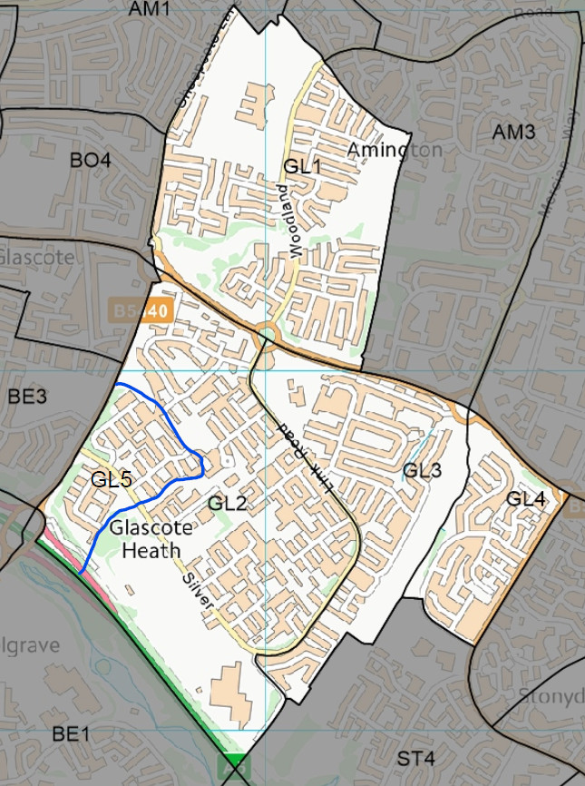

Polling District | Polling Station | Recommendations
GL1 | Sacred Heart Catholic Church | No change.
GL2 | Oakhill Primary School | Change.  Amend polling district boundary to create a new polling district to be known as GL5.
GL3 | Sacred Heart Catholic Church | No change.
GL4 | Stoneydelph Primary School | No change.
GL5 | Oakhill Primary School | Creation.  Creation of a new polling district to ensure that any combination of elections can be run successfully.

No negative comments or complaints have been received regarding the polling stations at recent elections. Therefore, no changes are proposed to these.

However, due to County Council boundary changes the creation of a new polling district is required to ensure that next year’s County Council election can be run successfully and to allow for different types of election to be run on the same day. This new polling district will be called GL5 and will be made up of properties from the following streets that were originally in GL2:
- Ivatt
- Maitland
- Kirtley

The remaining polling districts will remain unchanged.

Glascote Ward Polling Stations

GL1 & GL3 – Sacred Heart RC Church
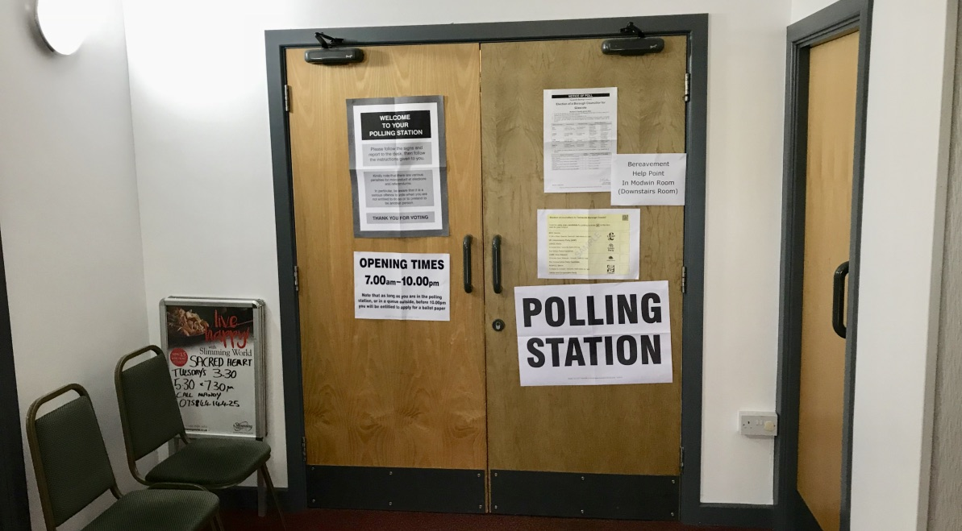

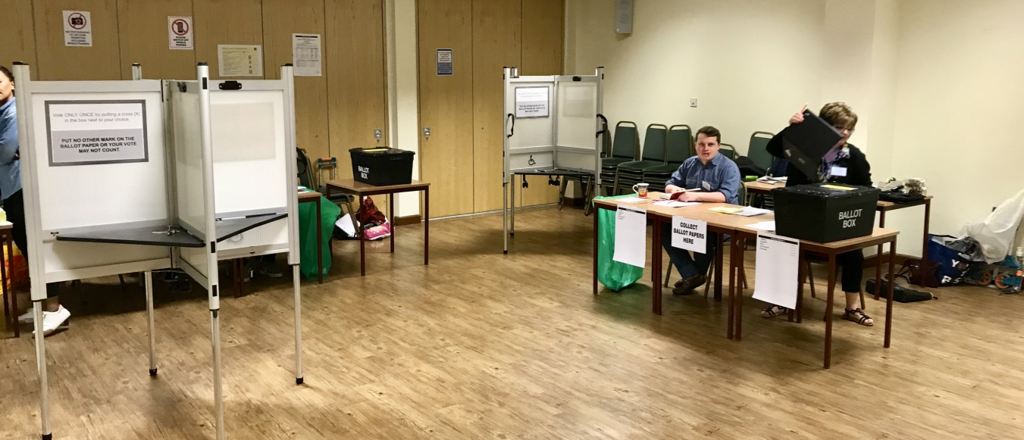

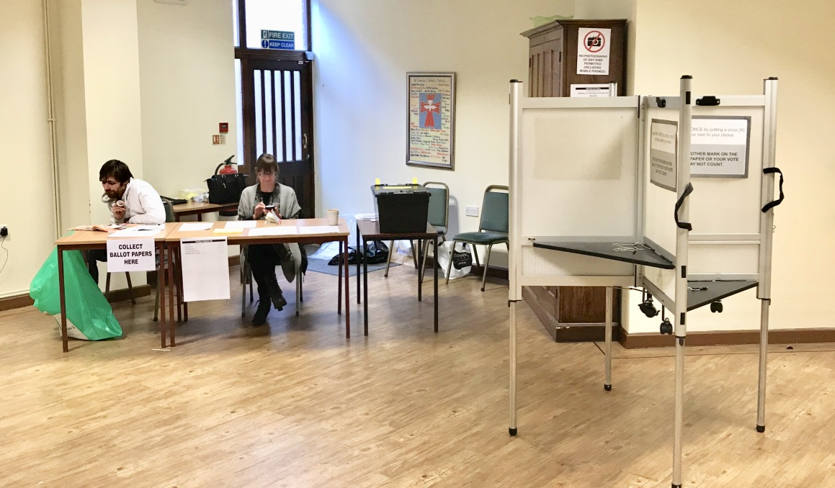

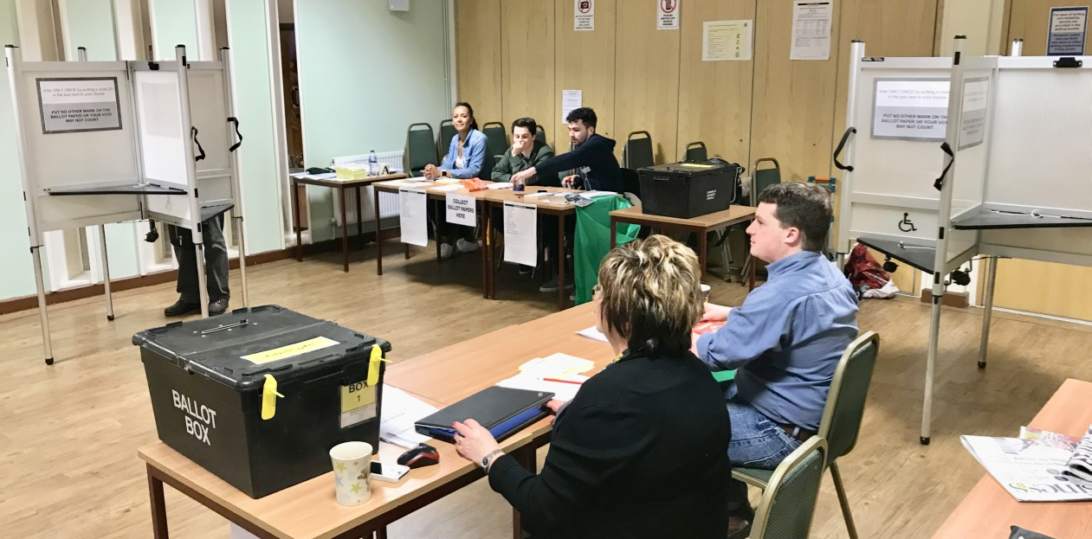

GL2 – Oakhill Primary School
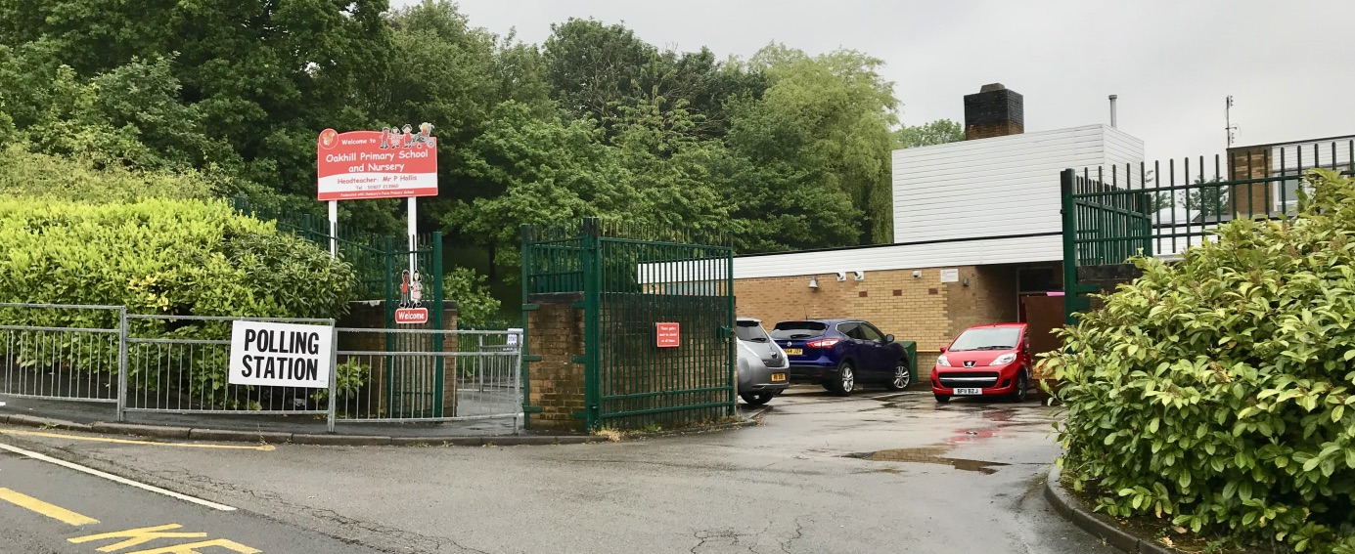

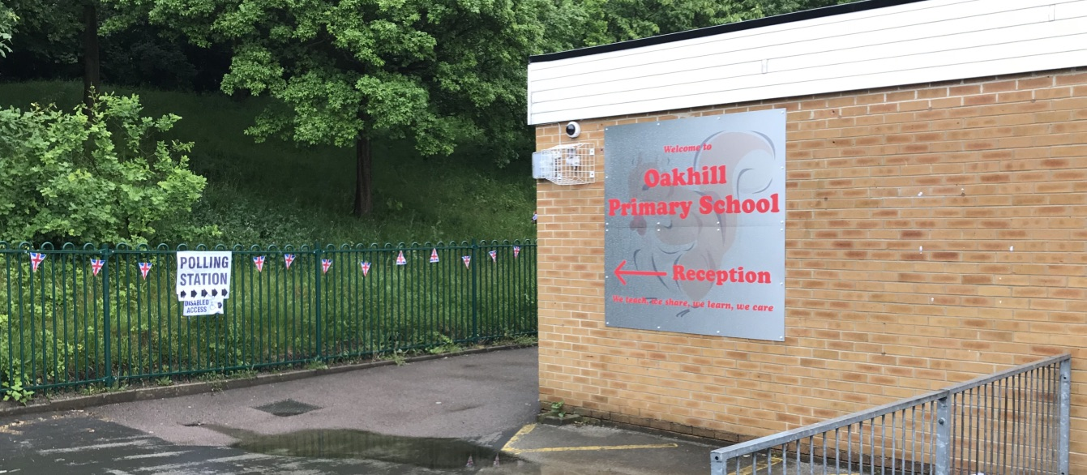

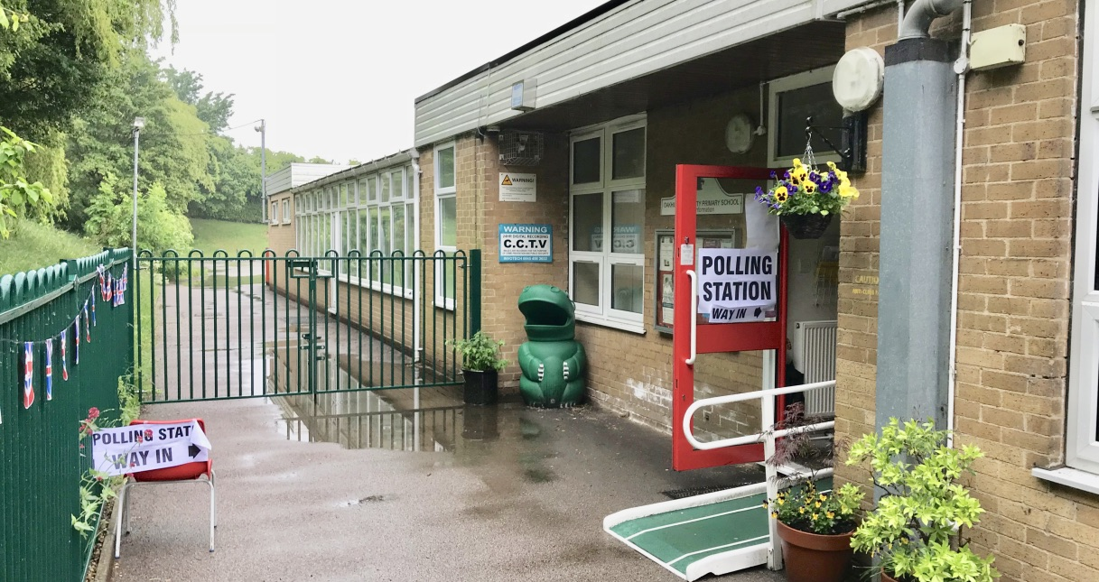

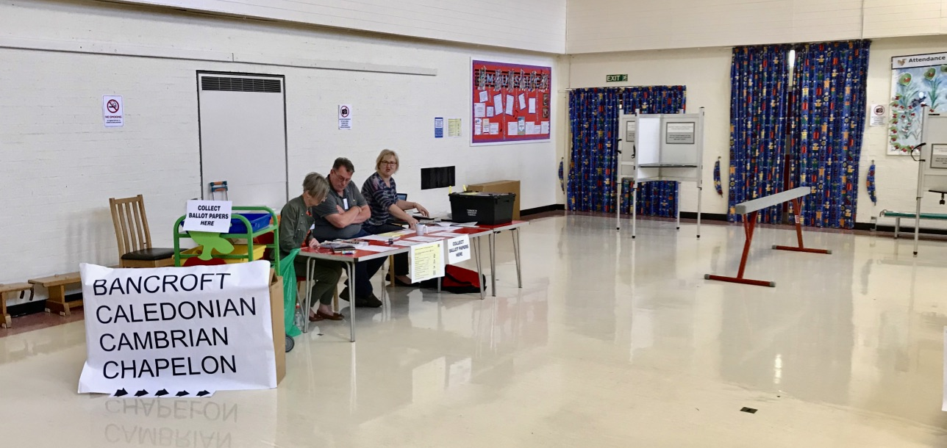

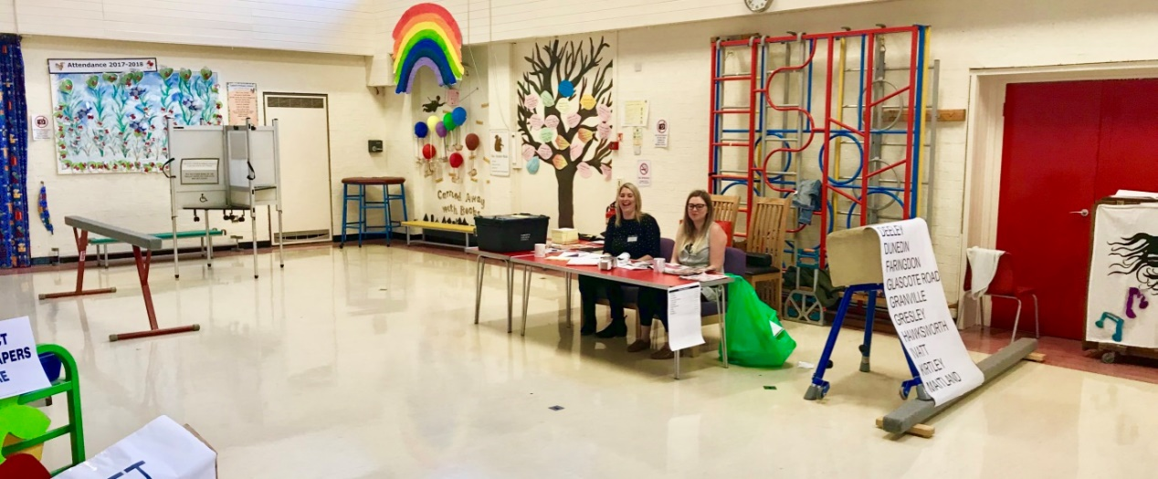

GL4 – Stoneydelph Primary School
