Stonydelph Ward

Existing Polling Districts

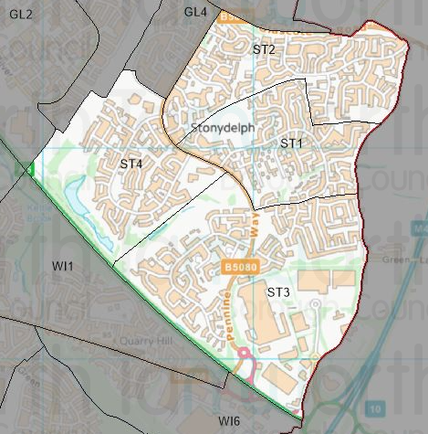

Existing Polling Stations
Polling District | Polling Station | Electorate | Polling Station Electorate | Disabled Access | What3Words Reference
ST1 | Pennymoor Community Hall | 1,271 | 1,029 | Yes | ///civil.bikes.gravy
ST2 | St Martin in the Delph Community Centre | 1,675 | 1,352 | Yes | ///media.goods.cheek
ST3 | Pennymoor Community Hall | 1,568 | 1,251 | Yes | ///civil.bikes.gravy
ST4 | Stoneydelph Primary School | 1,100 | 927 | Yes | ///smiled.stack.lands

Proposed Changes

Polling District | Polling Station | Recommendations
ST1 | Pennymoor Community Hall | No change.
ST2 | St Martin in the Delph Community Centre | No change.
ST3 | Pennymoor Community Hall | No change.
ST4 | Stoneydelph Primary School | No change.

No negative comments or complaints have been received regarding the polling districts or polling stations at recent elections. Therefore, no changes are proposed.

Stonydelph Ward Polling Stations

ST1 & ST3 - Pennymoor Community Centre

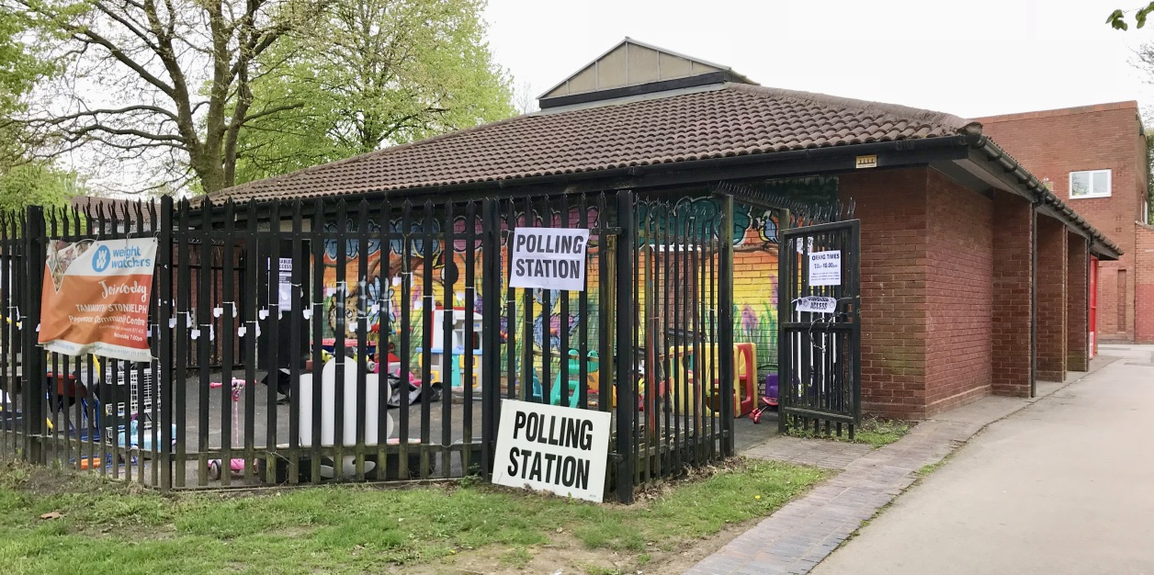

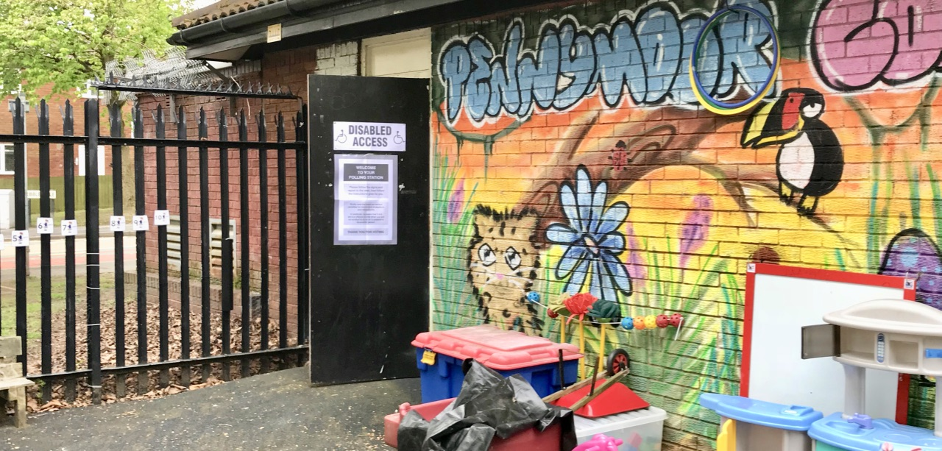

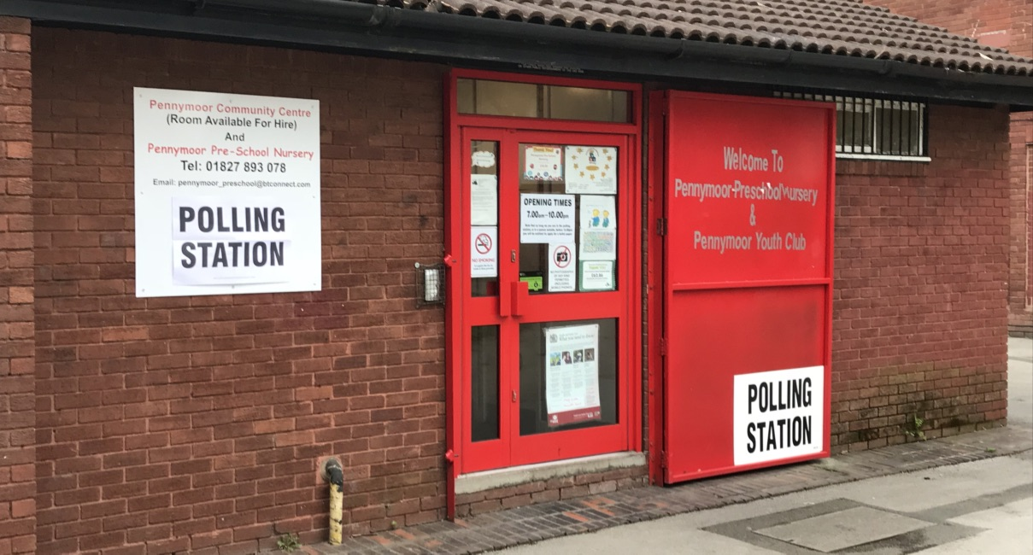

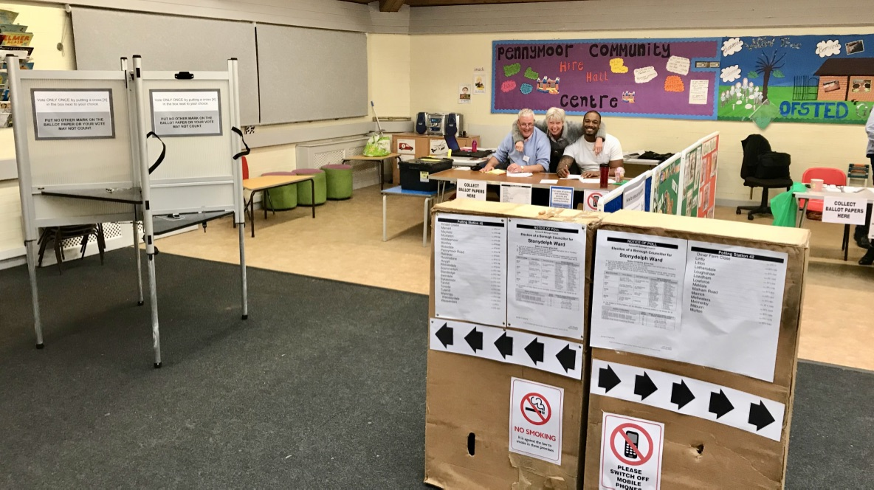

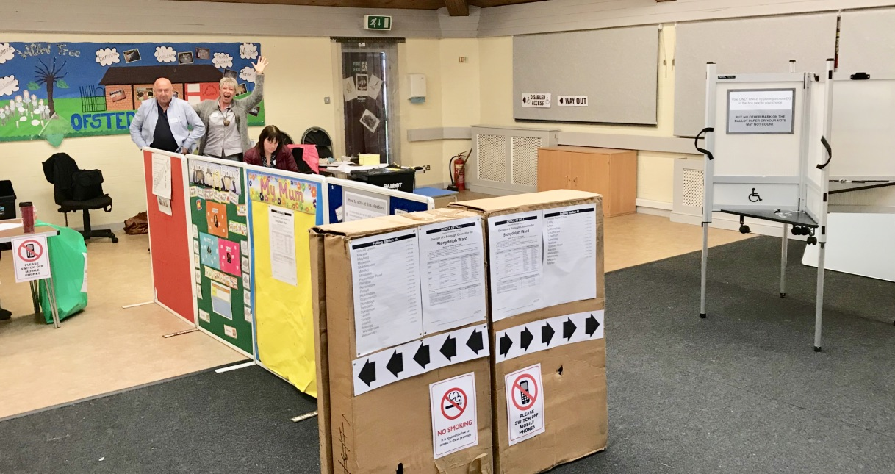

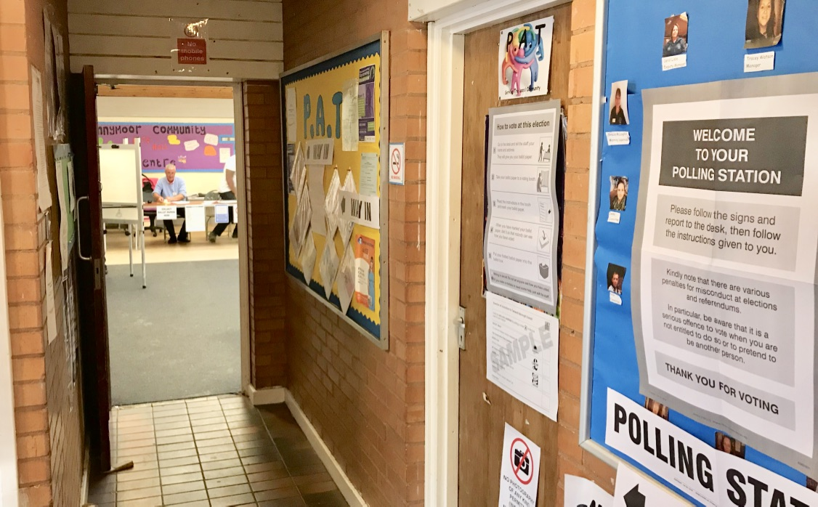

ST2 – St Martin in the Delph Community Centre

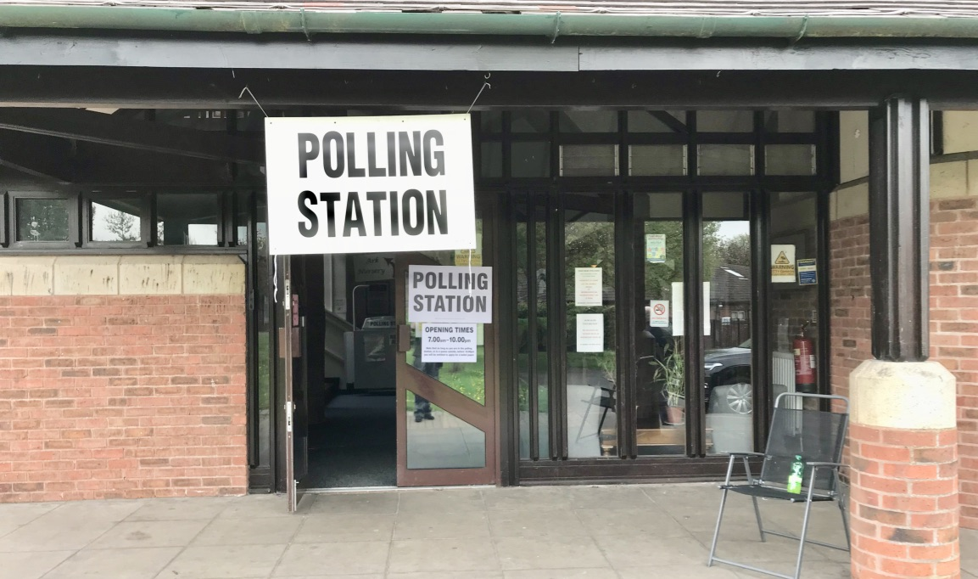

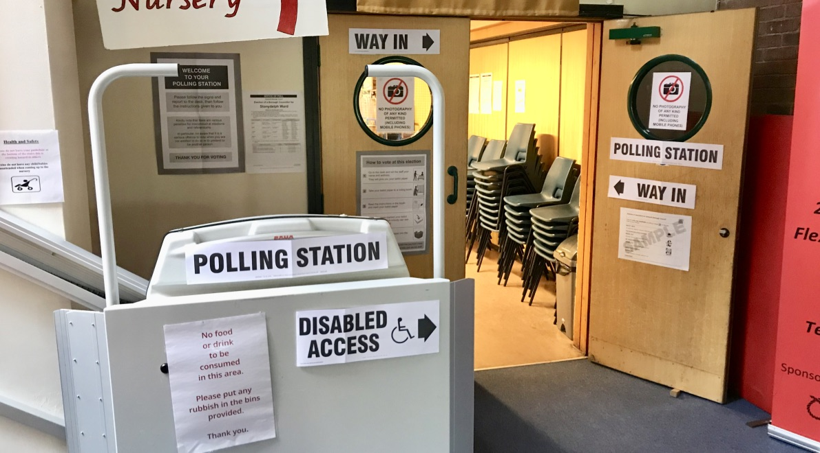

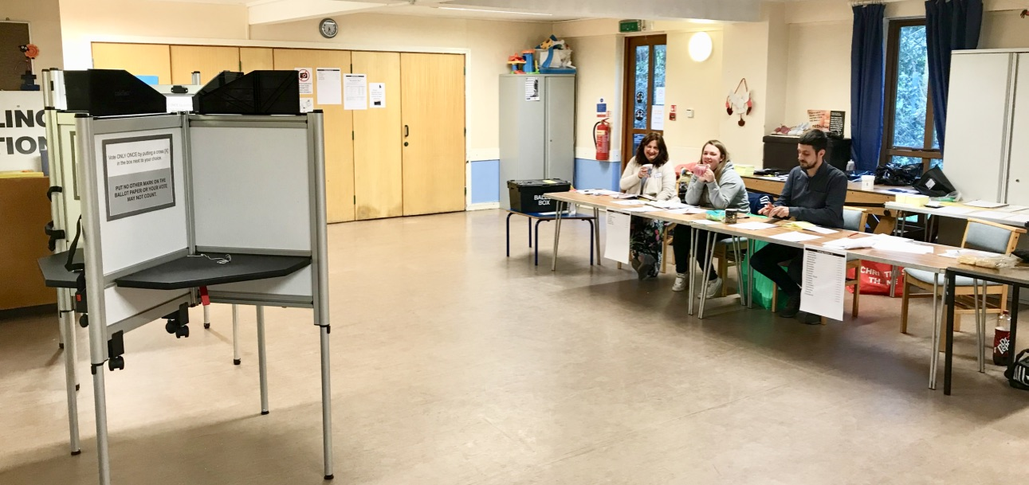

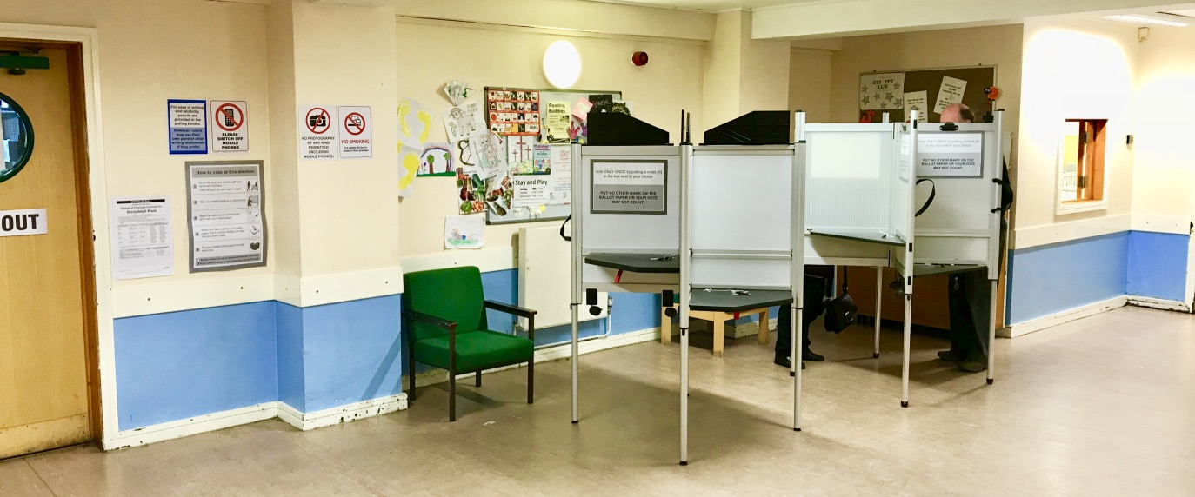

ST4 – Stoneydelph Primary School

