



Tamworth Net Zero
Climate Adaptation Strategy
November 2024



Tamworth’s changing climate
In July 2022, an intense heatwave in the UK saw record temperatures of over 40°C for the first time, leading to record numbers of excess deaths. In Tamworth, in January 2024, floodwaters from the Anker and Tame rivers submerged several town centre car parks, cut off surrounding villages and closed highways. These kinds of extreme events are expected to become more frequent and more extreme because of climate change. This adaptation strategy aims to influence and implement actions that will help the borough prepare for and adapt to these changes so that Tamworth continues to thrive in the future.
Tamworth’s current and future climate
Along with other boroughs in the Midlands region, Tamworth’s distance from the sea means the area experiences a greater range in annual temperatures compared to most parts of the UK. Annual rainfall in the Midlands has increased by 5% in the most recent 30-year period, compared to the period of 1961-1990.
Tamworth’s future climate is expected to change in the following ways in the future:
- Wetter, milder winters and more extreme rainfall events leading to more frequent, more intense flooding.
- Hotter, drier summers leading to droughts, wildfires and heatwaves becoming more intense and more likely.
The extent of future potential changes in temperature and precipitation is dependent on the level of action to mitigate against climate change. If global targets to reduce emissions are successfully met, summer maximum temperatures in Tamworth could increase by about 3.4°C, to 34.9°C, while the average amount of rain on winter days could increase by 7%. Under a reasonable worst-case scenario, these changes would be expected to be more significant with summer maximum temperatures in Tamworth increasing to about 38.5°C while the winter precipitation rate could increase by 18%, from about 1.8mm/day to about 2.1mm/day by the end of the century.
Climate risk and adaptation
Climate risk is the potential for negative consequences due to climate change where something of value is at stake and where the outcome is uncertain. Climate hazards that could cause negative consequences in the UK are likely to include flooding, heatwaves, wildfires, drought and long-term changes in overall temperature and precipitation. Here we identify climate risks and opportunities for Tamworth based on those for England in the third UK Climate Change Risk Assessment (CCRA3), in addition to further climate risks included in the West Midlands Climate Change Risk Assessment and Adaptation Plan 2021-2026.
To address these risks, adaptation actions have been identified that Tamworth can implement in the next five years. These adaptation actions have been selected based on a number of criteria including: prioritising actions that address the greatest risks, aligning with adaptation strategies for Staffordshire and the wider West Midlands, focusing on actions within the council’s control and particularly where they can be embedded in existing work, prioritising low-regret actions with co-benefits and ensuring long-term decisions made now consider possible future climate impacts to avoid the potentially higher future costs of not being prepared.
The greatest risks have been identified across the following themes, and examples of adaptation actions designed to address them, include:
 | Risk | Examples of adaptation action
Business and local economy | Increase in flood risk for businesses | Develop business continuity and contingency plans for outdoor events in Tamworth including the market.  Develop a communication plan on risk and adaptation for businesses.
Business and local economy | Increase in flood risk for industrial sites, increasing risk of water pollution | Encourage all sectors and businesses which require environmental permits to assess all impacts of climate change on their operations.
Housing, wellbeing and community | Higher summer temperatures impacting health and wellbeing e.g. due to overheating | Account for climate adaptation needs including ventilation, shading and green space during development, planning and retrofit.
Housing, wellbeing and community | Higher temperatures impacting food safety and extreme weather impacting food security | Prepare advice for the storage and handling of foodstuffs during extreme heat events.
Housing, wellbeing and community | Widening health inequalities due to more extreme weather | Identify existing data sources that can be used to understand community vulnerability to climate change in Tamworth and target adaptation measures in areas of greatest need.
Natural environment and green spaces | Negative impacts on terrestrial and freshwater species and habitats due to climatic changes, invasive species and pests | Work with Staffordshire wildlife trust to identify opportunities to improve biodiversity in the area and assess priority habitats.
Buildings, infrastructure, planning and development | Disruption to infrastructure networks from extreme weather such as flooding, storms and heatwaves | Integrate climate adaptation into the council’s new IT strategy.
Buildings, infrastructure, planning and development | Disruption to one infrastructure network impacting another (e.g. loss of energy provision affecting IT or communications networks) | Ensure the council’s corporate risk assessment and business continuity plans account for possible climate impacts on infrastructure dependencies and supply chains.
Buildings, infrastructure, planning and development | Increased flooding impacting buildings and communities | Update the local flood risk management strategy.

In addition to the actions categorised within the sectoral themes, four cross-cutting key areas of action have been identified that will benefit from cross-council implementation to maximise efficiency, take advantage of synergies and avoid siloed working. These cross-cutting actions are:
- Overall emergency response co-ordination - Although individual council service areas have emergency plans in place to ensure business continuity, and plans such as the Severe Weather Emergency Protocol to protect vulnerable people during severe weather, there is not a single point of contact responsible for co-ordinating emergency response. Creating a centralised information hub to disseminate information and offer training on emergency response to wider staff would enable the council to respond efficiently and effectively in the event of an emergency climate or weather event, but also in the event of other emergencies.
- Communications plan - There is a need to build awareness in the wider public, businesses and organisations in Tamworth about the climate risks they are likely to face and how they can manage them, as well as helping them understand and accept measures the council is taking. Opportunities to deliver the communications plan in partnership with other organisations such as the fire services or health services will be explored.
- Embedding adaptation and consideration of climate risk across relevant policies and strategies - If long-term policies and strategies are implemented without due consideration of climate risk, they may fail due to climate change impacts or require costly retrofit to improve their climate resilience in the future. Hence, the council will aim to develop processes to include consideration of climate risk in the development of new policies and strategies, including how it could impact the objectives of the new local plan and proposed corporate plan and where adaptation measures may be needed. Similarly, consideration of climate risks will be included as part of the corporate risk register and business continuity processes.
- Building awareness and understanding of climate adaptation within the council - To support implementation of the actions in this strategy and support the embedding of adaptation to make wider policies climate resilient, Tamworth will aim to introduce training for staff to improve their understanding of climate risk and adaptation.
These actions will be implemented where the council is financially able to do so and all opportunities for funding will be explored and utilised where possible. To measure progress achieved under this strategy, as well as improving understanding of the changing climate risk in Tamworth, Tamworth Borough Council will monitor progress against the actions in this plan on an annual basis and prepare an annual update for Scrutiny Committee and Cabinet. In 5 years, there will be a full review of the plans and amendments as necessary.

Contents
Executive Summary II
1 Introduction 1
1.1 The case for adaptation 1
1.2 Adaptation policy in the UK and Tamworth 2
1.3 Scope of this strategy 3
2 Tamworth’s climate 4
2.1 Annual trends 4
2.2 Extreme weather events 7
3 Assessment of climate risks for Tamworth 8
3.1 Climate risk and opportunity matrix 9
3.2 Interacting risks 14
3.3 Vulnerabilities and exposure 16
3.4 Transition risk 19
4 Development of the climate adaptation action plan 21
4.1 Structure of the action plan 21
4.2 Principles for developing the adaptation actions 21
4.3 Cross-cutting priorities 22
4.4 Monitoring and review 22
5 Climate adaptation action plan 24
5.1 Business and the local economy 24
5.2 Housing, wellbeing and community 28
5.3 Natural environment and green spaces 33
5.4 Buildings, infrastructure, planning and development 36

Tables
Table 1: Summary of projected changes in temperature and rainfall in Tamworth under different climate scenarios. 8
Table 2: Risks from climate change in Tamworth. 10
Table 3: Opportunities due to from climate change in Tamworth. 14
Table 4: Transition risks for Tamworth 19
Table 5: Adaptation actions for Tamworth Borough Council related to business and local economy 25
Table 6: Adaptation actions for Tamworth Borough Council related to housing, wellbeing and community 29
Table 7: Adaptation actions for Tamworth Borough Council related to natural environment and green spaces 34
Table 8: Adaptation actions for Tamworth Borough Council related to buildings, infrastructure planning and development 37

Figures
Figure 1. Average minimum and maximum temperatures recorded at Coleshill weather station 4
Figure 2. Average rainfall recorded at Coleshill weather station 5
Figure 4: Long-term river (left) and surface water (right) flood risk areas in Tamworth 6
Figure 5. Examples of recent extreme weather events in Tamworth 7
Figure 6: Socio-spatial heat vulnerability in Tamworth 18

- Introduction
In July 2022, an intense heatwave in the UK saw record temperatures of over 40°C for the first time, leading to record numbers of excess deaths. In Tamworth, in January 2024, floodwaters from the Anker and Tame rivers submerged several town centre car parks, cut off surrounding villages and closed highways. These kinds of extreme events are expected to become more frequent and more extreme because of climate change.
Climate change is the long-term shift in Earth's average temperature and weather conditions. This is driven by unprecedented levels of heat-trapping greenhouse gases (GHGs) entering the atmosphere due to human activity. There is an overwhelming scientific consensus that human activities are causing global temperatures to increase, with serious knock-on effects for our societies and economies.
These changes are affecting people and communities all over the world, including in Tamworth. Flooding in Tamworth is likely to become more frequent and more severe in the coming decades due to increased winter rainfall and potential increases in storms. Extreme heat events are also expected to become more frequent and severe over the coming decades and this could lead to increased incidence of wildfires, particularly as summer rainfall is expected to reduce, leading to a risk of water scarcity. In addition to increased extreme events, increases in annual average temperatures leading to overall hotter summers and milder winters are expected to occur. These long term, chronic changes will impact on natural habitats, agriculture and supply and demand in some sectors of the economy.
To address climate change, two branches of action are needed:
- Climate change mitigation: reducing the quantity of greenhouse gas emissions which are emitted into the atmosphere to reduce the severity of future climate impacts. Tamworth is contributing to the global effort to reduce emissions through the council’s Climate Change Mitigation Action Plan.
- Climate change adaptation: adjusting behaviour and putting measures in place to prepare for the effects of climate change and reduce harm or exploit beneficial opportunities. Climate change is already happening and even with very high levels of mitigation, which are not guaranteed, adaptation is needed to reduce harm to society and the economy from climate risks.
This document outlines a strategy for Tamworth Borough Council to influence and implement actions that will help the borough adapt to climate change.
  - The case for adaptation
Adaptation actions are wide ranging and could include building flood defences, increasing green space to provide cooling and drainage and changing behaviours so that people ventilate and shade their homes well during extreme heat. These actions help to reduce the damage to buildings and infrastructure and the risks to health and livelihoods that climate change is expected to bring. Local authorities like Tamworth have a particular role in adapting to climate change because the nature of the impacts is often very localised and appropriate adaptation actions will depend on the nature of the local community, economy, buildings, infrastructure and natural environment.
Regions of the UK already incur significant costs from extreme climate events. Investment is required to fund adaptation, but economic analysis shows that proactively preparing for future climate change can save costs in the long term compared to inaction, as damages and emergency response to impacts are avoided. For many adaptation actions, the benefits go beyond reducing risk and can contribute to other objectives. For example, increased green space can support increased biodiversity and provide recreation opportunities as well as reduce flooding and overheating. The National Audit Office has estimated that for every £1 spent on protecting communities from flooding, approximately £9 in property damages and other impacts can be avoided and the third UK Climate Change Risk Assessment (CCRA3) found that many adaptation actions can have a benefit to cost ratio of 5:1, with some as high as 10:1.
  - Adaptation policy in the UK and Tamworth
    - National adaptation policy
Under the Climate Change Act 2008, the UK government is required to publish an assessment of risks to the UK from climate change every five years. The most recent of these assessments, CCRA3, was published in January 2022 based on an independent evidence base and advice provided by the UK Climate Change Committee (CCC). CCRA3 identified 61 risks and opportunities to the UK from climate change and scored each of these on magnitude and urgency. The independent evidence base and advice for the next risk assessment, CCRA4, will be published in 2026, followed by the government’s risk assessment early in 2027.
To respond to the risks identified, the Climate Change Act also requires that the government prepares a National Adaptation Programme (NAP) for England every five years. The most recent programme, NAP3, was published in summer 2023 and responds to the 61 risks identified in CCRA3. NAP3 acknowledges the vital role that local government plays in adaptation, both through preparing for climate change via strategic planning and through responding and recovering from extreme events. The three action areas that NAP3 focuses on for local authorities are improving local and national government collaboration (particularly on emergency response, education and developing best practice), providing access to locally specific information and data, and empowering local government to adapt through devolution and funding programmes.
    - Regional and local adaptation policy
In November 2021, Sustainability West Midlands, in collaboration with the Environment Agency published an Adaptation Plan for the West Midlands region. This plan considered the risks outlined in CCRA3, as well as a number of additional specific risks for the West Midlands and developed recommendations for addressing these at the regional level. Many of the recommendations for urgent action in this plan involve integrating adaptation into wider work such as tree planting, nature restoration and planning and development.
The West Midlands plan was followed in 2023 by an adaptation strategy for Staffordshire. The Staffordshire strategy aims to achieve the following vision: “A resilient Staffordshire will be an attractive, safe and healthy place to live and work offering an excellent quality of life, thriving environment and prosperous economy.” It identifies key climate risks and the outcomes that adaptation should aim to achieve across four areas: critical infrastructure and buildings; natural environment and green spaces; health, wellbeing and safety; and the local economy.
Given the need for close collaboration between Staffordshire County Council and Tamworth Borough Council in many areas of adaptation, this strategy for Tamworth aligns with the structure and aims of the Staffordshire strategy, applying similar thinking to the Tamworth context.
In 2019, Tamworth Borough Council declared a climate emergency and committed to taking action on climate change. One of the recommendations made as part of this declaration was that “The Council (including the Executive and Scrutiny Committees) consider the impact of climate change and the environment when adopting and reviewing Council policies and strategies”. A range of individual pieces of work already being undertaken by the council aligns with this goal, for example updates to local flood risk management plans and the initiation of a working group for biodiversity net gain. The Climate Adaptation Strategy within this document is a first concerted step towards successfully and coherently integrating consideration of climate impacts across the council’s work.
  - Scope of this strategy
This document provides an adaptation strategy for Tamworth that includes actions for the next five years and is based on an assessment of the risks due to current and future climate impacts.
Section 2 describes Tamworth’s current climate and how this may be expected to change in the future
Section 3 assesses the climate risks and opportunities that Tamworth is likely to face between now and 2050, building on the risk assessment carried out for England in CCRA3 and for the West Midlands and Staffordshire adaptation plans.
Section 4 describes the principles behind the development of the adaptation strategy and action plan.
Section 5 provides an adaptation action plan of sectoral and cross-cutting actions that Tamworth will take, subject to resource, in the next 5 years to begin addressing the risks and opportunities.

- Tamworth’s climate
  - Annual trends
In Tamworth, summers are mild to warm, with average maximum temperatures from 1991-2020 ranging from 20-22°C, while winters are cool, with average maximum temperatures of 7.3-8.0°C. Along with other boroughs in the Midlands region, Tamworth’s distance from the sea means the area experiences a greater range in annual temperatures compared to most parts of the UK.
January tends to be the coldest month, with average minimum temperatures of around 1.4°C. The annual average maximum temperature recorded at Coleshill weather station (c. 11 miles from Tamworth) is just over 14°C.
As shown in Figure 1 below, average temperatures have increased slightly in recent decades. Solid lines indicate average temperatures in the period 1991-2020, while dotted lines are for the time period 1961-1990.
Figure 1. Average minimum and maximum temperatures recorded at Coleshill weather station
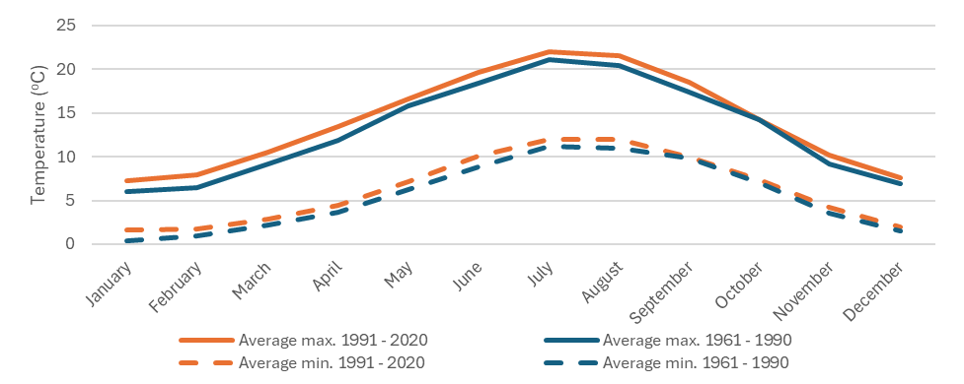
In addition to changes in average, maximum and minimum temperatures, there has been a reduction in the number of days of frost. From 1991-2020 there were, on average, around 42 days of air frost per year, compared with around 53 days per year between 1961-1990. This represents an approximately 20% decrease.
Due to its location in the Midlands, Tamworth is relatively sheltered from Atlantic storms and the distribution of rainfall is more even over the course of the year. The average annual rainfall recorded in the Midlands from 1991-2020 was approximately 810 mm, compared to the England average of 870mm. Annual rainfall in the Midlands has increased 5% since 1961-1990, where annual rainfall was 768mm.
Figure 2. Average rainfall recorded at Coleshill weather station
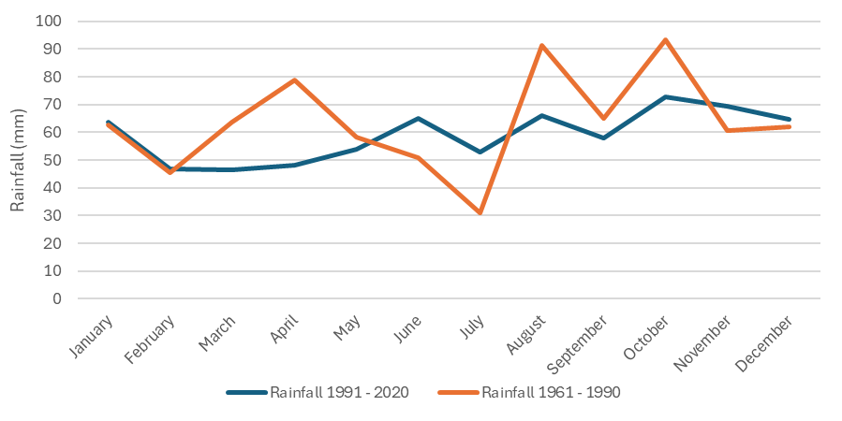
These observed trends are broadly consistent with those seen in England as a whole, which has experienced increases in annual average temperatures, rainfall and sunshine.
Tamworth is built around the confluence of the River Anker and the River Tame. Approximately 42% of the Tame basin is urbanised, making it the most heavily urbanised river basin in the United Kingdom. As such, various areas in the borough are susceptible to flood risk. Tamworth was identified in the 2015 Local Flood Risk Management Scheme (LFRMS) as the urban area at the 3rd highest risk of surface water flooding in Staffordshire, with 920 properties at risk.
Figure 4 below shows the long-term river and surface water flood risk in Tamworth. There is a high risk of surface water flooding along the railway line and throughout the town centre, as well as on major roads such as the A453. Areas of high river flood risk are concentrated along the Anker and the Tame. Areas at risk of flooding include the Ventura Retail Park, the SnowDome and the westerly side of the Castle Gardens, including the Old Swimming Baths. Flooding in these areas could impact on local businesses and footfall in particular. Additionally some major roads around Tamworth are at risk of river flooding, including the A51, which could impact accessibility for both residents and businesses.

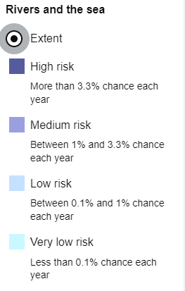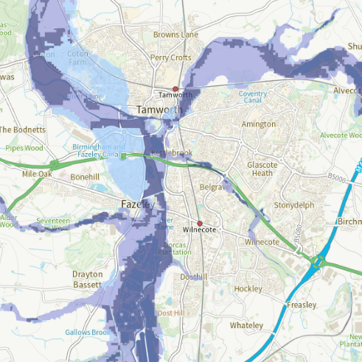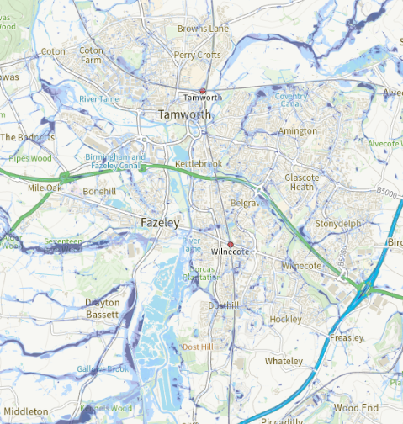
Figure 4: Long-term river (left) and surface water (right) flood risk areas in Tamworth

  - Extreme weather events
Alongside annual trends, it is important to consider more extreme weather events, as these are expected to become more frequent in future due to climate change. In Tamworth, records from the Met Office and local newspapers suggest that heatwaves and flooding have had a particular impact on local communities and businesses in the borough.,
Figure 5. Examples of recent extreme weather events in Tamworth
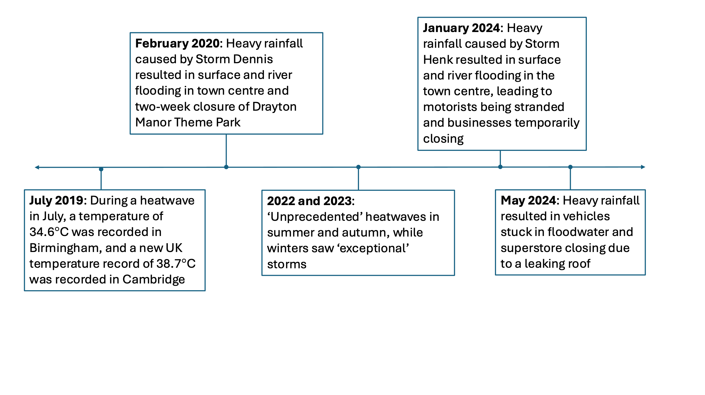

- Assessment of climate risks for Tamworth
The Met Office regularly produces projections of future climate as part of their UK Climate Projections series, with the latest dataset being the UK Climate Projections 2018 (UKCP18). The Met Office has recently released the Local Authority Climate Explorer which provides an interface for exploring the data from these projections at a local authority level. Data from this tool is presented here to illustrate future climate changes in Tamworth.
The extent of future climate change is dependent on the level of global action taken to mitigate against climate change. The Paris Agreement, a legally binding internationally agreed treaty on climate change, aims to hold “the increase in the global average temperature to well below 2°C above pre-industrial levels”. Under a reasonable worst-case scenario, where global mitigation efforts do not significantly reduce greenhouse gas emissions, global average temperatures could rise to 4ºC above pre-industrial levels. Projected changes in temperature and precipitation under these two scenarios for Tamworth are shown in Table 1. The range in brackets shows the uncertainty in the estimates. The CCC advises organisations to adapt to 2°C and assess the risks for 4°C. In 2023 the world has warmed by 1.3°C compared to pre-industrial levels.
Table 1: Summary of projected changes in temperature and rainfall in Tamworth under different climate scenarios.
Scenario | Success of the Paris Agreement (2ºC) | Reasonable worst-case scenario (4ºC)
Change in max summer temperature | +3.4°C  (+2.4 to +5.2) | +7°C  (+6.2 to +8.8)
Change in min winter temperature | +2.6°C  (+1.3 to +4.4) | +4.8°C  (+3.6 to +6.2)
Change in summer precipitation rate | -10%  (-25% to -4%) | -27%  (-43% to -17%)
Change in winter precipitation rate | +7%  (-1% to +16%) | +18%  (+11% to +29%)
In Tamworth, overall this means:
- Wetter, milder winters and more extreme rainfall events, leading to increased flooding.
- Hotter, drier summers leading to droughts, wildfires and heatwaves becoming more intense and more frequent.
These changes could pose significant risks to communities, infrastructure, the economy and the natural environment. For example, a recent study identified that under a 2ºC scenario an average school in the UK could see temperatures above a comfortable limit of 26ºC for over one-third of the academic year.
  - Climate risk and opportunity matrix
Within this strategy we distinguish between negative risks and positive opportunities associated with climate change, as is done in CCRA3.
Climate risk is the potential for negative consequences due to climate change where something of value is at stake and where the outcome is uncertain. Climate hazards that could cause negative consequences in the UK are likely to include flooding, heatwaves, wildfires, drought and long-term changes in overall temperature and precipitation.
Climate change opportunities arise where there is the potential for positive consequences due to climate change. For example, changes in temperature and precipitation patterns may offer opportunities to grow new types of crops in the UK. In some cases, the opportunity may have a corresponding risk, for example yields from crops suited to the current UK climate may decrease as the climate changes. As with the risks above, there is uncertainty in the outcome of these opportunities and adaptation actions are required to maximise the chance of positive outcomes. The IPCC defines adaptation as “the process of adjustment to actual or expected climate and its effects, in order to moderate harm or exploit beneficial opportunities”.
Table 2 presents the climate risks and Table 3 presents the climate opportunities that are relevant to the borough of Tamworth. The climate risks and opportunities have been based on the risks and opportunities for England in the independent evidence base for CCRA3 and filtered for those relevant to Tamworth. A few additional risks have been added from the West Midlands Climate Change Risk Assessment and Adaptation Plan 2021-2026 where they were deemed relevant to Tamworth. International risks were not considered for the purpose of this work.
The risks and opportunities have been scored qualitatively based on their potential magnitude and how that may change between now and 2050, considering scenarios for 2°C and 4°C global warming by the end of the century. Where possible, the risk scores have been refined based on Tamworth’s local context and information on this has been included in the table below. Where relevant local information was unavailable, they have been assumed to be the same as the scores for England as a whole and more justification for these scores can be found in CCRA3. The risks and opportunities are categorised according to the broad sectors on which they impact.
<–––––––––––––– Risks –––––––––––––––> |  |  |  |  |  |  |  | <––––––– Opportunities ––––––>
High | Medium, rising to high | Medium | Low, rising to medium | Low | Insufficient evidence |  | Low |  | Low, rising to medium | Medium | Medium, rising to high | High
Table 2: Risks from climate change in Tamworth.
Climate Risk | Risk score | Supporting information
Business and local economy
Increase in flood risk for businesses | High | Tamworth lies within the Humber river basin district which has been estimated to have the highest number of non-residential properties and key services at risk of flooding of all the English river basin districts.
Increase in flood risk for industrial sites, increasing the risk of water pollution | High | Increased contamination due to small manufacturing plants in Tamworth could result from increases in surface water flooding.
Extreme weather impacting business access to finance, investment and insurance | Medium rising to high | In the longer term, an increase in extreme events is likely to make insurance less available and affordable and could also reduce the value of assets and investments.
Reduced employee productivity resulting from infrastructure disruption and higher temperature working environments | Low rising to medium | Future climate change could reduce employee productivity in a number of ways. For example the flooding of roads in Tamworth could affect commuters and high summer temperatures could affect outdoor workers in particular.
Drought impacting business operations | Low rising to medium | Current economic impacts of water scarcity in England are low but could increase if not managed. The risk in Tamworth is likely to be lower than other parts of the country (e.g. the east of England).
Extreme weather disrupting business supply chains and distribution networks | Insufficient evidence | There is currently limited information on the supply chain impacts of climate change and impacts are expected to vary by sector.
Housing, wellbeing and community
Higher summer temperatures impacting health and wellbeing e.g. due to overheating | High | The risk of heat related mortality across England is rated as high in the UK CCRA. Figure 6 illustrates how heat vulnerability varies across Tamworth currently with some areas having acute or extremely high vulnerability.
Higher temperatures impacting food safety and extreme weather impacting food security | High | The risk to Tamworth is assumed the same as that for England in CCRA3. Food security can be impacted by climate change impacts in other countries or regions of the UK affecting food production and supply chains.
Widening health inequalities due to more extreme weather | High | The 2021 census results show a 33% increase in people aged 65+ compared to 2011 in Tamworth. The elderly are more vulnerable to the impacts of climate change. Other factors impacting this risk include people on lower incomes being less able to adapt their homes. Existing vulnerability to heat and how it may vary by demographic in Tamworth is shown in Figure 6.
Warmer summer temperatures increasing household energy demand | Medium rising to high | Cost of energy and energy demand in the summer across England could increase if mechanical cooling or air conditioning is widely adopted. There is uncertainty in the amount of uptake that there might be.
Increased household water supply interruptions due to drought | Medium rising to high | A major drought leading to loss of water to hundreds of thousands of households is possible under future climate change and therefore the future risk is assessed as high, in line with CCRA3.
Deterioration of cultural heritage sites due to changes such as rising temperatures, flooding and drought | Medium | Specific assessment of Tamworth’s heritage assets has not yet been carried out in the course of this work but across England, risks to heritage assets and their use has been rated medium.
Impacted quality of delivery of health and social care services due to extreme weather such as flooding and heatwaves | Medium | Challenges for health and social care delivery across England include damage to buildings and assets, difficulty in patients accessing services (for example due to floods) and adapting services for changing demand (for example increases in heat related illnesses).
Risks to health from indoor and outdoor air quality | Medium | Overall, outdoor air quality is likely to improve over the coming decades due to decarbonisation measures for transport and buildings. The impact of future temperature and wind pattern changes on air quality is highly uncertain but wildfire events could cause episodes of increased air pollution.
Impacted quality of delivery of education services due to extreme weather such as flooding and heatwaves | Medium | Delivery of education is likely to become more challenging under climate change as many schools have not been constructed to be resilient to future climate change so may overheat or flood and more may be need to be spent on repairs.
Increases in diseases spread by mosquitoes and ticks due to higher temperatures. | Medium | In 2022 there were 30 cases of laboratory confirmed Lyme disease in the West Midlands. Future changes are uncertain but higher temperatures are thought to make it more likely that new diseases become established in the UK.
Natural environment and green spaces
Negative impacts on terrestrial and freshwater species and habitats due to climatic changes, invasive species and pests | High | This risk is rated as high due to the number of species and habitats expected to be negatively impacted by climate change and the resulting potential impacts on green and blue spaces in Tamworth.
Reduced soil health due to heavy rainfall causing erosion and summer drought reducing soil moisture. Healthy soil is needed to support biodiversity and store carbon. | Medium rising to high | Decreasing soil health over time could have significant negative impacts on local biodiversity and the quality of Tamworth’s green spaces, as well as agricultural productivity in the wider Staffordshire area.
Reduction in uptake of carbon by natural carbon stores such as trees due to temperature change and water scarcity. | Medium rising to high | Trees act as carbon sinks but can be damaged by impacts such as drought and wildfire, both of which are expected to increase in future.
Changes to landscapes and land use due to climate change could change the character of green spaces and how people relate to them and use them. | Medium rising to high | Hazards such as wildfire, flooding and drought could pose high risks to the character and beauty of Tamworth’s green spaces if adaptation measures are not taken.
Wildfires causing destruction to habitats and carbon stores | Low rising to medium | Tamworth does not have significant agricultural land or open habitats such as peatland that would be areas of high risk. However, increased heat and drought in future could pose a risk of wildfire, especially to habitats at the urban to rural interface.
Negative impacts on agricultural and forestry productivity due to changing climatic conditions, pests, pathogens and disease | Low rising to medium | There is limited agriculture within Tamworth itself, reducing the risk of direct impacts. However, food price shocks and supply issues resulting from the impacts on agriculture in other parts of the country and world could still affect Tamworth.
Buildings, infrastructure, planning and development
Disruption to one infrastructure network impacting another (e.g. loss of energy provision affecting communications networks, even if the communication network is not directly impacted) | High | Infrastructure systems are highly interdependent and so if one fails during a climate event it could cause others to fail. For example, IT infrastructure could be well adapted to the direct effects of climate change but fail because the energy system is not well adapted, causing the IT system to lose power. This risk is rated is high for the UK in CCRA3 as it could have significant impacts.
Direct disruption to infrastructure networks from extreme weather such as flooding, storms and heatwaves | High | Flooding of the road and rail network is likely to be a particularly significant infrastructure risk in Tamworth.
Increased flooding impacting buildings and communities | High | Tamworth already experiences impacts from flooding. Expected annual damages from flooding in England could rise by up to 50% by 2080, even under a scenario where the goals of the Paris Agreement are achieved.
Reduced water availability due to drought impacting public water services | Medium rising to high | A major drought leading to loss of water to hundreds of thousands of households is possible under future climate change and therefore the future risk is assessed as high, in line with CCRA3.
Flooding, erosion and subsidence impacting bridges, pipelines, transport and other infrastructure | Medium | Long-life infrastructure such as bridges were generally built for past climates and so can be vulnerable to future climate changes. For the UK as a whole this risk is rated as medium.
Moisture and wind impacting quality of building fabric | Medium | Wetter winters may exacerbate issues with damp in homes. Wind storms already cause damage to buildings but it is uncertain whether these will increase as a result of climate change.
Disruption to availability and reliability of ICT infrastructure due to extreme weather such as heatwaves and flooding | Low rising to medium | There is limited evidence relating to climate impacts on ICT infrastructure in the UK so far but impacts are expected to grow. There have been some examples of previous disruption such as mobile base station outages in Lancaster following Storm Desmond in 2015.

Table 3: Opportunities due to from climate change in Tamworth.
Opportunity | Opportunity score | Supporting information
Business and local economy
Climate change changing demand for goods and services | Low rising to medium opportunity | For some sectors, including tourism in Tamworth, there may be opportunities stemming from longer summer tourist seasons
Housing, wellbeing and community
Warmer winter temperatures decreasing winter household energy demand | Low rising to high | UK level projections suggest that high economic savings will be possible due to higher winter temperatures reducing the need for building heating.
Opportunities for health and wellbeing due to warmer summers and winters | Low | It is possible that a warmer climate could provide wellbeing benefits from increased physical activity and contact with nature but evidence on this link is limited.
Natural environment and green spaces
Changing climatic conditions result in new species becoming suitable and opportunities to enhance green space character. | Medium rising to high opportunity | There could be opportunities to introduce new species into Tamworth’s green spaces.
New terrestrial species and habitats due to changing climatic conditions | Medium opportunity | The arrival of new birds or other species as they migrate with the changing climate could increase biodiversity within terrestrial habitats. Note from Table 2 there are also significant risks to biodiversity from climate change
New freshwater species and habitats due to changing climatic conditions | Low opportunity | This could potentially increase biodiversity of Tamworth’s wetlands though evidence is limited.
Buildings, infrastructure, planning and development
No opportunities identified
  - Interacting risks
The climate risks outlined in section 3.1 are unlikely to operate in isolation, and instead interact, with the potential for total risk to be greater than the sum of individual risks. This is particularly true where dependencies between different infrastructure systems mean that risk can cascade, where a failure in one system can cause a failure in any systems dependent on it. The case study below presents an example of the interacting risks which may occur during a severe heatwave.

An example of impacts of a heatwave on local businesses
A large number of warehouses and small manufacturing sites exist within Tamworth. These supply a wide variety of goods to the rest of the country. As highlighted in section 2.1, temperatures have already increased in the past few decades in Tamworth and this trend is expected to continue. What happens if there is a severe heatwave?
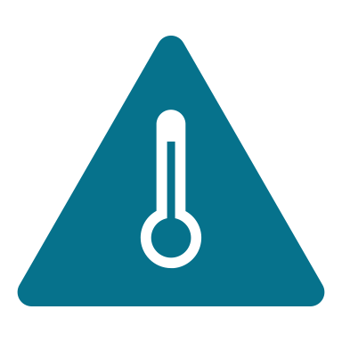 | If buildings are not properly insulated, ventilated, and cooled, they are likely to overheat. In warehouses, staff welfare would be affected, with more people at risk of falling ill. For some people, particularly those who are older or vulnerable, the health impacts could be severe or even fatal.
 | In extremely hot weather, more electricity would be needed to power air conditioning and cold appliances. However, this would also be the time when power networks are at higher risk of faults or outages. This would not only impact the buildings and cold storage, but other utilities and infrastructure that underpin logistics supply chains.
 | Meanwhile, transport networks could be affected, with railway lines buckling, overhead cables sagging, and vehicles overheating or unable to charge. This could prevent goods being distributed from warehouses – if the employees manage to commute to work in the first place.
 | In a reasonable worst-case scenario, therefore, a severe heatwave in Tamworth could disrupt supply chains not just locally but in other parts of the UK. These might include food, medicines and other vital supplies.
 | More frequent or prolonged disruption to the supply of goods such as food, in Tamworth, in wider areas of the UK or internationally, could result in shortages or price spikes, amplifying existing inequalities and food insecurity.
It is therefore critical to ensure that adaptation measures are incorporated at a strategic level, across all types of infrastructure – beyond the design of individual buildings.

Note that many of the solutions to these risks are outside Tamworth Borough Council’s direct ability to control, therefore collaborative and partnership working will be essential to combat the potential impacts.

An example of impacts of flooding on the local community
Tamworth is built around the confluence of the River Anker and the River Tame and parts of the borough are also at risk of surface water flooding. As highlighted in section 2.1, winters in Tamworth are expected to get wetter in the future which is likely to lead to more frequent and intense flooding. What happens if there is a severe flood?

 | If effective early warnings are not received and heeded by the community, people and businesses may not have time to prepare, for example by moving items upstairs within properties or moving vehicles to higher ground. Some vulnerable people such as the elderly may be less able to access warnings or be less mobile and hence less able to make preparations. In the event of property flooding, this could result in worse damages.
 | Floodwater in properties not only causes damage to the building fabric and contents, contaminated water, sometimes containing sewage, can pose a risk of illness to inhabitants. Electrical installations could also become damaged, posing a safety risk as well as potentially extended power outages.
 | Accessing flooded properties for emergency service provision or supporting the clean-up operation could be hindered by roads also being flooded. Those not living in the flood zone may still experience disruption if they are unable to commute to work or travel into the town centre, resulting in impacts on local businesses.
 | Experiencing flooding can cause long term mental health impacts such as anxiety, depression and PTSD which can affect people’s ability to work as well as their wellbeing. Other long term impacts could include increased insurance premiums for households and businesses.
As flooding becomes more intense and more frequent, more households and businesses could be affected and damages are likely to increase. Effective adaptation action can help communities mitigate, prepare for, respond to and recover from these risks.

Note that many of the solutions to these risks are outside Tamworth Borough Council’s direct ability to control, therefore collaborative and partnership working will be essential to combat the potential impacts.
  - Vulnerabilities and exposure
Certain groups may be more vulnerable or exposed to the effects of climate impacts and extreme weather than others. Vulnerability and exposure can be driven by many factors:
- Physical factors: Factors such as age and health mean some groups are more sensitive to climate impacts. For example, the elderly are more vulnerable to heatwaves and may be less mobile so less able to evacuate during flooding. They may also be less able to receive information and warnings, for example if they are not online.
- Environmental factors: Factors such as type or elevation of buildings and proximity to a floodplain or an urban centre can increase or reduce exposure to flooding or heat.
- Social and institutional factors: Levels of inequality and income, strength of social networks within communities, and institutional practices affect people’s ability to adapt. For example, lower income households may be less able to afford housing upgrades to reduce overheating or protect against flooding.
An example of the spatial variation in heat vulnerability across Tamworth is shown in Figure 6, taken from ClimateJust. The figure shows socio-spatial vulnerability – how the personal, social and environmental factors which help to explain uneven impacts on people and communities combine in some areas. It shows where negative social impacts from rising temperatures are more likely. There is an area in the town centre (Tamworth 002A Lower layer Super Output Area (LSOA) (2011), shown in red in Figure 6) that has an acute socio spatial heat vulnerability index. This is driven by a number of characteristics of households in the area: a higher proportion of elderly people, particularly single pensioner households, higher levels of illness and disability, higher levels of income deprivation, higher levels of private renters and a larger number of flats without gardens. These characteristics mean that households are more vulnerable to the risks associated with heat and less able to prepare, respond and recover from extreme events. Some of these characteristics may also make these households more vulnerable to other climate hazards such as flooding.

Figure 6: Socio-spatial heat vulnerability in Tamworth
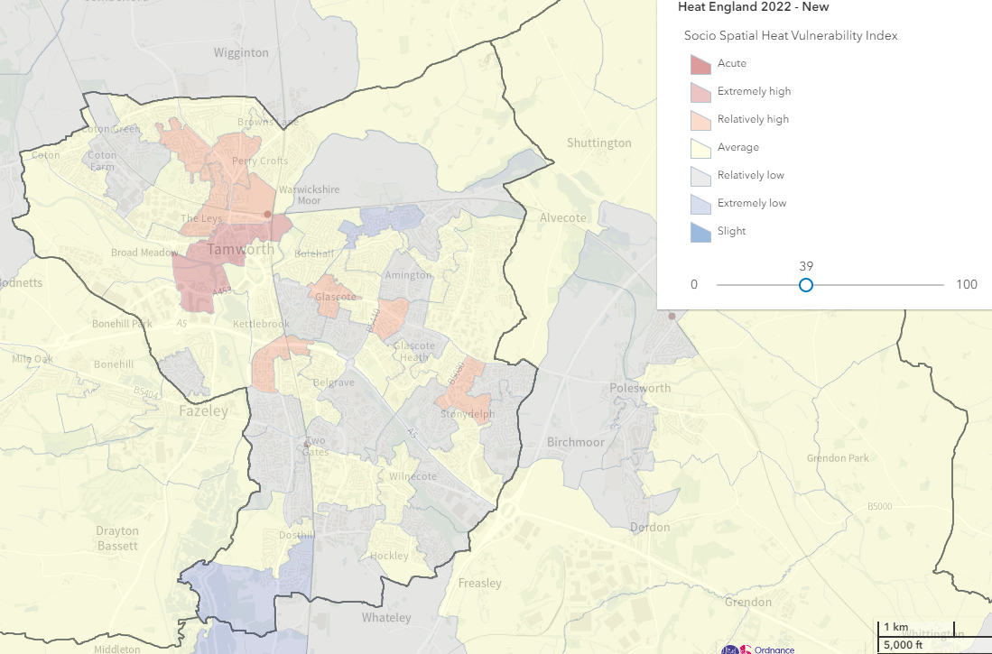

  - Transition risk
So far, this document has considered the physical climate risks that are likely to affect Tamworth in the future. Additionally, the council and other organisations in Tamworth will face transition risks due to the transition to a net zero economy. Policy, legal, technological and market changes are needed to reach net zero and adapt to climate change, and the impact of these changes could pose financial and reputational risks to organisations. There risks fall into four categories listed in Table 2.
Table 4: Transition risks for Tamworth
Type of risk | Description | Example of potential impacts on Tamworth council
Policy and legal | Changes in policy or legislation at the national level may put additional responsibilities on local authorities that require resourcing, while failure to comply with these requirements carries a risk of litigation. Additionally, changes in local policy by Tamworth to mitigate and adapt to climate change may result in policy and legal risks for local organisations affected by these changes. | If national government were to increase climate reporting requirements for local authorities, for example by extending the Adaptation Reporting Power, additional resource may be required to meet this requirement.  Implementing climate policies in Tamworth’s new local plan could present risks to local businesses and developers who would need to ensure compliance with any new measures.
Technology | Technological innovations that support the transition to net zero (such as electric vehicles and renewable energy) may require assets to be retired and investments to be made in these new technologies with these changes, and their timing, representing a potential financial impact. These innovations could also lead to changes in supply and demand of products and services which could affect local businesses. | Investment will be required to transition council assets, such as building heating systems and vehicles, to net zero. This may require early retirement of existing assets.
Market | Changes to supply and demand for different products and services. | Potential increases to the costs of raw materials, or market shocks, could result in increased costs for procurement.
Reputation | Stakeholder perception of Tamworth’s contribution to the net zero transition, and building climate resilience, may lead to opportunities or risks for the council’s reputation. | The council may need to deal with more complaints and negative feedback from the local community if their climate strategy is not perceived as effective.
Tamworth is already undertaking action that can help combat these risks, for example, this climate adaptation strategy and complementary climate action plan will help combat reputational risks by ensuring Tamworth has a coherent, effective plan for tackling climate change. Additionally, the Staffordshire Pension Fund (part of the Local Government Pension Scheme) already reports on transition risks to the pension in alignment with the recommendations of the Taskforce on Climate-Related Financial Disclosures (TCFD). To ensure the actions in the climate plan and adaptation strategy support the mitigation of transition risk, and where possible take advantage of transition opportunities, the council will remain mindful of these risks and carry out comprehensive stakeholder engagement and utilise partnership working where possible when implementing actions.

- Development of the climate adaptation action plan
Tamworth Borough Council has developed a climate adaptation action plan, presented in section 5. This section describes the principals for who this plan was developed and how it will be monitored and reviewed.
The actions within the plan will enable Tamworth Borough Council to start building its resilience to future change and ensure the town and surrounding area continues to thrive under these changes. The plan focuses on actions which can be implemented within the next five years and actions are presented alongside the positive outcomes they hope to achieve.
The action plan has been informed by a review of the evidence base on climate risks facing Tamworth, a review of relevant local, regional and national policy, and a series of focus groups and workshops with officers and members of Tamworth Borough Council.
  - Structure of the action plan
Actions have been divided into themes corresponding to those in the risk assessment to ensure all significant risks and opportunities have been addressed. However, it is important that adaptation actions are not siloed as there will be actions, such as catchment scale flood management, that can reduce risk across themes and actions, such as improving the ecological health of green spaces, that have wide ranging benefits for human and environmental health and other areas if they are implemented appropriately. In addition to the themed adaptation plan, section 4.3 identifies four cross-cutting key priorities that will help to ensure holistic, systemic action is taken to embed adaptation across all the council’s work.
This is Tamworth’s first adaptation strategy and action plan, as it is implemented there will be opportunities to learn from and refine the actions proposed. Actions will be implemented where the council is financially able to do so and all opportunities for funding will be explored and utilised where possible. Furthermore, as time goes on, more information on climate change and other future changes will become available which can be used to refine the actions proposed here. To ensure this plan is adaptive to new information and subject to continuous learning and improvement, a monitoring, evaluation and learning plan is described in section 4.4.
  - Principles for developing the adaptation actions
In selecting priority actions for Tamworth, the following principles have been applied, following discussion with Tamworth council officers:
- Prioritise actions where the climate risks are assessed to be most significant.
- Align with the wider area strategies for Staffordshire and the West Midlands.
- Focus on actions within the council's control that enable the council to begin setting an example in the wider community. Where actions could be implemented in partnership, possible partners are identified in Tables 5 - 8.
- Identify policies, plans and projects already happening in Tamworth where measures for climate resilience can be embedded.
- Prioritise easy wins and low-regret actions with co-benefits where possible in the short term, acknowledging resourcing is often a barrier.
- Avoid lock-in, i.e. making sure any long-term decisions and strategies such as those for infrastructure and housing that are made now consider possible future climate impacts, to avoid the potentially higher future costs of not being prepared.
  - Cross-cutting priorities
Four cross-cutting key areas of action have been identified that would benefit from cross-council implementation to maximise efficiency, take advantage of synergies and avoid siloed working. These cross-cutting actions were:
- Overall emergency response co-ordination - Although individual council service areas have emergency plans in place to ensure business continuity, and plans such as the Severe Weather Emergency Protocol to protect vulnerable people during severe weather, there is not a single point of contact responsible for co-ordinating emergency response. Introducing this role and creating a centralised information hub to disseminate information and offer training on emergency response to wider staff would enable the council to respond efficiently and effectively in the event of an emergency climate or weather event but also in the event of other emergencies. It may be possible to apply learnings from the response to the Covid-19 pandemic in setting up this co-ordination function.
- Communications plan - There is a need to build awareness in the wider public, businesses and organisations in Tamworth about the climate risks they are likely to face and how they can manage them, as well as helping them understand and accept measures the council is taking. This will require a communications plan that could be targeted to different organisations and sectors and could cover decarbonisation as well as adaptation measures. Opportunities to deliver the communications plan in partnership with other organisations such as the fire services or health services will be explored.
- Embedding adaptation and consideration of climate risk across relevant policies and strategies -If long-term policies and strategies are implemented without due consideration of climate risk, they may fail due to climate change impacts or require costly retrofit to improve their climate resilience in the future. Hence, the Council will aim to develop processes to include consideration of climate risk in the development of new policies and strategies, including how it could impact the objectives of the new local plan and proposed corporate plan and where adaptation measures may be needed. Similarly, consideration of climate risks will be included as part of the corporate risk register and business continuity processes.
- Building awareness and understanding of climate adaptation within the council - For many organisations in the UK, action to decarbonise is much more mature than action to adapt to climate change. To support implementation of the actions in this strategy and the embedding of adaptation to make wider policies climate resilient, Tamworth will aim to introduce training for staff to improve their understanding of climate risk and adaptation.
  - Monitoring and review
To measure progress achieved under this strategy, as well as improving understanding of the changing climate risk in Tamworth, ongoing monitoring and evaluation will be undertaken. This will be require identifying relevant data sources to demonstrate the effectiveness of actions taken and identify where further action is needed, supporting cross-council learning on how to ensure Tamworth is well-adapted for future climate risks. . To measure progress achieved under this strategy, as well as improving understanding of the changing climate risk in Tamworth, Tamworth Borough Council will monitor progress against the actions in this plan on an annual basis and prepare an annual update for Scrutiny Committee and Cabinet. To support this review process, key indicators to monitor progress will be identified and data will be collected to measure against these to ensure decisions are data driven and improvements can be targeted. In 5 years, there will be a full review of the plans and amendments as necessary.

- Climate adaptation action plan
  - Business and the local economy
The key risks to businesses and the local economy are the risk to business sites from flooding and the impact of extreme events, including flooding, on businesses’ access to finance and insurance. Tamworth is already seeing the impacts of extreme events on the local economy, particularly on outdoor events such as the market which have seen disruptions due to high winds, heavy rain and high temperatures in recent years. To avoid lock-in and ensure Tamworth builds future resilience to climate change, as well as tackling the climatic changes that are already happening, regeneration and other future planning for the local economy also needs to take climate change into consideration. Businesses will benefit from wider adaptation measures, such as improved flood defences and resilient infrastructure, throughout the town but there are also specific actions the council can take to support businesses and build their understanding of climate change and these are detailed in this section. Simple, low-regret actions can make financial sense and build resilience for businesses. For example, the total amount that could be collectively saved by UK SMEs if they check and act on accurate weather information is £15.4bn, and the total amount lost by not reacting to accurate weather information is £9.9bn.
    - Alignment with the Staffordshire adaptation strategy
This theme maps to ‘The Local Economy’ theme in the Staffordshire adaptation strategy which identifies the impacts of extreme weather events on business operations, supply chains and price volatility as a key risk, as well as the potential skills gap resulting from increased demand on the green economy. That strategy identifies building understanding of climate risk and adaptation, within councils so they can share relevant information as well as within businesses, to be a key outcome in this area and this is addressed by the actions in Table 4. Training and education programmes may enable improved understanding.

Table 5: Adaptation actions for Tamworth Borough Council related to business and local economy
Outcome | Action | Responsible service area | Resource requirements | Timescales | Possible delivery partners | Possible co-benefits or trade-offs of actions
Risks to business sites are minimised.  Risks to business sites are minimised. | Business Communication Strategy  Produce a communications plan to build local businesses understanding of climate risk, opportunities and adaptation, and how to respond during extreme events. Tailor communications to different types of business based on their existing engagement, actions already being taken, vulnerability and their capacity to adapt and respond to climate change.  Information to share could include:  - Building understanding of climate risk and adaptation by providing clear explanations of why climate adaptation differs from, but is needed alongside, decarbonisation measures.  - Advice on climate risk in Tamworth including future changes in flooding, heatwaves, drought, storms etc.  -Advice on measures businesses can take to prepare for and respond to climate change e.g. providing sun protection and water for outdoor workers during heatwaves to protect them and reduce productivity losses.  -Acknowledge potential opportunities climate change could bring for businesses.  - Details of council emergency response plans and contact details for extreme events (what businesses can expect and what is within the Council's remit)  -Signposting wider resources and examples of good practice. | Economic development and regeneration,  Communications,  Climate Change | Medium  May require collaboration across internal teams including  Corporate Communications and Partnerships. May require  funding for engagement events. | Develop during 2025-2026.  Review annually | Tamworth Business Forum, Tamworth Chamber of Commerce,  Support Staffordshire,  Staffordshire County Council | üBuilding relationships with local businesses.
 | Flood warnings  Encourage local businesses to sign up for Environment Agency flood warnings | Economic development and regeneration,  Communications | Low, signpost to UK Government website | Ongoing | Local businesses | üShare warnings with other local groups operating in the town centre, increasing preparedness for all.
 | Issuing public advice for visitors and car parking during flood events  The new Visit Tamworth microsite will provide emergency "safe to visit" messaging to the public and local authority stakeholders during extreme events. | Economic Development and Regeneration,  Communications | Low | 2025 – share information when necessary | Visit Staffordshire to take ownership | ü Reduced inconvenience for visitors.
 | Environmental permits  Encourage all sectors and businesses which require environmental permits, such as for activities involving potentially harmful substances, cement works, petrol stations to assess all impacts of climate change on their operations. | Environmental Health | High, may require some upskilling and resource to engage with operators. | Ongoing | Environment Agency | üReduced likelihood of health impacts  üReduced negative effects on local biodiversity
 | Develop business continuity and contingency plans for outdoor events in Tamworth including the market.  Create plans to reduce the impact of extreme weather events such as heavy rain, wind and heatwaves on outdoor events including the market. This could include identifying alternative venues, providing additional shelter or shading, procuring different types of temporary structure and encouraging participating businesses to develop contingency plans. | Arts and Events team, Economic Development and Regeneration,  Assets | Medium to high, some measures, such as identifying and using alternative venues could be costly. | Develop plan during 2025-2026 which will be reviewed every 2 years | Tamworth Chamber of Commerce | üPotentially diversify the locations and participants in events.
 | Data collection on events disruption  Continue and develop data collection on events disruption in Tamworth. Data on frequency of disruption, cause and costs can be used to better understand climate impacts and build future business cases for adaptation measures. | Economic Development and Regeneration,  Internal Events Working Group | Medium, resource required to manage and develop data collection | Ongoing | Events participants | üData may also be useful for developing other policies such as regeneration and planning.
Regeneration projects are climate resilient | Planning for regeneration projects: overheating, flooding risk  Account for future climate risks including flooding and overheating in the planning stage of regeneration. | Economic Development and Regeneration,  Planning | Medium | Ongoing | Supporting consultants | üDesign out unintended consequences of new development, potentially saving costs in the long term.

  - Housing, wellbeing and community
The risk assessment has identified higher summer temperatures leading to health and wellbeing impacts, and potential impacts on food safety, as the most significant risks in this area. Homes and workplaces in central Tamworth are likely to be most impacted by overheating due to the urban heat island effect (where built-up areas experience higher temperatures than the surrounding countryside) and demographics such as very young children and the elderly are also likely to be more vulnerable to the health impacts of extreme heat. Those in rented accommodation may be less able to adapt the buildings they live in, those living in flats or other homes with limited ventilation may be less able to cool their surroundings and those working outdoors may be more exposed to high temperatures and other extreme weather. The wellbeing of the local community is also dependent on council service delivery and so actions to build the resilience of this, as well as actions that directly tackle the impacts of heat and other extreme events on health and wellbeing, are listed in Table 5. There may also be significant benefits for health and wellbeing from green infrastructure and green space, both from the direct benefits of cooling and flood mitigation that this can bring, as well as the co-benefits of increased recreation opportunities. This is covered in section 5.3.
    - Alignment with the Staffordshire adaptation strategy
This theme maps to the ‘Health, Wellbeing and Safety’ theme in the Staffordshire adaptation strategy which identifies specific risks to health and wellbeing from extreme weather, particularly for vulnerable groups, and the risk of widening health inequalities. It also identifies risks for workforce health and safety, particularly for outdoor staff during extreme heat events, and the risk of service delivery being impacted by extreme events. These risks are addressed for Tamworth by the actions in Table 5. For adapting to these risks, the Staffordshire strategy notes the need to integrate the health impacts of climate change into corporate risk registers and business continuity plans, targeting community resilience programmes towards the most vulnerable and ensuring that the use of green and blue infrastructure contributes to health and wellbeing (see section 5.3 for green infrastructure actions for Tamworth).

Table 6: Adaptation actions for Tamworth Borough Council related to housing, wellbeing and community
Outcome | Action | Responsible service area | Resource requirements | Timescales | Possible delivery partners | Possible co-benefits or trade-offs of actions
Council service delivery is resilient to climate change | Corporate plan  Ensure that resilience is a consideration within the ‘Environment’ priority of the new corporate plan, alongside broader sustainability and net zero. | Executive Leadership Team | Low | The current plan is until 2030. This will be ongoing every time is it reviewed. | Internal to Tamworth Borough Council | üPotential for cost saving by recognising synergies between policy areas.
Council service delivery is resilient to climate change | Estate risk assessment  Ensure the council estate is subject to continuous risk assessment of potential damage to on-site infrastructure and climate risk is included in corporate risk assessments. | Finance Team, Assets | Low, potentially rising to high if risk mitigation measures such as repairs need to be implemented. | 2025-2028 | Internal to Tamworth Borough Council | üPotential for improved health and safety in the workplace
Council service delivery is resilient to climate change | Business continuity plans  Ensure business continuity plans account for potential disruption from extreme weather and climate events. | Assets | Low, integrate into existing work | Annual update | Internal to Tamworth Borough Council | üPotential for cost saving by recognising synergies between policy areas.
Council service delivery is resilient to climate change | Climate adaptation training  Develop and roll out a climate adaptation training programme ensuring all members of staff and elected members are aware of their role in the delivery of climate action. | Head of HR, Organisational Development,  Climate Change | Medium, may need to procure external training. | 2025 -2026 As new staff are onboarded, training will be mandatory | Internal to Tamworth Borough Council | üUpskilling and development of the workforce
Council service delivery is resilient to climate change | Adaptive work processes  Consider policy for adaptive work processes to minimise risk to the workforce during heatwaves and other climate events. For example, changes to work patterns, hybrid working patterns and provision of sun protection and drinking water for council outdoor workers. | HR and AD’s to coordinate service operations | Low | Ongoing, responsive to current weather conditions/ challenges  Potential to formalise policy 2026-2027 | Staffordshire County Council  Civil contingency unit | üFewer work days lost to weather related illness  üMaintains better productivity
Risks to vulnerable groups are reduced | Improve understanding of climate vulnerability  Identify existing data sources that can be used to understand community vulnerability to climate change in Tamworth and target adaptation measures in areas of greatest need. For example, source data on council housing residents who are elderly or have disabilities so may be more vulnerable to health impacts caused by heatwaves or may be less able to manage without electricity in the event of substation flooding. Having identified these vulnerabilities, measures such as communications campaigns or upgrades to council housing could be targeted. | Partnerships | Medium | 2025-2026 | Tamworth wellbeing partnership, community groups, emergency services,  NHS | ü Improved data on vulnerabilities and demographics for other policy development.
Tamworth council and the local community are able to effectively respond to extreme weather events | Communications with housing residents  Expand existing communications campaigns on damp and mould to address actions residents can take to reduce indoor temperatures and protect health during heatwaves. | AD for Neighbourhoods  Comms. | Medium, expansion of existing campaign and new content would be needed. | Pilot for summer 2026 | Tamworth Borough Council | ü Potential improved health and environmental quality for residents.
 | Planning for flood recovery  Ensure plans are in place for efficient and effective clean up after flood events and these plans are reviewed in light of likely increases in the frequency and intensity of future flooding. | AD for Environment, culture and wellbeing | Low, plans are already in place and will be reviewed. | Review every 3-5 years | Staffordshire County Council  Others depending on event and location e.g. Highways, Severn Trent Water | - Co-impacts not identified
Health impacts of climate change are minimised. | Account for climate adaptation needs during retrofit  Ensure retrofit or renovation of any council owned buildings considers opportunities to add adaptation measures such as ventilation or shading as required and encourage a similar approach by other organisations in Tamworth. | Assets | Medium, could increase up-front costs. | 2025 onwards - address during the planning stage of relevant projects. | Planning and building control | üPotential for reduced costs from higher water efficiency  üPotential for improved indoor air quality from improved ventilation  üImproved health and wellbeing of residents  ûClimate adaptation and decarbonisation measures should be considered together to avoid trade-offs (e.g. between insulation and ventilation) and potentially save costs (e.g. scaffolding)
Health impacts of climate change are minimised. | Food safety during extreme heat  Prepare advice for Tamworth operational buildings,  businesses and schools that handle, prepare and manufacture food around storage and handling of foodstuffs during extreme heat events. | Environmental health | Medium | 2025-2026 | Premises managers of operational buildings | üPotential for improved food safety awareness more generally

  - Natural environment and green spaces
The risk assessment has identified significant risks for both terrestrial and freshwater habitats and species from impacts such as drought and other extreme weather as well as long term changes in temperature and the timing of seasonal events. Resilience of the natural environment can be improved by improving biodiversity and overall ecosystem health so there are strong links between adaptation actions and wider policies such as biodiversity net gain for addressing these risks. The health of the natural environment is key for society as industries such as agriculture and forestry rely on an environment free from pests and disease that can affect yield, as well as healthy soils and water supply. In 2023, Tamworth Borough Council made a nature recovery declaration meaning they made a commitment to undertake targeted actions to make a positive contribution to the Local Nature Recovery Strategy and the Nature Recovery Network, by embedding nature recovery across council policy and all work areas.
A healthy natural environment and green space can also provide an adaptation solution in itself. The presence of trees can slow water run-off while green spaces can increase drainage in urban areas, thus providing a natural flood management solution. Trees and green space can also reduce the temperature of urban areas, potentially reducing the health impacts of extreme heat events. A healthy environment and access to green space can also improve health and wellbeing and provide recreation activities. Hence the strategic implementation of green space and other green infrastructure can provide wide ranging benefits, both for and beyond adaptation. In Tamworth, the draft local plan for 2022-2043 recognises the many functions of green space in Tamworth and aims to manage and protect the existing network of green spaces, to ensure that they all remain functional, of high quality, and both socially and environmentally beneficial.
    - Alignment with the Staffordshire adaptation strategy
This theme maps to ‘The Natural Environment and Green Spaces’ theme in the Staffordshire adaptation strategy which identifies disruption to nature and management regimes due to climate change changing seasonal timings, increases in wildfires, increase in pests and disease and damage to footpaths and similar infrastructure as key risks. It also identifies opportunities for the natural environment resulting from the use of natural flood risk management and other green infrastructure with co-benefits for carbon sequestration and cooling, as well as opportunities resulting from legislation on local nature recovery strategies and biodiversity net gain. The Staffordshire strategy identifies the need for better understanding and monitoring of habitats and species to inform management and the importance of developing green infrastructure plans in a holistic way that supports biodiversity as well as climate resilience.

Table 7: Adaptation actions for Tamworth Borough Council related to natural environment and green spaces
Outcome | Action | Responsible service area | Resource requirements | Timescales | Possible delivery partners | Possible co-benefits or trade-offs of actions
Habitats and species in good ecological health | Improve biodiversity and habitats  Work with the Staffordshire Wildlife Trust to identify opportunities to improve biodiversity in the area and assess priority habitats. More biodiverse, healthier habitats are more resilient to climate change. | AD for Environment, culture and wellbeing,  Planning | Medium to high, there is already engagement with the Wildlife Trust but further funding might be required to implement measures. | 2025 onwards | Staffordshire Wildlife Trust | üImproved biodiversity  üNature more resilient to other pressures such as pollution  üPossible increases in tourism and wellbeing from improved natural spaces
Habitats and species in good ecological health | Embedding adaptation in the local nature recovery strategy  Influence development of the Staffordshire local nature recovery strategy to address climate risk and improve resilience. | AD for Environment, culture and wellbeing | Low, already involved in strategy development. | Drafting in 2025-2026, 5 year delivery timescale | Staffordshire County Council | üAvoids possible trade-offs between climate and biodiversity objectives.
Habitats and species in good ecological health | Communication and education on wildlife friendly management practices  Develop tools for communicating the benefits of wildlife friendly management to the public to increase acceptance of practices such as less frequent mowing. | AD for Environment, culture and wellbeing,  Comms | Medium, resources to develop tools, may be able to build on existing work. | 2026-2027 | Staffordshire County Council | üPossible cost reductions in some areas e.g. less frequent mowing  üPublic awareness of environmental issues increased
Habitats and species in good ecological health | Successful delivery of biodiversity net gain requirements.  A working group has been established to deliver on biodiversity net gain requirements. | Planning | Medium | Ongoing from 2025-2026 | Internal to Tamworth Borough Council | üImproved biodiversity
Wildfire risks managed | Manage wildfire causes  Assess areas that may be most prone to wildfires and provide signage and guidance at these sites by encouraging users not to exacerbate the risk, for example by having barbecues or campfires. | AD for Environment, culture and wellbeing | Medium, will require some resource to assess and develop guidance. | 2025 onwards, reviewed annually in the spring. | Fire service | Co-benefits not identified
Strategic delivery of green infrastructure for resilience  Strategic delivery of green infrastructure for resilience | Tree management plan  Develop a tree management plan for the borough using the ‘right tree, right place’ principle. Map canopy cover of trees in Tamworth. Ensure planting regime and choice of species is resilient (e.g. by choosing drought resilient species) and brings benefits for climate adaptation (e.g. planting trees where they can offer shade and cooling during heatwaves). A full-time tree officer has been employed to develop this plan. | AD for Environment, culture and wellbeing | Medium, possibly rising to high for implementation | 2027-2030  3- 5-year delivery timescale | Staffordshire County Council | üImproved biodiversity  üCarbon sequestration  üPotential aesthetic benefits  üAim to achieve Green Flag status for the Castle Grounds  ûPotential for tree damage due to disease, drought, wind etc. if wrong species or wrong places chosen.
 | Green infrastructure strategy  Develop a green infrastructure strategy with Staffordshire County Council, including the use of green infrastructure for flood, drought and heat mitigation. Ensure the strategy includes a plan for monitoring and evaluation so data that can be used for monitoring and maintenance, as well as assessing the effectiveness of different interventions, is collected. | AD for Environment, culture and wellbeing | Medium, possibly rising to high for implementation | 2027 – 2030  3–5-year delivery timescale | Staffordshire County Council | üPotential for recreation and wellbeing benefits  üPotential aesthetic benefits  üPotential for improved biodiversity
 | Green spaces in the local plan  Phase 1: Ensure the New Local Plan and Open Spaces Strategy mandate the protection and enhancement of natural spaces where they can provide protection against flooding and overheating, as well as benefits for biodiversity, wellbeing and recreation.  Phase 2: Integrate adaptation measures where appropriate in existing spaces, such as strategic tree planting, changing mowing regimes, installing drinking water fountains and planting more drought-resistant species, to ensure they can continue to be enjoyed in the future climate. | Planning  AD for Environment, culture and wellbeing | Medium to high, depending on measures implemented | Aim for the new local plan to be adopted by April 2028 | Internal to Tamworth Borough Council | üPotential for recreation and wellbeing benefits  üPotential aesthetic benefits  üPotential for improved biodiversity

  - Buildings, infrastructure, planning and development
The risk assessment has identified the risk of flooding to buildings and communities, as well as disruption to infrastructure from flooding and high temperatures, to be two of the key risks in this area. Additionally, the risk of one infrastructure system failing and impacting another is rated as high risk. For example, failure of the energy system due to high temperatures could result in a power outage to IT and communications systems, causing disruption. The failure of infrastructure systems can also have particular impacts for vulnerable groups who may rely more heavily on service provision and also on local businesses who rely on local transport and other infrastructure. In January and May 2025-2026-2026, heavy rainfall in Tamworth resulted in vehicles being stranded amid flood water and these kinds of events are predicted to become more frequent and more intense.
In Tamworth the new local plan offers a particular opportunity for implementing adaptation in this area. For buildings and infrastructure to be fit for the future, and avoid costly retrofit in the decades to come, the planning system must prepare for the future impacts of climate change now. To do this, the local plan must consider the potential impacts of climate change on its objectives and ensure measures are in place to reduce this, in line with good practice guidance. Table 7 contains more specific actions to ensure this as well as actions to protect existing buildings and the infrastructure the council relies on.
    - Alignment with the Staffordshire adaptation strategy
This theme maps to the ‘Critical Infrastructure and Buildings’ theme in the Staffordshire adaptation strategy which identifies key risks to the county from power outages, road closures and hazardous conditions due to extreme weather, as well as increases in resource requirements for maintenance and repairs due to climate impacts such as flooding and overheating. Key actions identified for reducing these risks include improving road surfaces, putting measures and business continuity plans in place to assess and reduce the impact of infrastructure outages and targeting flood risk prevention work to protect infrastructure and buildings.

Table 8: Adaptation actions for Tamworth Borough Council related to buildings, infrastructure planning and development
Outcome | Action | Responsible service area | Resource requirements | Timescales | Possible delivery partners | Possible co-benefits or trade-offs of actions
Planning and development in Tamworth prioritise resilience to future climate change. | Ensure early engagement between developers and the Lead Local Flood Authority (LLFA, Staffordshire County Council)  Ensure developers and planning applicants engage with the lead flood authority as early as possible to reduce delays and embed flood resilience measures in new developments from the start. | Planning | Low, already being undertaken | 2025 onwards | Lead Local Flood Authority (LLFA, Staffordshire County Council) | üPotential for more efficient processes
 | Encourage climate resilient development  Encourage climate resilient design and locations for new developments and buildings aligned with guidance on best practice. In the longer term, integrate requirements for these measures into policies on design guidance. Measures could include:  - Green and blue infrastructure to manage heat risk and flooding  - Shading through use of overhangs or balconies, external shutters, street layout, landscaping, shaded external seating areas  - Building form and layout to promote natural cross-ventilation through use of dual-aspects and shallow plans  - Inclusion of Sustainable Drainage Systems (SuDS)  - Water efficiency and harvesting measures that could include e.g. water efficient fittings and/or greywater recycling, on-site water collection for irrigation and toilet flushing. | Growth and regeneration | High. May require training of council officers on good practice, resource to engage with developers and funding to commission design guidance. | Aim for the new local plan to be adopted by April 2028 | Developers | üPotential for wider benefits such as reduced costs from higher water efficiency  üImproved health and wellbeing of residents  ûClimate adaptation and decarbonisation measures should be considered together to avoid trade-offs (e.g. between insulation and ventilation)
 | Update flood management strategy  Work with the Environment Agency and Staffordshire County Council to review flood defences coming to the end of life and identify needs for new or enhanced defences, accounting for future climate change, to feed into an updated Local Flood Risk Management Strategies and infrastructure delivery plans.  A community flood risk assessment: FAIR - ‘Flood Aware Informed, Resilient’ programme is currently being undertaken with a 6 year timescale for delivery. | AD for Environment, culture and wellbeing, Planning  AD for Economic Development and Regeneration | Low, already being undertaken.  Rising to high for implementation of new defences. | Will form part of the infrastructure delivery plan for the new local plan to be adopted by April 2028 | Environment Agency  Staffordshire County Council | üPossible benefits for biodiversity, recreation and wellbeing from natural flood management measures.
 | Integrate climate adaptation in Tamworth's new local plan  Embed adaptation measures within Tamworth's new local plan which will run to 2043. Specifically:  - Ensure new developments and infrastructure account for overheating risks as well as flooding.  - Ensure that any changes to green space account for possible impacts on climate risk.  - Ensure re-use and retrofit of heritage assets assesses adaptation needs. | Planning,  Climate Change | Low, rising to high for implementation of some measures. | Aim for the new local plan to be adopted by April 2028 | Internal to Tamworth Borough Council | üProtected and enhanced green space could also benefit biodiversity, recreation and wellbeing.  ü Benefits for health and wellbeing from reducing overheating risk in buildings.
Existing buildings in Tamworth are maintained and developed to be fit for the future. | Account for climate adaptation needs during retrofit  Ensure retrofit or renovation of any council owned buildings considers opportunities to add adaptation measures such as ventilation or shading as required and encourage a similar approach by other organisations in Tamworth. | Neighbourhoods, Assets, Premises managers,  Planning | Medium, could increase up-front costs. | 2025 onwards | Building Control | üPotential for wider benefits such as reduced costs from higher water efficiency  üImproved health and wellbeing of residents  ûClimate adaptation and decarbonisation measures should be considered together to avoid trade-offs (e.g. between insulation and ventilation) and potentially save costs (e.g. scaffolding)
IT Infrastructure in Tamworth is resilient to future climate change. | Integrate climate adaptation into new IT strategy  Identify and manage relevant climate risks within the new IT strategy. For example, consider overheating and flooding risks when making decisions about local IT infrastructure and consider supplier and supply chain resilience during procurement. | Technology information services | Medium, may require additional resource to implement risk mitigation measures if needed. | Strategy to be developed in 2025-2026 | IT service providers | ûPossible increased costs if additional requirements are introduced to procurement.
Interdependencies between infrastructure and other services are recognised and managed. | Awareness of infrastructure dependencies  Ensure corporate risk assessment and business continuity plans account for possible climate impacts on infrastructure dependencies and supply chains. | Finance,  Assets | Medium, may require additional resource to implement risk mitigation measures if needed. | 2025 onwards | Service providers | üPotential for improved understanding to also support wider risk management.

As defined in the third UK Climate Change Risk Assessment: Introduction - UK Climate Risk
https://www.sustainabilitywestmidlands.org.uk/wp-content/uploads/2023/12/West-Midlands-Climate-Change-Risk-Assmt-Adaptation-Plan-2021-26.pdf
Resilience to flooding - NAO report
Independent-Assessment-of-UK-Climate-Risk-Advice-to-Govt-for-CCRA3-CCC.pdf (theccc.org.uk)
Staffordshire Adaptation Strategy
Climate Change Declaration Update.pdf (tamworth.gov.uk)
https://www.metoffice.gov.uk/research/climate/maps-and-data/uk-climate-averages/gcqf99dn5
An ‘air frost’ is an event where the temperature at 1.25m above ground falls below 0°C.
https://www.metoffice.gov.uk/research/climate/maps-and-data/summaries/index
http://www.tamevalleywetlands.co.uk/discover/landscape/river-tame/
https://www.sstaffs.gov.uk/planning/planning-policy/strategic-flood-risk-assessment-2019
https://check-long-term-flood-risk.service.gov.uk/map?easting=420506&northing=303952&map=RiversOrSea
https://www.metoffice.gov.uk/weather/learn-about/past-uk-weather-events
https://www.birminghammail.co.uk/news/midlands-news/dramatic-footage-shows-flooded-tamworth-17764416
https://www.metoffice.gov.uk/research/approach/collaboration/ukcp/index
Explore the Climate of your Local Authority (arcgis.com)
The Paris Agreement | UNFCCC
CCC Adaptation Monitoring Framework - Climate Change Committee (theccc.org.uk)
The CAT Thermometer | Climate Action Tracker
Explore the Climate of your Local Authority (arcgis.com)
Precipitation rate is defined as average millimetres of precipitation per day.
https://www.carbonbrief.org/english-schools-face-overheating-for-one-third-of-year-under-2c-warming/
As defined in the third UK Climate Change Risk Assessment: Introduction - UK Climate Risk
IPCC Glossary Search
Technical reports - UK Climate Risk
https://www.sustainabilitywestmidlands.org.uk/wp-content/uploads/2023/12/West-Midlands-Climate-Change-Risk-Assmt-Adaptation-Plan-2021-26.pdf
Chapter 6: Business and Industry - UK Climate Risk
Taken from West Midlands Climate Change Risk Assessment and Adaptation Plan 2021-2026. The risk score presented was derived separately to the risk scores from the CCRA3 through expert judgement and consultation.
Taken from West Midlands Climate Change Risk Assessment and Adaptation Plan 2021-2026. The risk score presented was derived separately to the risk scores from the CCRA3 through expert judgement and consultation.
https://www.ons.gov.uk/visualisations/censuspopulationchange/E07000199/
Common animal-associated infections (England): first quarter 2023 - GOV.UK
Taken from West Midlands Climate Change Risk Assessment and Adaptation Plan 2021-2026. The risk score presented was derived separately to the risk scores from the CCRA3
Future-Flooding-Main-Report-Sayers-1.pdf
Chapter 4: Infrastructure - UK Climate Risk
https://www.climatejust.org.uk/map.html
https://www.climatejust.org.uk/map.html
https://www.staffspf.org.uk/Finance-and-Investments/Corporate-Governance-and-Responsible-Investment/Documents/TCFD-Report-June-2024.pdf
https://www.sustainabilitywestmidlands.org.uk/wp-content/uploads/2022/12/SWM-Weathering-the-Storm-2022-FINAL-1.pdf
Indicative additional resource requirements where low means the action is already being undertaken or resource has been assigned, medium means the action can largely be carried out in-house but additional time, funding or upskilling may be required, and high means procurement or significant additional staff time is likely to be required.
For example, the Green Buildings Council provides guidance on measuring and assessing physical risk and the Royal Town Planning Institute (RTPI) and the Town and Country Planning Association (TCPA) provide guidance for local authorities on planning for climate change.

