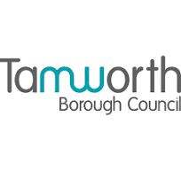

Annual Complaints Performance and

Service Improvement Report 2024-2025

- Introduction

- Annual self-assessment

- Analysis of complaint handling performance

- Learning from complaints and service improvements

- Housing Ombudsman Service landlord performance report

- Governing body response to the report

- Appendices

- Introduction

Tamworth Borough Council is committed to delivering high-quality, responsive services that reflect the needs and aspirations of our community. As part of our ongoing journey to ‘Build a Better Tamworth’, we recognise that listening to feedback, especially when things go wrong, is essential to driving meaningful change and continuous improvement.

This is the second annual complaints performance and service improvement report produced by Tamworth Borough Council, in compliance with the Housing Ombudsman's complaint handling code. The report must be presented to the governing body (Cabinet) and published on the Council’s website. The governing body's response to the report must also be published alongside it. The original submission date to the Housing Ombudsman was set for 30 June 2025; however, following feedback, the Housing Ombudsman has adjusted the deadline for submissions of the report to 30 September each year.

This report provides a transparent overview of the complaints received over the past year, how they were handled, and the actions taken to address them. It also highlights the service improvements implemented as a direct result of this feedback, demonstrating our dedication to accountability and customer-focused service delivery.

The report outlines:
- The volume and nature of complaints received
- Response times and resolution outcomes
- Key themes and trends identified
- Lessons learned and service improvements made
- Future commitments to enhance service quality
- A summary of the types of complaints the Council has refused to accept

It also includes:
- the annual self-assessment against the code to ensure the Council’s complaint handling policy remains in line with its requirements.
- the governing body response to the self-assessment.
- any findings of non-compliance with the code by the Ombudsman.
- any annual report about the Council’s performance from the Ombudsman.
- any other relevant reports or publications produced by the Ombudsman in relation to the work of the Council.

By listening to our community and acting on their concerns, we aim to build trust, improve satisfaction, and ensure that Tamworth remains a place where people are proud to live, work, and visit.

The Information Governance Team manages the council's corporate complaints process (comments, compliments, and complaints). They collaborate with colleagues who provide the services being addressed to develop a clear plan to resolve immediate issues and work on preventive measures for the future.

The council uses a 2 stage process for complaints, with stage 2 being the final response. For housing landlord complaints, complainants can escalate to the Housing Ombudsman at any stage of the process.

The Council follows the Housing Ombudsman Complaint Handling Code requirements in the management of complaints which became a statutory requirement on 1 April 2024. The Social Housing (Regulation) Act 2023 mandates that the Ombudsman oversee the compliance of social housing landlords with the Code. Consequently, the Council, in its capacity as a social housing landlord, is required to generate an annual report detailing complaints performance and service improvements

- Annual Self-Assessment
Since 2023, the council has published annual self-assessments against the Housing Ombudsman complaint handling code.

The annual self-assessment has again been completed, reaffirming our commitment to high standards of transparency, fairness, and accountability. The assessment confirmed that we are broadly compliant with the Code’s requirements, however, several challenges have been identified, including the need to further embed a consistent approach to complaint resolution across all service areas and to enhance staff training on early resolution techniques. Resource pressures and increasing service demand have occasionally impacted response times, highlighting the importance of ongoing investment in digital systems and staff development. These insights have informed our service improvement actions for the coming year, ensuring we continue to strengthen our complaint handling processes in line with best practice.

Appendix A sets out the full self-assessment for 2024-25.

The self-assessment found strong compliance with the code in policies, procedures, and best practices. Highlights include:
- A two-stage council complaints process
- A universal complaint definition
- Timescales for accepting, acknowledging, and extending complaints align with the complaint handling code
- Complaints performance is reviewed by various groups and committees

The self-assessment has highlighted areas that, while currently compliant, present further opportunities for enhancement as detailed in the table below.

Improvement | Actions
Enhancing service quality through learning from customer feedback | Use data and learning from complaints to identify touch points where we can improve the experience for our residents.
Action tracker | Improve the way we monitor actions derived from a complaint response to ensure completion of the complaint lifecycle
Housing Complaints Working Group | A regular meeting to review complaints data, analyse issues, and identify ways to improve service.
Complaint response times | Working with service areas to improve response times to complaints by building on existing processes and monitoring trends in complaint response times.

- Analysis of complaint handling performance in Housing Services
From 1 April 2024 to 31 March 2025, the council received 531 housing-related enquiries via its comments, compliments, and complaints channel. Of these, 211 were complaints 193 at stage 1, and 18 at stage 2. Furthermore, 254 contacts were identified as either service requests, enquiries, or updates to existing service requests.

Tenant Satisfaction Measures TSM’s
The Tenant Satisfaction Measures Standard requires all registered providers to collect and report tenant satisfaction measures (TSMs) according to regulator specifications. The TSMs are intended to give tenants information about their landlord’s performance and to provide data to the regulator regarding compliance with consumer standards.

Stage 1 complaints
Table 1 presents data on the number of Stage 1 complaints received and the corresponding rate per 1,000 homes within council owned housing stock.

Table 1
Stage 1 | April | May | June | July | Aug | Sept | Oct | Nov | Dec | Jan | Feb | Mar | Total
No. of complaints received | 7 | 13 | 7 | 11 | 12 | 25 | 9 | 21 | 14 | 18 | 24 | 32 | 193
No. per 1,000 housing stock | 1.63 | 3.02 | 1.63 | 2.56 | 2.79 | 5.82 | 2.10 | 4.89 | 3.26 | 4.20 | 5.65 | 7.47 | 44.89

The following charts present data on both the number and percentage of complaints responded to within 10 working days.

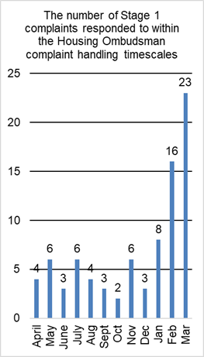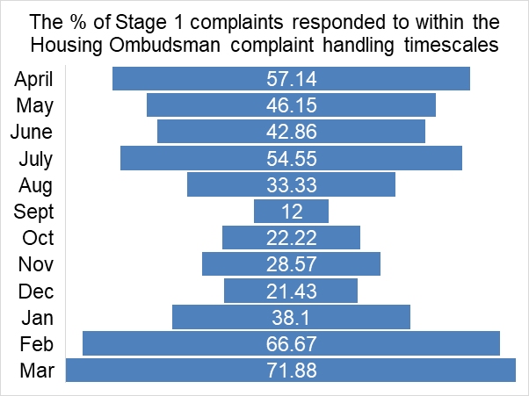

Stage 2 complaints
Table 2 presents data on the number of Stage 2 complaints received and the corresponding rate per 1,000 homes within council owned housing stock.

Table 2
Stage 2 | April | May | June | July | Aug | Sept | Oct | Nov | Dec | Jan | Feb | Mar | Total
No. of complaints received | 5 | 2 | 1 | 1 | 0 | 0 | 1 | 2 | 3 | 0 | 2 | 1 | 18
No. per 1,000 housing stock | 1.16 | 0.47 | 0.23 | 0.23 | 0 | 0 | 0.23 | 0.47 | 0.70 | 0 | 0.46 | 0.23 | 4.20

The following charts present data on both the number and percentage of complaints responded to within 20 working days.

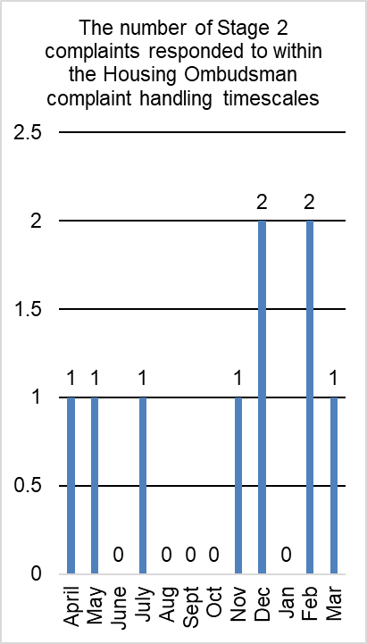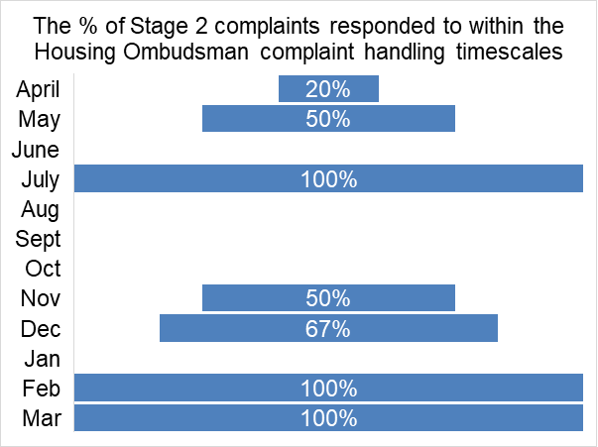

Progress has been made toward meeting the Housing Ombudsman’s response time targets of 10 days for stage 1 complaints and 20 days for stage 2 complaints. Annual performance data for 2024/2025 shows that 43.52% of stage 1 complaints and 50% of stage 2 complaints were resolved within the designated timeframes. Importantly, quarter 4 results demonstrate substantial improvement: in March, 71.88% of stage 1 complaints were addressed within 10 days, and all stage 2 complaints achieved the 20 day resolution target. This upward trend is expected to continue into 2025/2026.

The following chart presents a summary of complaints recorded at both stage 1 and stage 2 across each department. Housing Repairs received the highest volume of complaints in both stages, with 118 at stage 1 and 10 at stage 2.
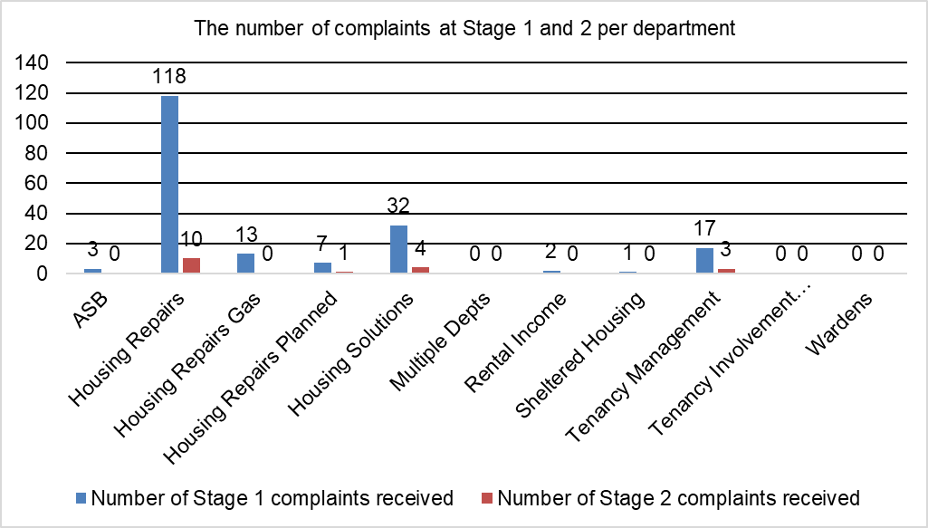

Acknowledgment of complaints
The complaint handling code requires complaints to be acknowledged, defined, and logged at stage 1 or 2 within 5 working days of receipt. The Council showed strong compliance, recording 200 out of 211 complaints (96.68%) within this timeframe.

Upheld complaints
Of the 211 complaints responded to, 111 (53%) of complaints were upheld.
The 106 upheld stage 1 complaints account for 55% of all stage 1 complaints received.
Five stage 2 complaints were upheld, representing 27.8% of all stage 2 complaints received.

Other contacts
254 contacts were determined to be a service request, an enquiry, or service request update and 66 compliments were received. A summary of these contacts is provided in the chart below.
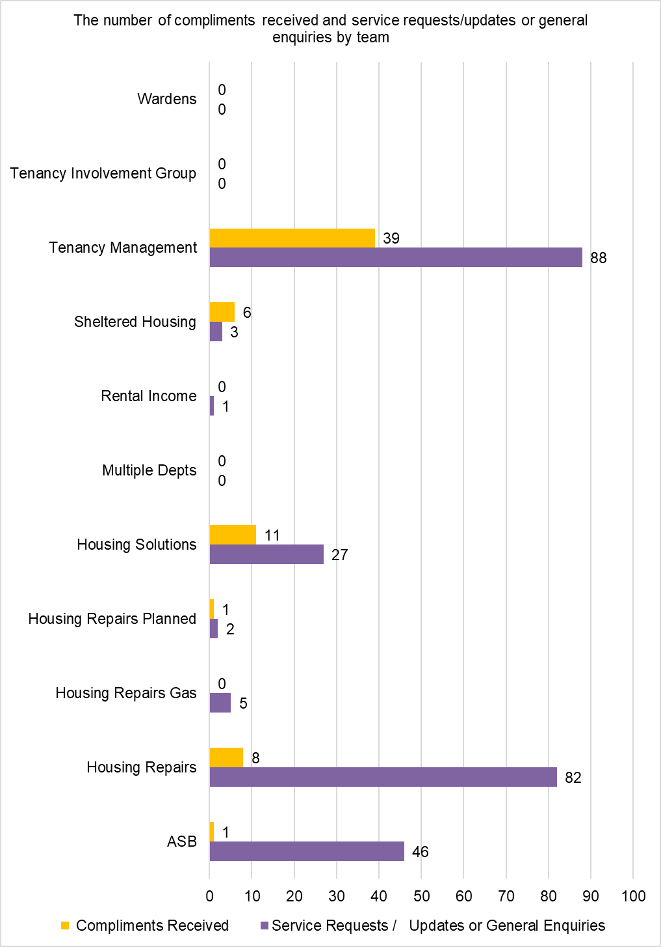

- Learning from Complaints and Service Improvements
Our ongoing focus is to embed best practice throughout all aspects of service delivery. Building on robust compliance in policy and procedure, we recognise the value of continually reviewing and refining our approach. This means not only adhering to the standards of the Complaint Handling Code, but also proactively seeking opportunities to improve through feedback, regular review, and meaningful engagement with tenants and stakeholders. As we look ahead, we are prioritising further investment in digital solutions, comprehensive staff training, and more consistent processes to support early and effective resolution of complaints. These steps will help us maintain and enhance the quality of our services while responding dynamically to the evolving needs of our community.

In line with national trends, complaints relating to housing repairs have continued to rise, reflecting broader challenges across the social housing sector. The Housing Ombudsman’s 2025 report Repairing Trust highlights a 474% increase in repair-related complaints since 2019–20, driven by issues such as delays, poor communication, and inadequate complaint handling. The report emphasises the importance of rebuilding trust between landlords, residents, and contractors. In response, Tamworth Borough Council will prioritise the following actions:
- Enhancing communication with tenants throughout the repair process to ensure clarity and to manage expectations.
- Adopt a more proactive maintenance approach, shifting from reactive to preventative repairs where possible.
- Strengthen contractor accountability through improved performance monitoring and resident feedback mechanisms.
- Further developing a culture of empathy and respect in all housing services, ensuring residents feel heard and valued.
These steps will support our commitment to delivering a more responsive, transparent, and resident-focused housing repairs service.

The council is dedicated to providing a broad range of services, striving to get things right the first time. We acknowledge that we don’t always succeed, and when mistakes occur, it’s crucial that we learn from them. Complaints give us valuable information, enabling us to improve our services and overall customer satisfaction.

We are committed to listening, when we have not got it right we will ensure we are doing all we can to prevent it happening in the future. We will continue to use complaint feedback alongside the other feedback we get from customer satisfaction surveys to drive improvements this year.

The council continues its efforts in analysing data and customer satisfaction metrics, collaborating closely with service areas to pinpoint valuable insights and areas for improvement. This ongoing effort will ensure that feedback is effectively utilised to enhance processes and elevate the overall quality of service delivery.

By maintaining a proactive approach to learning from complaints, the council aims to foster a culture of continuous improvement and responsiveness to residents' needs.

In 2024/2025, residents most frequently submitted complaints regarding service levels, delays in completing work, appointments being cancelled without completion of work, and issues with communication.

Theme/trend | Actions taken to improve the customer journey
Housing Repairs  Most housing related complaints are associated with repair matters. Common issues identified include missed appointments, repeated repairs for the same problem, and instances where repairs are not completed successfully on the first attempt. | Appointments cancelled/ work not completed  The information provided to tenants when a scheduled appointment may be missed reviewed and the missed appointment process published. Appointment cards advise the residents of what actions are required should a missed appointment occur. This information is also available on our website and will be added to the tenant handbook to ensure consistency across all communication channels.  Right First Time  As part of the contract work, a right first time protocol will be developed and agreed upon with our contractors.  Repairs Contract Reset  We have developed a service improvement plan to deliver key improvements in service delivery with our contractors, Equans.  Delays and poor communication  A documented process requiring initial telephone contact with complainants has been implemented.  Clear SLAs for contractors (e.g. Equans) and regular performance monitoring implemented.  Housing Compensation Policy  A policy implemented to support complaint handlers in making offers of financial redress to complaints at stage 1 and stage 2.  In line with the Housing Ombudsman Code and remedies guidance, the Council implemented its new housing compensation policy  Referrals for financial redress are considered by the review board consisting of the Head of Repairs and Head of Housing Management and Neighbourhoods  It is recognised while the new housing compensation policy is embedded within the organisation, not all cases for financial redress are picked up at stage 1 and further departmental training will be explored.  Damp and Mould  An automated survey evaluating satisfaction is distributed upon the initiation of a job concerning damp and mould.  A review of the damp and mould process has been conducted, identifying improvements such as immediate diagnostics and the exploration of third-party support for specific advice.
Housing Register | Requests for multiple copies of documentation.  The procedure for providing documentation during the housing application process will be evaluated with the aim of enhancing the customer experience.  Waiting list times  The council acknowledges the issues concerning waiting list times, noting that the shortage of affordable housing is a contributing factor.  The council website provides information on waiting times. A review will be conducted, with scrutiny of the findings.
Housing Management | Level of customer care from staff  Customer care training for the Neighbourhoods team has taken place.  Succession Rights  The council’s tenancy management policy has been updated, so tenants’ rights are made clearer, particularly on succession.  Dealing with ASB effectively  HATE crime training has been delivered for the Neighbourhood Impact Team, each officer has achieved BETEC qualification in managing ASB to ensure they are competent in tackling ASB across the borough including complex cases which require legal intervention.  Addressing issues with fly tipping in high rise properties  Improvements have been made to the health & safety booklet which is annually given to all high rise residents and provides a wide range of health & safety information including what is expected from all tenants and visitors to help keep their block clean & safe.  Timely responses to tenancy management requests Introduced tenancy management service request monthly monitoring to ensure such requests from our tenants are carried out in a timely manner and each tenant received a good quality level of service.  Addressing untidy gardens  Introduction of a garden leaflet which provides tenants with information about how to keep their gardens tidy and includes useful information on recycling and local tips etc.  Keeping tenants informed about important matters Frequent home visits to our older tenants in Thomas Hardy Court to ensure they are updated on the water hygiene position across their scheme.
Other areas of improvement | Housing complaints working group  A cross departmental group has been established to  - Review complaint data and identify systemic issues.  - Coordinate improvements.  - Promote a culture of continuous learning  Public communication and transparency  Rising complaint volumes have been reframed as a sign of resident engagement. Public messaging now emphasises:  - The council’s responsiveness.  - Improvements made as a result of feedback.  - Commitment to transparency and trust-building  Resident hub  Implementation of a new customer contact solution in autumn 2025 to improve the effectiveness of enquiry management at the first point of contact. Being a modern solution, several enquiry types will be managed through a casework system to ensure no enquiry is left unanswered.  Improved technology  The repairs contact centre will also benefit from advanced technology features that provide a better customer experience including call recording, callback, chatbots, translation etc. In providing these features team members will have greater availability to support those with greater vulnerabilities.  Marmion House reception  Reopened face to face reception services at the councils Marmion House building, providing support for general enquiries, housing matters, and assistance for vulnerable customers.

- Housing Ombudsman Service
The Housing Ombudsman Service investigates complaints from tenants and leaseholders of social landlords, such as housing associations and local authorities, as well as from private landlords who voluntarily join the scheme. It acts as the final decision maker in disputes. In addition to resolving individual complaints, the Ombudsman encourages landlords to learn from these cases to improve their services and prevent similar issues from recurring. It also conducts systemic investigations to identify broader issues affecting residents and promotes good practice across the housing sector.

Where a complaint is accepted for investigation, the Ombudsman seeks to establish whether the member has been responsible for maladministration (which includes findings of service failure, maladministration and severe maladministration). This may be that the council:
  - failed to comply with any relevant legal obligations
  - failed to comply with any relevant codes of practice
  - failed to apply its own policies and/or procedures
  - delayed unreasonably in dealing with the matter
  - behaved unfairly, unreasonably or incompetently; or
  - treated the complainant personally in a heavy-handed, unsympathetic, or inappropriate manner

Annual Landlord Performance Report
This report offers a comprehensive evaluation of the manner in which social housing landlords in England manage complaints and deliver services to residents. It is distributed to landlords for whom the ombudsman has made five or more findings within the reporting year. Additionally, the report is published on the Housing Ombudsman website.

The report includes:
Case Determinations: The number of cases determined by the Ombudsman for Tamworth Borough Council during the reporting period.
Findings: Categorised outcomes of those cases (service failure, maladministration or severe maladministration).
Orders made: issued when maladministration is found, to put things right for the resident in terms of service practice or financial redress.
Recommendations made: actions to be considered for implementation
Maladministration rate: includes service failure, maladministration, severe maladministration
Comparative Data: Where applicable, year-on-year comparisons
Compliance with orders: the % of orders completed in line with ombudsman requirements

The goal is to promote transparency, accountability, and continuous improvement by identifying both effective practices and areas needing improvement. This report aims to inform residents, influence policy, and assist landlords in improving their complaint handling and service delivery standards.

Tamworth Borough Council did not receive a report in either 2022-23 or 2023-24, however, has received a report for the 2024- 25 reporting year (1 April 2024 to 31 March 2025). The full report is available at appendix B. In summary the ombudsman made 4 determinations, 6 findings, 6 maladministration findings, made 11 orders, 3 recommendations and ordered compensation of £3,900. A summary of the 4 cases is below.

Case 1 was determined on 30 April 2024 in respect to the councils handling of damp and mould and repairs at a property. It was determined that there was severe maladministration in our handling of damp and mould at the property. It was also determined that there was maladministration in our handling of repairs. The council was ordered to:
- apologise to the resident
- to collaborate with the resident to produce an action plan
- to support the resident in making an insurance claim
- pay the resident £3250 compensation
- share the Ombudsman’s report with the Executive Team and Cabinet member for housing
- update the Ombudsman service on progress of the damp and mould policy
- incorporate a damp and mould assessment into the void inspection process and
- inspect a broken fence in line with policy and explain the obligations of the council to the resident

All orders were adhered to and on 12 June 2024 the Ombudsman confirmed the case had been closed satisfactorily.

Case 2 was determined on 19 June 2024 in respect of the councils handling of a leak from a water tank in the residents home.

It was determined that there was maladministration in our handling of the residents report of a leak from a water tank in the property.

The council was ordered to:
- Apologise to the resident in writing
- Pay the resident £300 compensation
- Provide the resident with details of how to claim against its liability insurance
- Remind front-line staff of the importance of appropriately handling information from residents concerning arising repair needs, particularly in the case of emergencies

All orders were adhered to, and the case was closed.

Case 3 was determined on 29 July 2024 and was in respect of the resident not being giving adequate notice of additional work needed to the property or the impact of the work and that the resident’s property and possessions were damaged. The Ombudsman determined that there was a service failure by the council in both matters. The council was ordered to
- apologise for the failings identified in the report
- pay the resident £150 compensation

All orders were adhered to, and the case was closed.

Case 4 was determined on 30 September 2024 and was in respect of the councils handling of the residents reports of antisocial behaviour. The Ombudsman determined that there was a service failure by the council and ordered the following:
- apologise for poor communication
- pay the resident £200 compensation

All orders were adhered to, and the case was closed.

Looking across the four cases, the Ombudsman found service failures or maladministration in every instance. This resulted in a local maladministration rate of 100% for cases that were fully investigated higher than the national average of 71%. Of course, with only a few cases, the percentage can seem more dramatic, but it does serve as a strong reminder of the need for close attention and continual learning.

What’s happening here in Tamworth isn’t unique. Across the country, councils housing providers are under growing pressure to handle complaints openly and effectively, especially when things go wrong. The Housing Ombudsman’s national reports often highlight the same kinds of issues we’ve seen locally delays with repairs, poor communication, and complaints not being dealt with as thoroughly as they should.
By looking at the bigger picture, it’s clear the challenges we face are part of a wider pattern. But it also means we have plenty of opportunities to learn from others and keep making improvements, so every resident gets the service they deserve.

- Governing Body Response to the report
As the elected members responsible for overseeing complaints and customer engagement, we are pleased to present the Annual Complaint Performance and Service Improvement Report for 2024–25.

This report reflects our unwavering commitment to transparency, accountability, and continuous improvement. Complaints are not just expressions of dissatisfaction they are valuable insights into how our services are experienced by residents and where we must do better. Each one is an opportunity to listen, learn, and act.

Over the past year, Tamworth Borough Council has taken significant steps to strengthen our complaint handling processes in line with the Housing Ombudsman’s complaint handling code. We have improved response times, enhanced staff training, and embedded a culture of learning across all service areas. Importantly, we have used feedback to drive tangible service improvements that benefit our community.

This work aligns closely with our Corporate Plan 2025–2030 and the vision to Build a Better Tamworth a borough that is prosperous, sustainable, and inclusive. By taking complaints seriously and responding with integrity and purpose, we are helping to shape a council that residents can trust and be proud of.

We acknowledge the crucial contribution of our partners in achieving improved outcomes for residents. Through collaborative efforts, we have shared insights, enhanced service delivery, and adopted a more coordinated approach to complaint resolution. These initiatives have further strengthened our capacity to respond effectively and empathetically to the needs of our community.

We would like to thank our officers for their dedication and professionalism, and our residents for their honesty and engagement. Together, we are making Tamworth better one improvement at a time.

Councillor Carol Dean Councillor Ben Clarke
Leader of Tamworth Borough Council Portfolio Holder for Housing, Homelessness and Planning

- Appendices
Appendix 1 – Self-Assessment Form 2025 (v1)
Appendix B – Landlord report – Tamworth Borough Council

