Tamworth Borough Council
TSM survey 2024/2025

Technical Report
May 2025

Company information

Name of company | M·E·L Research Ltd
Registered company address | Somerset House  37 Temple Street  Birmingham  B2 5DP  Company registration number: 3000946  VAT registration number: 655 3827 14
Main contact | Gayle Higginson | Tel number | 0121 604 4664
Position | Research Manager
Email address | gayle.higginson@melresearch.co.uk
Website address | melresearch.co.uk
Reference | 24243

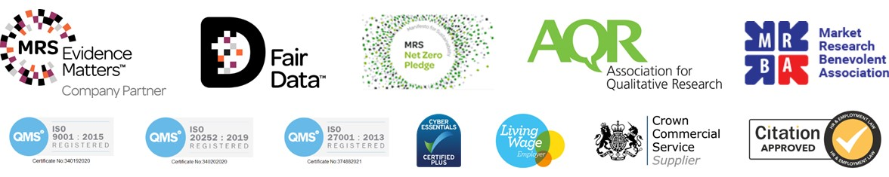

Tenant survey approach summary
M·E·L Research is an ISO 9001:2015 and ISO 20252 accredited organisation which demonstrates our commitment to providing quality products and services consistently. We ensure that all interviewers operate within IQCS guidelines and that Market Research Society customer care standards are met.
- The Tamworth Borough Council Tenant Satisfaction Measure (TSM) survey took place in February and March 2025.
- General needs, Sheltered, Supported and High Rise/ Eringden tenants were all given the opportunity to share their views.
- These tenures are all classed as Low Cost Rental Accommodation (LCRA) and therefore are in scope for the Tenant Satisfaction Measure.
- The questionnaire deployed was based on the 12 TSM questions, required by the Regulator, with supplementary open text style questions asked in order to understand the reasons for the satisfaction/dissatisfaction expressed.
- Contact details for 4,267 let properties as of 14th January 2025, were provided by Tamworth Borough Council and divided into two groups: 1) General Needs tenants and 2) Sheltered, Supported and High Rise/ Eringden tenants.
- The survey with General Needs tenants was carried out using a telephone and online approach from our in-house team whilst a postal approach and online was adopted for High Rise, Sheltered and Supported Housing tenants.
- Tamworth Borough Council wished to ensure that all tenants were given the opportunity to complete the TSM and this mixed method census approach provided a cost-effective solution to this requirement.
- Targets were set based on the overall profile of the Low Cost Rental Accommodation population based on tenure type, property type, age, gender and ward. The Regulator has stressed the need for a representative sample, so this approach supports this requirement.
- 1,027 Low Cost Rent Accommodation surveys were completed which provides TSM data with a confidence interval of +/-3, well below the maximum confidence interval set by the regulator of +/-4%.
- The return of 1,027 surveys provides a response rate of 24% of tenants which is an increase of +6% since the 2023/24 TSM.
As a final step to ensure a representative sample was delivered, responses were weighted by tenure, property type, age, gender and ward to match the proportions within Tamworth Borough Council’s housing stock.

Meeting regulatory requirements

A summary of achieved sample size (number of responses)
1,027 surveys were completed.

Collection method(s)
The General Needs tenant survey was conducted either via an online survey or by telephone interview. The Sheltered, Supported and High Rise/ Eringden survey was completed by self-completion method, being conducted by either a postal survey or via a QR code.

Timing of survey
Telephone fieldwork with General Needs tenants was conducted between 10th February and 17th March 2025. A maximum of four attempts were undertaken to contact residents, covering different times of the day and different days of the week.
The online survey was launched on 19th March 2025 and the last online survey was completed on 31st March 2025.
A single postal survey was sent out on 18th February 2025. The first returned survey was received by MEL Research on 19th March 2025, and the last returned survey was data entered on 31st March 2025.

Sample method
Contact information for all tenants was provided by Tamworth Borough Council to enable a comprehensive survey.
For General Needs tenants, all contacts provided by Tamworth Borough Council were loaded onto the contractors’ system with the potential to be included in the telephone survey.
All Sheltered, Supported and High Rise/ Eringden tenants were sent a postal survey.
This approach ensured that all eligible participants were invited to take part in the survey, However, as participation is optional, not all tenants chose to take part in the survey.

Summary of the assessment of representativeness of the sample against the relevant tenant population (including reference to the characteristics against which representativeness has been assessed)
The representativeness of the sample has been ensured by setting quotas on tenure, property type, age, gender and ward.

Any weighting applied to generate the reported perception measures (including a reference to all characteristics used to weight results)
Once all the data was collected it was assessed for its representativeness against the stock profile as it was when the contact list was provided in January 2024. Where required responses were weighted by tenure, property type, age, gender and ward.

The role of any named external contractor(s) in collecting, generating, or validating the reported perception measures
MEL Research are conducting fieldwork, collecting data and generating results, as well as validating them. MEL Research are an ISO 9001:2015 accredited organisation which demonstrates our commitment in providing quality products and services consistently, as well as ISO 20252. We ensure that all interviewers operate within IQCS guidelines and that MRS customer care standards are met. Telephone interviews are conducted using our in-house telephone team.

The number of tenant households within the relevant population that have not been included in the sample frame due to the exceptional circumstances described in paragraph 63 with a broad rationale for their removal (this relates only where we exclude due to capacity issues to respond)
None.

Reasons for any failure to meet the required sample size requirements summarised (+/-5%)
N/A.
With an overall sample size of 1,027, the confidence interval is +/-3% which is lower than that required by the Regulator (+/-4%).

Type and amount of any incentives offered to tenants to encourage survey completion
No incentives were offered.

Any other methodological issues likely to have a material impact on the tenant perception measures reported.
None

Quality monitoring processes

Data processing
All completed postal surveys are logged daily by our in-house field and data team and we provided weekly updates on returns.
Returned surveys were entered into our survey analysis software. A minimum of 10% of data entered by our field and data team is re-entered for quality assurance purposes and to meet the Market Research Society and our ISO 9001 and ISO 20252 requirements. If any issues arise in terms of quality further checking up to 100% is undertaken.

Quality management throughout the project
We are ISO 9001:2015 accredited organisation which demonstrates our commitment in providing quality products and services consistently, as well as ISO 20252. We ensure that all interviewers operate within IQCS guidelines and that MRS customer care standards are met.
There are numerous standard checks throughout our core processes to ensure data quality, summarised below.
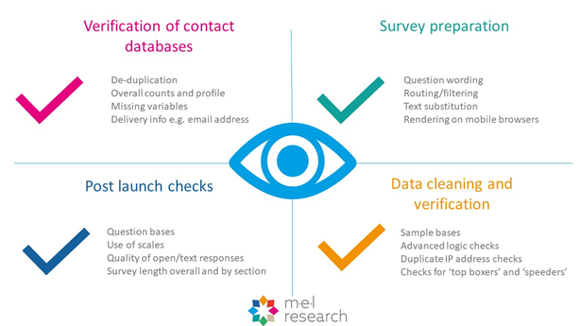
For this project:
- All survey instruments, mailing and materials have a double signoff process. This includes the draft questionnaire, letter, sample frame and reporting outputs.
- The questionnaire when scripted for the telephone survey is thoroughly ‘tested’ internally by members of the research team before it is formally piloted and tested in the field. We ensure that skips, data rules, variable labels etc are fully checked.
- Given each household is allocated a unique survey number this ensures there are no duplication of responses.
- Regular ‘cuts’ of the data are undertaken to sense check the data.
- A minimum of 10% of paper survey data entered by our field and data team is re-entered for quality assurance purposes and to meet the Market Research Society and our ISO 9001 and ISO 20252 requirements. If any issues arise in terms of quality further checking up to 100% is undertaken. Returned questionnaires are logged on an ongoing basis, giving direct access to response rates.
- 100% of telephone interviews are audio recorded. 10% of telephone interviews are listened to and quality checked.
- All code frames are checked and signed off by the research team.
- We undertake a 20% back check on coding to check the accuracy and consistency of our outputs.
- Analysis and reporting outputs are proofread by a second member of the team prior to release.


M·E·L Research
Somerset House, 37 Temple St, Birmingham, B2 5DP
info@melresearch.co.uk
melresearch.co.uk
0121 604 4664

