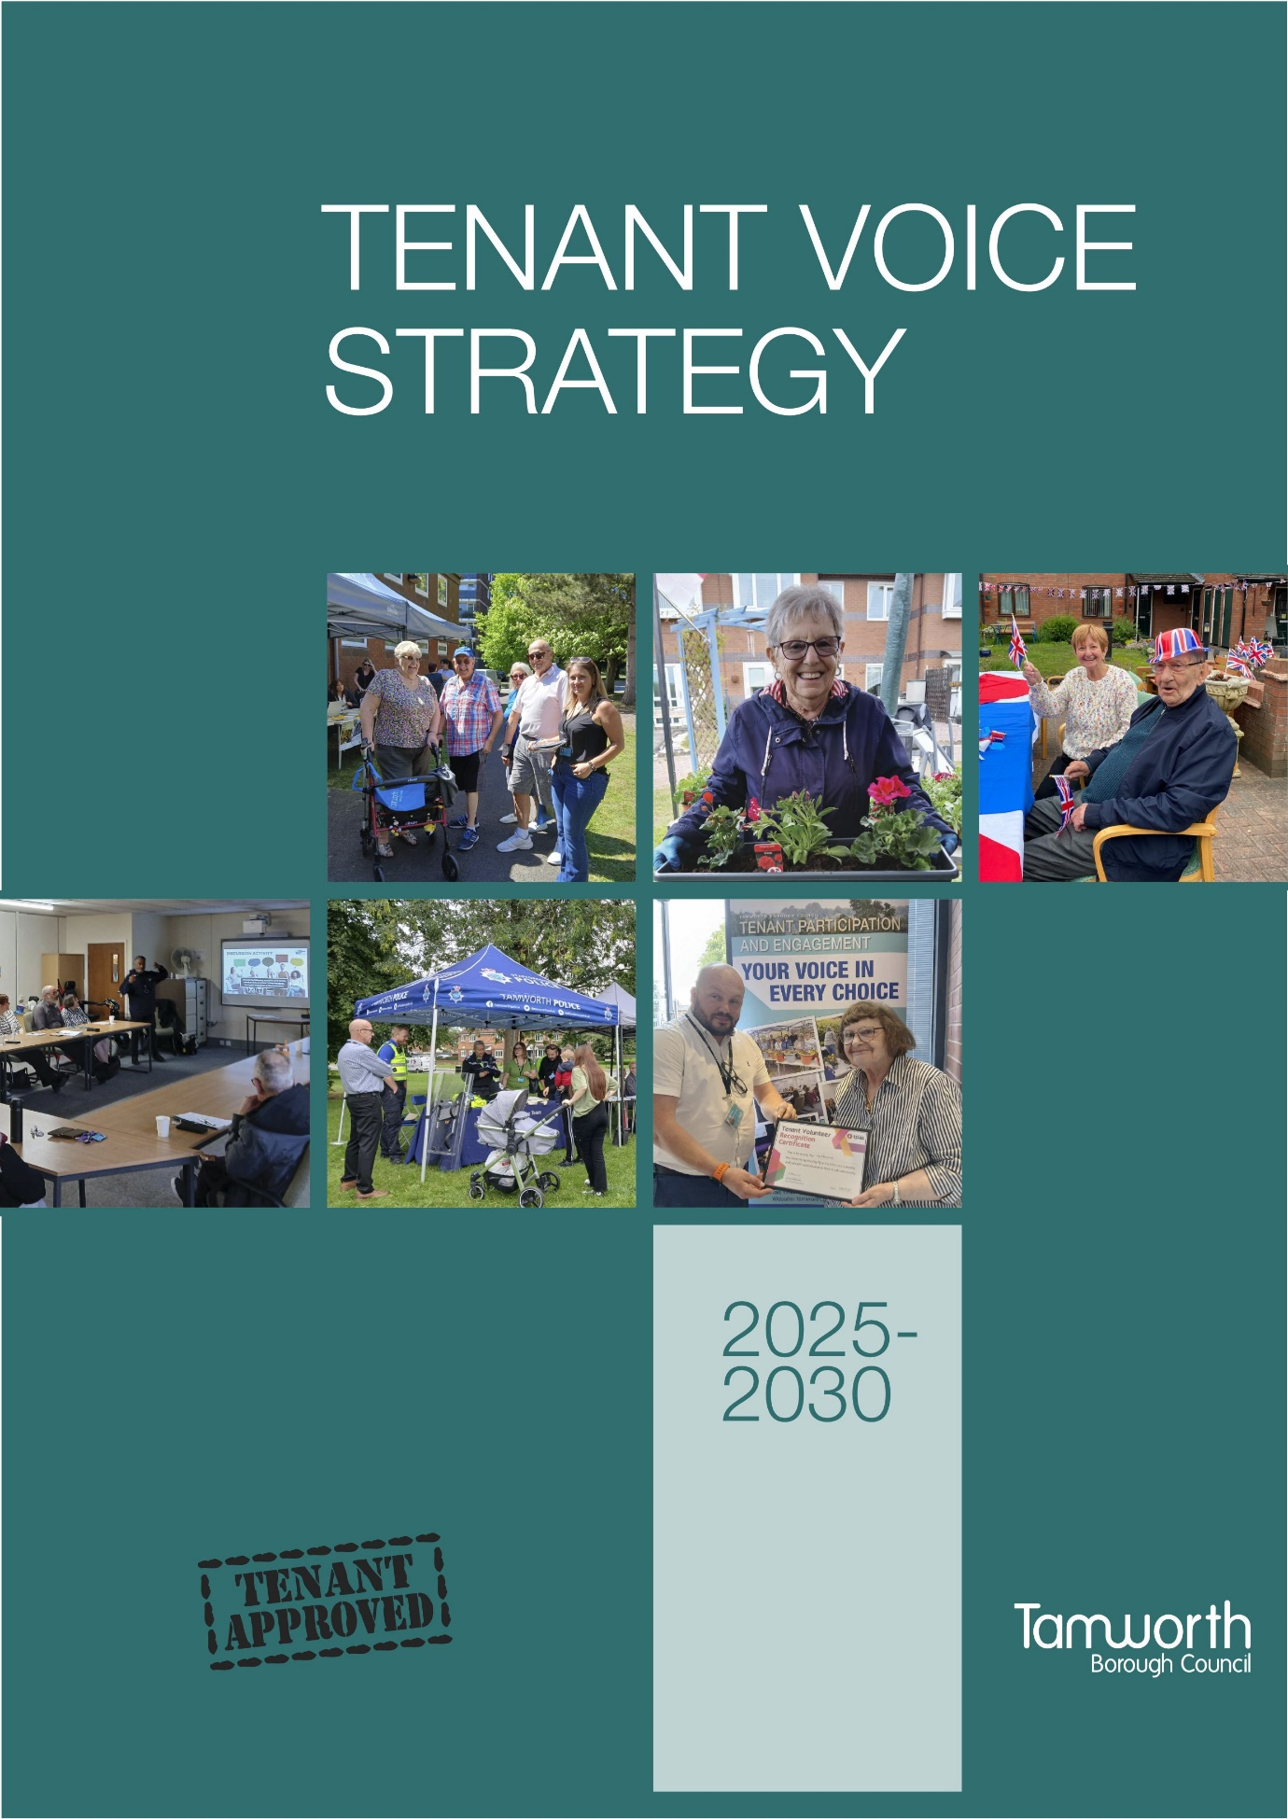

Contents
INTRODUCTION 3
JOINT FOREWORD 4
NATIONAL CONTEXT 5
PURPOSE AND SCOPE 6
VISION 7
AIMS 8
OBJECTIVES 9
WHY TENANTS SHOULD GET INVOLVED 10
WAYS TENANTS CAN GET INVOLVED 11
TYPES OF TENANT INVOLVEMENT GROUPS 13
TENANT INVOLVEMENT STRUCTURE 16
LET’S WORK TOGETHER APPROACH 17
TENANTS’ CHARTER 21
SUPPORT FOR TENANTS 22
WHAT SUCCESS LOOKS LIKE 23
SHARING OUR TENANT VOICE ACHEIVEMENTS 24
HAVE YOUR VOICE HEARD 25
THANK YOU 25
REVIEW 25
TENANT VOICE STRATEGY ACTION PLAN 2025-2030 26

INTRODUCTION

Tamworth Borough Council (the Council) believe that including the opinions and thoughts of our tenants, within our decision-making process, is key in building a successful housing service which works well for everyone. “Your voice in every choice”.
This strategy aims to create a fully accessible, inclusive, transparent, and supportive framework which will provide many opportunities for tenants’ active involvement, to comment on and scrutinise the Council’s housing services.
This strategy builds on previous tenant involvement achievements and aligns with regulatory standards, including the Regulator of Social Housing's ‘Transparency, Influence, and Accountability Standard`. The government recognises how important it is that landlords listen to what their tenants have to say and have introduced new rules and regulations which they must follow. The regulator will be checking that the Council are doing all that we can to listen to, and consider the views of as many, and as wide a range of our tenants as we can. Guided by these principles of fairness and respect, our mission is to empower tenants, work together, and ensure that tenants’ voices are central to our decision-making processes.
In this strategy, the term ‘tenant’ encompasses, tenants, leaseholders, and their family members, ensuring that all voices within our community are heard and represented.
This strategy explains our plans for the next five years to help tenants become more involved in their housing service, and to make sure tenants are at the heart of shaping all housing strategies, polices and housing services. It covers both new and improved ways to do this and compliments Tamworth Borough Council’s strategic vision `Building a Better Tamworth`.
We have extensively engaged and consulted with tenants, housing staff and councillors to find out what good tenant involvement looks like and have adopted their ideas into the development of this strategy.

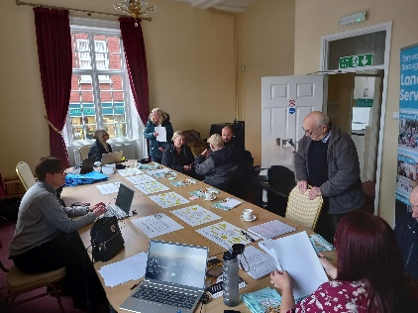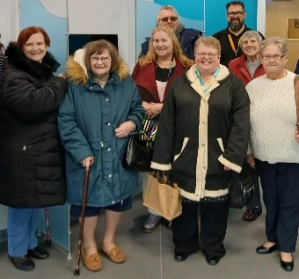

JOINT FOREWORD

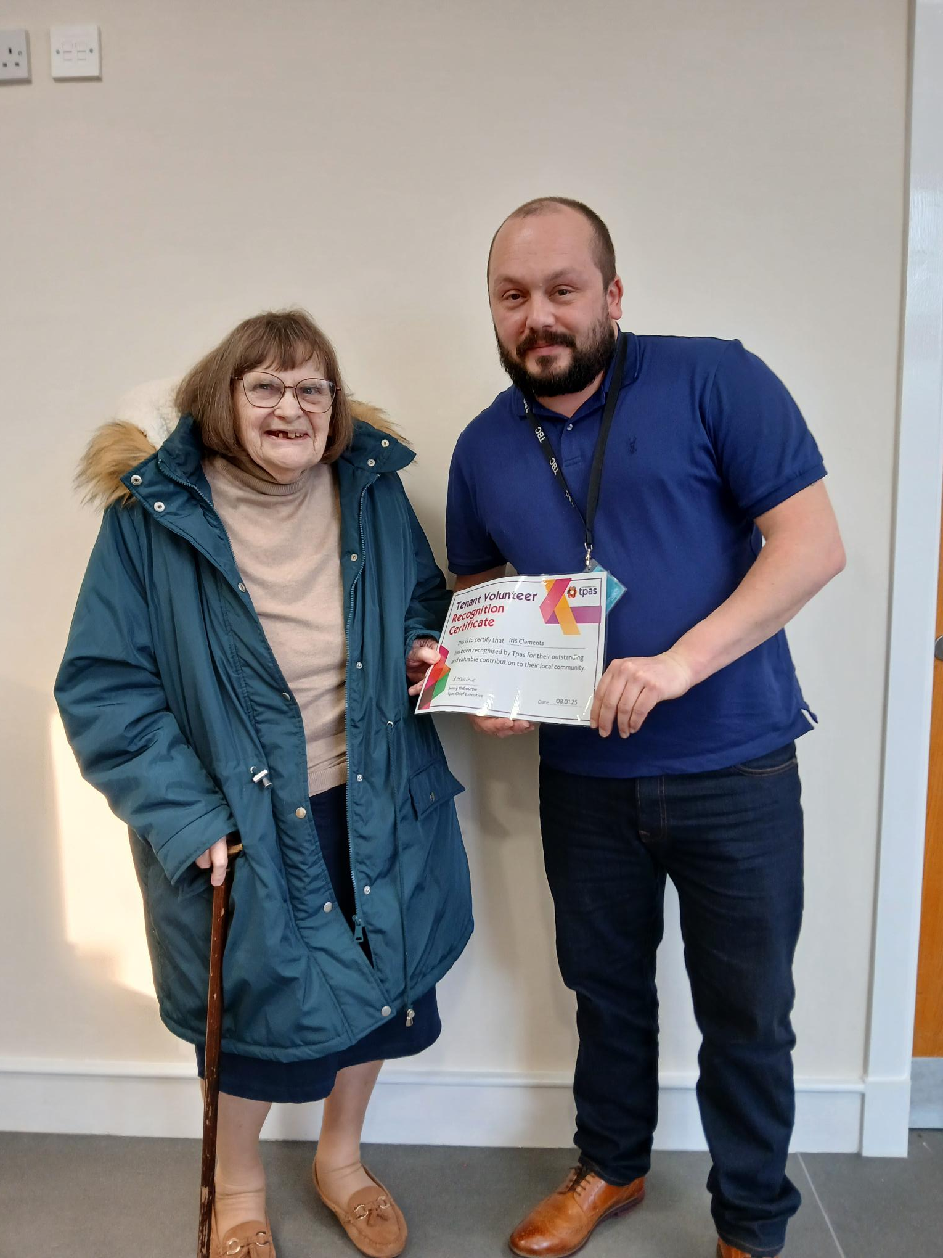
Iris Clements and Councillor Ben Clarke

Joint foreword by Councillor Ben Clarke, Portfolio Holder for Housing, Homelessness and Planning and Iris Clements, Tenant Consultative Group Chair.
“We are extremely grateful for the time and effort tenants have given in helping the Council to understand their needs and aspirations. We continue to work closely together, sharing information and developing our housing service. Transparency with our tenants is very important with a very challenging future ahead of us”
This is the first refresh of the Tenant Voice Strategy (formerly known as the Tenant Involvement & Consultation Strategy 2020-2024) following its review back in 2020.
We feel that this strategy provides us with the principles to respond positively to the expectations of the consumer regulation being developed as part of the future direction of Social Housing Regulation.
This strategy enables us to respond to changes to the regulations, which place an emphasis on the importance of tenants being listened to, being able to hold their landlord to account, making sure homes and communities are warm, and secure.
We recognise the work of all tenants that have been part of delivering our strategy, and for their commitment and time given to develop and improve our housing services. We also thank them for helping to shape the future direction of our tenant involvement opportunities and look forward to working with them to ensure that this strategy remains fit for purpose in this changing and challenging environment for social housing. This strategy formally reinforces our commitment to involving tenants in shaping the housing services that the Council provides.

NATIONAL CONTEXT
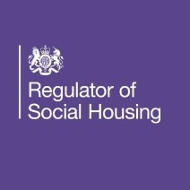 | - Safety and quality standards  - Transparency, influence and accountability standard  - Neighbourhood and community standard  - Tenancy standard
There is a much stronger focus on the tenant voice within social housing, to make sure tenants are kept informed, can shape and meaningfully influence the decision making of their landlord, and that the homes provided are warm, safe and secure.
From 1st April 2024, the Regulator of Social Housing (RSH) has had new responsibilities and powers, with a new focus on proactive consumer regulation. This includes using inspections and the Tenant Satisfaction Measures (TSMs) to help monitor that social housing landlords are meeting the new Consumer Standards.
The new Consumer Standards reflect the Regulator’s revised statutory objectives as set out in the Housing and Regeneration Act 2008, as amended by the Social Housing Act 2023, and the expectations set out in the Social Housing White Paper in respect of a revised consumer regulation role for the Regulator.
There are four Consumer Standards:
- The Safety and Quality Standard
- The Transparency, Influence and Accountability Standard
- The Neighbourhood and Community Standard
- The Tenancy Standard
Of particular relevance to this strategy is the `Transparency, Influence and Accountability Standard` which will require the Council to be open with tenants and make sure:
- They are treated with fairness and respect
- They can access services, raise complaints, and influence decision making
- They can hold us, as their landlord, to account
This change has brought about an emphasis on the need to a) give tenants their voice by providing meaningful involvement opportunities to enable them to influence and scrutinise the Council’s strategies, policies, services and b) deliver fair, inclusive and equitable outcomes for tenants.

PURPOSE AND SCOPE

The Council is committed to making tenant involvement a central part of how their homes and communities are managed by working in partnership with tenants and meeting their diverse needs.
Tenants must be treated fairly, listened to and respected to help shape the future of housing services. It is crucial we keep tenants involved in a meaningful way to help shape the future of our housing services across the borough.
This strategy aims to strengthen the tenants voice by being transparent and ensuring tenants can genuinely influence decision making at every level. It also aims to encourage tenants to improve their communities. We want our tenants to feel they are listened to and can see the difference their involvement makes. The strategy aims to set out the direction for tenants’ involvement and support our commitment to co-regulation by involving tenants in governing, shaping, co-designing and scrutinising housing services.
The Council will work with tenants to make sure that they have a voice and meaningful influence at every level of decision making and will assess its performance against tenants’ experience. The tenant voice, and the diversity of that voice are key to delivering good quality housing services.
We are committed to working together with tenants to create good quality homes in strong, safe, and sustainable communities. The focus on gathering opinions and feedback from all tenant involvement will mean we know what our tenants want and their views of the housing services we provide. By listening to our tenants, we can then respond appropriately and effectively.
- To be safe in their home
- To know how the council is performing
- To have your voice heard
- To be treated with respect
- To have your complaints dealt with promptly and fairly
- To have a good quality home and community to live in
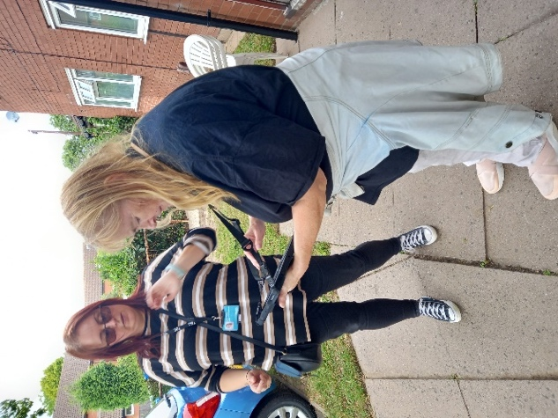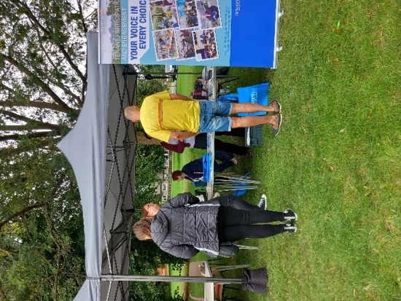

VISION

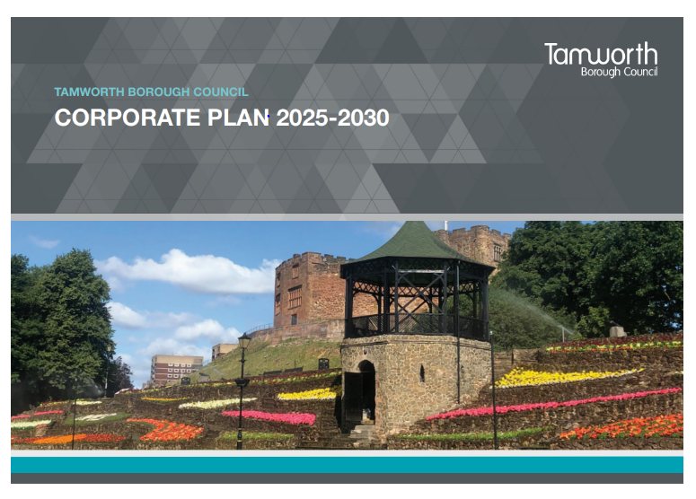

Tamworth’s Corporate Plan Vision: Building a Better Tamworth.
The 4 corporate plan strategic ambitions are around Prosperity & Place; Community wellbeing; Environment and Council which aims to put tenant at the heart of everything we do; for tenant involvement to continue to be ingrained in our culture, with tenants influencing all that we do at every level and helping to shape and improve housing services. We want tenants to know that their voice has been heard, listened to, valued and their views acted upon.

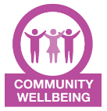

AIMS

- To empower and give tenants their voice, the Council will offer a wide range of accessible and inclusive ways to be involved.
- To encourage a diversity of tenants to actively be involved in decision making at all levels that affect their homes & communities, from service design to strategic planning. “Your voice in every choice”.
- To demonstrate the impact of tenant involvement through a “You said, we did” approach.
- To make sure we are responsive to the changing environment and new legislation, and regulatory requirements are met.



OBJECTIVES

The Council recognise that we can only improve on our housing services by working together in partnership with tenants. To do this we must collect opinions and views of tenants by using a full menu of involvement opportunities which are convenient and provide choice, regardless of circumstances, location and individual needs.
- Customer care and putting tenants first: We will treat tenants with fairness and respect in every interaction and meet their diverse needs.
- Maximise tenant engagement, involvement & influence opportunities: We will actively involve tenants in decision making that affects their homes and communities, ensuring tenants voices are heard and considered during planning and delivery of housing services. We will aim to provide broad representation and involvement from all areas of the community, developing targeted approaches to engage quieter voices and removing any barriers to participation.
- Use tenants’ feedback to shape & improve housing services: We will listen to and learn from tenants’ feedback to identify areas of improvement and consistently strive to deliver good quality housing services. Wherever possible the council will feedback the results we receive though a “You said, we did” approach.
- Increase the skills & knowledge of tenants: We will empower tenants to have their voices heard and feel valued with opportunities to engage in various ways. Providing training and development opportunities to help tenants build on their individual and community skills to enable them to actively engage with the Council. Tenants involved in tenant groups will be offered training where appropriate to help them to run the groups in accordance with their constitution.
- Develop strong and vibrant communities: We will provide good quality affordable homes, in strong, safe, and sustainable communities. Promote and encourage community improvement such as community fun-days, improvements to estate open spaces and drop in events.
- Honest, transparency, visibility & accountability: We will be accessible, open, honest to our tenants and ensure we are accountable for the decisions we make.
How we plan to implement these six objectives is outlined in full detail within the action plan set out at the end of this strategy.

WHY TENANTS SHOULD GET INVOLVED

The Council want to provide the best housing service we can, and to do this we need to work together in partnership with our tenants in governing, shaping, co-designing and scrutinising housing services.
Tenants living in the borough of Tamworth have first-hand experience of housing services delivered to them by the Council. By tenants sharing with us what they believe works well, or where we can improve, gives important feedback the Council need to help improve services for everyone.



WAYS TENANTS CAN GET INVOLVED
The Council have a lot of different ways for tenants to be involved in housing services and have their say, making it simple for tenants to pick from in terms of how and when they can get involved, give their feedback, scrutinise housing services or influence housing service delivery.
A full menu of tenant involvement opportunities is available that tenants can choose from. Many involvement options only ask for a small amount of time, as and when. Other options ask for larger and a more regular time commitment. Whichever option is chosen; tenants will be playing a very important part in helping the Council make the housing service better and work for everyone.
Tenants can take advantage of one of the many different involvement opportunities detailed below, where they can have their say and make a real difference to the future of the Council’s housing services which affect their homes and communities.

Full menu of tenant involvement opportunities

- A small amount of time is required i.e. 5-10 minutes as & when

If you can only afford to give 5 minutes of your time to complete a quick survey or take an occasional look at one of our may housing publications, and give us some feedback, then we’d love to hear from you.
- A medium amount of time is required i.e. 2-3 hours every 2-3 months
If you fancy a little more then why not consider a starter or light bite. This could be completing an occasional survey or giving us your feedback when we write to you asking for your comments. You may even want to pop along to an organised community estate-based event to see what we get up to on our estates, meeting lots of new tenants and talking to you about what really matters.
- The highest amount of time is required i.e. 2-3 hours per month
Join one of our many already established tenant involvement groups. Pop along to a consultation or estate-based event, fill in one of our annual surveys or became one of our valued tenant inspectors joining staff out on estate inspections or inspecting the standard of communal cleaning within our communal buildings, or simply read one of many publications and just let us know what you think and give us your feedback.
To get involved or to find out more information, tenants can contact the Council’s friendly Tenant Voice Team during normal office opening hours – Monday to Friday between the hours 9am to 5pm expect bank holidays: 01827 709709 or email tenantparticipation@tamworth.gov.uk
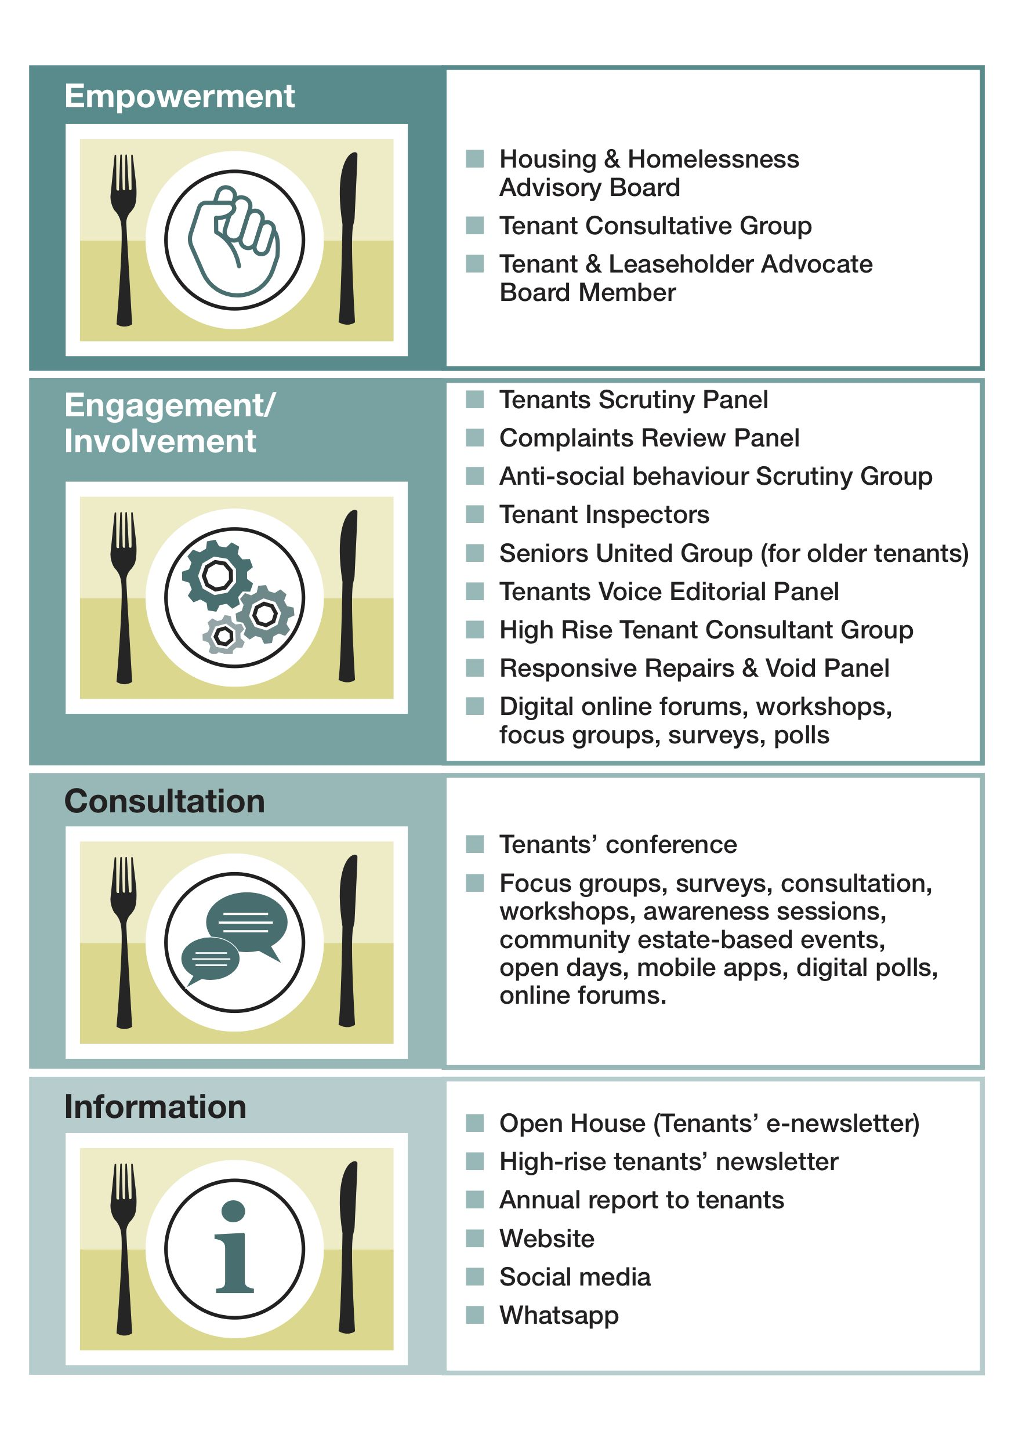

TYPES OF TENANT INVOLVEMENT GROUPS

Formal Involvement Tenant Groups

Formally involved tenants are our critical friends. They not only oversee the journey of the tenant’s voice but also rigorously evaluate performance and ensure compliance with regulatory consumer standards. In addition to their ongoing scrutiny, they will conduct in-depth reviews independently. To strengthen our working together arrangements, these groups will play a more integral role within our governance structure, adopting stronger connections with the Council. To support this effort, we have established an Independent Tenant & Leaseholder Advocate Board member role which is detailed below.
Tenant Consultative Group (TCG): TCG provides a united voice for tenants to discuss a range of issues and get involved in the decision-making process to improve housing services for all. The group is consulted on a wide range of housing-related policies, practices and procedures.
Scrutiny Panel: The scrutiny panel will collect evidence to enable a housing service area to be scrutinised. They will examine the evidence and make recommendations for service improvements.
Housing and Homelessness Advisory Board: Tenant representatives are invited to all housing and homeless advisory board meetings.
Independent Tenant & Leaseholder Advocate Board Member: The independent Tenant & Leaseholder Advocate board member will be key in supporting the council and tenants in meeting the requirements of the housing regulatory standards, specifically contributing to the Transparency, Influence and Accountability Standard which sets out how landlords must give tenants a wider range of meaningful opportunities to influence and scrutinise their landlords’ strategies, policies and housing services.

Informal Involvement Tenant Groups

More informal involvement offers flexibility, inclusivity, and a range of involvement opportunities that cater for the diverse needs of tenants. It allows for continuous feedback, trust and assurance that all voices are considered in decision-making processes. ​This may include:
High Rise Tenant Consultant Group: This group provides a united voice for high rise residents. This group discusses a wide range of housing issues unique to high-rise living and is involved in the decision-making process to improves housing services for all.
Tenant Voice Editorial Panel: This group meets to plan, design and contribute housing literature including the tenant’s newsletter before it is published.
Tenant Champion Programme: Tenant champions will act as liaisons between the council and the tenant community, particularly focusing on quieter voices.
Seniors United: A forum for sheltered housings tenants to share ideas and discuss relevant issues regarding living in sheltered living.
Complaints Review Panel: Reviews anonymised complaints and housing member enquiries, identifying trends and common themes and making recommendations for service improvements.
Tenant Inspectors: This tenant group audit the delivery of communal cleaning services and estate inspections. Tenant inspectors monitor the quality-of-service delivery against the defined standards and undertake one-site inspections. They are empowered to call the Council to account if services do not meet the required standards and their feedback will part of the improvement plan.
Response Repairs & Void Panel: This panel will look at the repairs and voids performance data, turnaround times, key issues it raises, and other areas tenants’ feel are relevant.
Anti-Social Behaviour Scrutiny Group: Oversees the delivery service improvements, considers and discusses best practice and monitors performance data.
Focus Groups: Provide tenant feedback on a wide range of housing issues, providing an opportunity to maximise understanding of tenant opinions and expectations etc.
Community events / estate days / open days: Provide informal opportunities to give information about housing services, promote tenant involvement and the benefits of getting involved - all carried out in fun, friendly and informal environment out in the community.
Estate inspections: Regular annual inspections by tenants and neighbourhood staff, to assess the condition of estates and communal cleaning and identify areas for improvement.
Digital panels and focus groups: Online platforms for tenants to participate in discussions and provide feedback on assorted topics.
Digital workshops and polls: Virtual sessions and surveys to engage tenants in decision-making processes.
Mobile apps and online forums: Tools to facilitate easy communication and feedback between tenants and the council.
Smart technologies: Implementing technologies that allow tenants to report issues and track service requests digitally.
One-on-one interactions: Personalised strategies to address individual tenant needs, ensuring their preferences are met.
Mystery shopping: Evaluates service quality through hidden testing, ensuring that services meet necessary standards.

TENANT INVOLVEMENT STRUCTURE

The below diagram illustrates the tenant involvement groups structure which is in involved in shaping, influencing and scrutinising housing services.

The Tenant Consultative Group (TCG) are consulted on housing service policy changes prior to a decision being made by the Council’s Cabinet.

LET’S WORK TOGETHER APPROACH

The Council’s ‘let’s work together’ approach will be enhanced by increasing a diversity of tenants becoming involved in governing, shaping, co-designing and scrutinising housing services.
We have listened to our tenants and will introduce and use innovative digital tools such as mobile apps, online forums and smart technologies to enhance our informal engagement with tenants, ensuring we reach a diverse audience and effectively respond to tenant feedback.
Personalised engagement through updated tenant surveys, polls, and regular one-on-one interactions will also allow us to address individual needs.
We will put in place transparent feedback processes and develop targeted approaches to engage quieter voices, removing barriers to participation and ensuring fairness and respect.
Additionally, we will offer tenant training, support and resources to enable tenants to actively be involved.

- Let’s work together
We are committed to further embedding our let’s work together approach, by involving tenants in the design and implementation of services, we make sure that their voices are central to our housing services decision-making processes.
Let’s work to together principles:
- Creating an environment where tenants feel comfortable voicing their opinions, by holding meetings in community settings and ensuring staff are responsive to feedback and recommendations.
- Encouraging open and honest feedback from tenants.
Involving tenants in the design and implementation of service changes:
- Engaging tenants from the very beginning to shape the scope and direction based on their experiences and insights.
Encouraging tenant-led community improvement projects:
- Support tenant-led community projects.
- Offering training sessions and workshops to build tenants’ skills in project management, leadership, and community engagement.

- Innovative digital tools – launching a digital platform for all our tenants
The Council believe that growing digital engagement will enable us to expand our reach to more tenants and improve the overall quality of tenant involvement. By going digital, we can engage more tenants, on their terms, and respond effectively to both individual and collective feedback, ensuring we hear diverse voices within the community.
Mobile apps, online forums, and smart technologies to enhance digital engagement:
- Running digital panels and focus groups.
- Establishing digital workshops, digital polls, and digital service testers.
- Creating engaging user-friendly digital content such as videos, infographics, and interactive guides.
- Utilising social media platforms to share updates, gather feedback, and promote tenant participation.
- Offering access to digital devices and internet connections for tenants who may lack these resources.
Digital inclusion training to ensure all tenants can participate effectively:
- Enhancing digital inclusion through training to improve skills and confidence to use online and digital services.
- Offering virtual tours and webinars to provide tenants with a comprehensive understanding of council services and initiatives.

- Personalised engagement
The Council are committed to refreshing and updating tenant profile information to make sure tenants feel recognised as individuals. By keeping tenant profile information current, including communication and involvement preferences better meets tenant expectations.
Building stronger relationships through regular updates:
- Engaging tenants in meaningful, everyday conversations to build stronger relationships.
- Using everyday one-on-one interactions as opportunities to better understand our tenants' needs and preferences.
- Transparent feedback processes
The Council will be clearer about how the tenants’ voice has influenced our learning and decision-making processes.
Clearly communicating how tenant feedback influences decisions:
Your voice in every choice.
- Implementing a "You said, we did" approach to demonstrate the impact of tenant contributions.
- Clearly show how tenant feedback has led to specific actions and changes.
Quality and responsive communication:
- Providing communication to all tenants in a range of formats, ensuring accessibility and responsiveness.
- Utilising mobile apps or online platforms for real-time tenant feedback to demonstrate how tenant input influences decisions.
Proactive analysis of complaint data:
- Analysing complaint data to identify and address common themes and trends proactively.

- Inclusive outreach
The Council will develop innovative approaches for reaching those tenants we don’t regularly hear from and removing any barriers to engagement.
Developing targeted approaches to engage less active tenant voices:
- Reach out to traditionally quieter voices, so their perspectives are heard and respected.
- Identify and remove barriers that prevent tenants from getting involved. i.e. providing transport, providing information in a range of formats, supplying large print material or helix magnifying sheets, using venues that are convenient and accessible.
- Provide multiple engagement platforms, offering numerous ways for tenants to participate, such as online forums, virtual meetings, and in-person gatherings, to cater to different preferences and accessibility needs.
Conducting regular ‘getting to know you better activities’ to continuously understand and address tenants’ diverse needs:
- Participate in local area community events.
- Support regular community engagement activities.
- Empowerment through training
Recognising the importance of training for both tenants and staff, enhance engagement, and ensure effective participation in decision-making processes. To achieve this, we will focus on comprehensive training programmes, digital literacy, and capacity-building initiatives.
Comprehensive training programmes:
- Develop tailored training programmes that cover all aspects of involvement for both tenants and staff.
- Provide adequate resources to support these training initiatives, so that both groups are well equipped to participate meaningfully.
Tenant training programme:
- Deliver a range of training opportunities, including housing-specific and digital skills training.

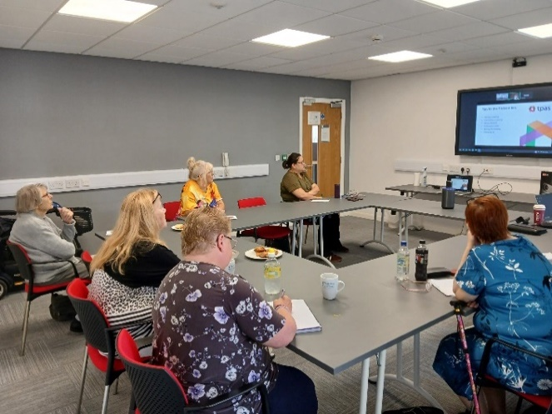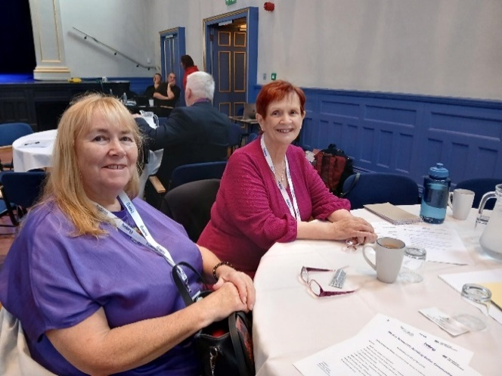
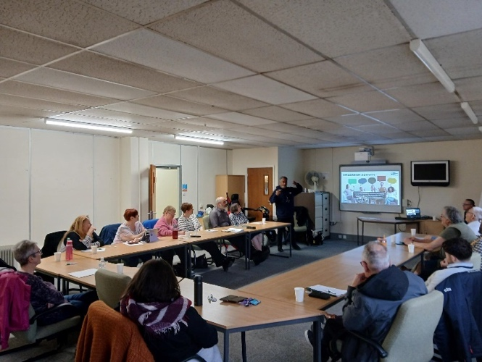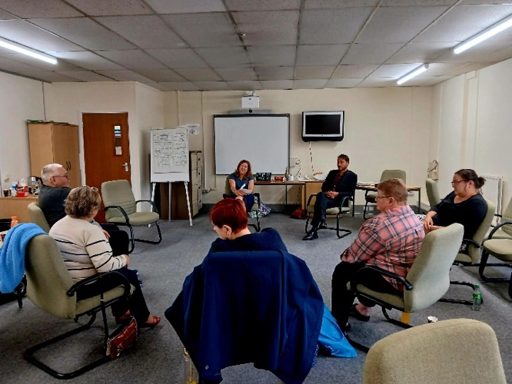

TENANTS’ CHARTER

The Council’s Tenant Charter detailed below is a clear set of commitments that we make to tenants, like being open and honest, treating tenants with respect, and making sure their voices influence decisions affecting their homes & communities.
The charter aims to strengthen the relationship between the Council and its tenants.

“Your voice in every choice”

Relationships: We will build a clearer picture of who our tenants are, gain a better understanding of their diverse needs and treat all tenants with respect in all interactions. Relationships will be based on openness, honesty and transparency.
Communication: Tenants will receive clear, accessible and timely information on issues that matter to them, including important information about their homes and local community, how the Council is working to address problems, and information about performance on key issues. We will tailor our communication to meet tenants contact preferences where possible.
Voice and influence: We will seek and value the views of tenants and will use this information to inform decisions. Every individual tenant will feel listened to on the issues that matter to them.
Empowerment: We will give tenants the training and skills that they need to get the most out of working together with us. Ensure that the time that tenants give to help us make changes is valued and purposeful.
Accountability: Collectively, tenants will work in partnership with the Council to scrutinise and hold the Council to account for the decisions that affect the quality of their homes and housing services.
Quality: Tenants can expect their homes to be good quality, well maintained, safe and well managed.
When things go wrong: Tenants will have simple and accessible routes for raising issues, making complaints and seeking redress. Tenants will receive timely advice and support when things go wrong.
Equality, Diversity and Inclusion: Approaches to tenant involvement will be inclusive by engaging with tenants from a range of backgrounds and experiences.

SUPPORT FOR TENANTS

To encourage the development of individual tenants and groups in all areas of tenant involvement, the Council recognises the importance of providing sufficient resources, support and learning opportunities.
We will:
- Provide a dedicated and friendly Tenant Voice Team member of staff who will help support the work of tenants to meet this strategy’s aims.
- Offer skills development and a dedicated training programme in the form of learning opportunities and information awareness sessions.
- Ensure there is sufficient funding to support tenant involvement activities carried out locally for consultation, involved working groups, development opportunities and estate-based events.
- Provide specialist communication services & reasonable adjustments for those who may need further assistance e.g. signers for British Sign Language etc.
- Provide travelling expenses for tenants attending tenant group involvement meetings, if required, to and from venues for the purpose of any tenant involvement activity.

WHAT SUCCESS LOOKS LIKE

This strategy aims to create a more positive and empowering experience for tenants, leading to better housing services outcomes for tenants and stronger communities.

- Good quality housing & better housing service delivery: tenant involvement can lead to more effective and efficient housing service delivery, tailored to tenants’ needs.
- Build tenant trust: by being open and honest and to make sure we are accountable for the decisions we make.
- Improved tenant satisfaction: by listening to and acting on tenant feedback, we can improve tenant satisfaction and build stronger relationships.
- Improved digital involvement: through digital platforms, tenants can communicate more effectively with the Council.
- Stronger communities: empowering tenants to be involved in their communities can foster a sense of ownership and belonging.
- Meeting the diverse needs of tenants: housing services are accessible, inclusive and fair.
- More tenants are working together with the Council: more tenants are actively involved in improving housing services.
- Continuous improvement: using tenant feedback to identify areas of improvement and consistently strive to deliver good quality housing services.
- Achieving Tenant Participation Advisory Service (TPAS) accreditation: We will aim to achieve accreditation for tenant participation, independent accreditation dedicated to improving tenant engagement standards.
- Meet our regulatory requirements: demonstrating our commitment to tenants’ voice.

SHARING OUR TENANT VOICE ACHEIVEMENTS

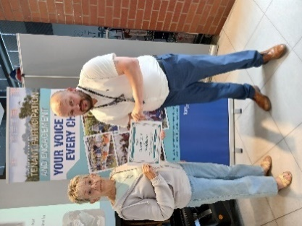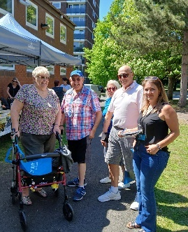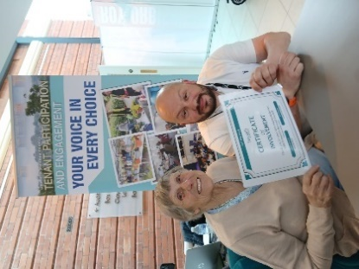

The Council will provide an annual summary of all its tenant voice achievements through a range of events and publications including:
- the tenant and leaseholder conference, which all tenants will be invited to attend
- tenants annual report, which is available to view and/or download from the Councils website www.tamworth.gov.uk
- tenant involvement groups and board meetings



HAVE YOUR VOICE HEARD
If you are one of Tamworth Borough Council tenants and would like the opportunity to get involved, then please contact us on 01827 709709 or email: tenantparticipation@tamworth.gov.uk | 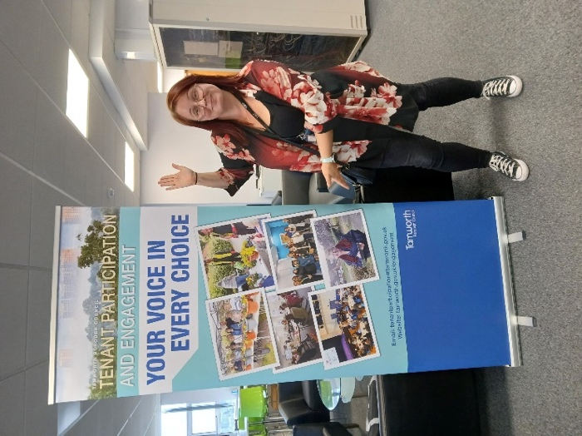

THANK YOU

Thank you to all the tenant involvement working groups and other tenants who have given us their views about getting involved at Tamworth Borough Council. You’re your help we have co-designed this strategy which aims to encourage a diversity of tenants to actively be involved in decision making at all levels that affect their homes and communities, from service design to strategic planning. “Your voice in every choice”

REVIEW

This strategy will be reviewed annually by tenant groups and the Council’s Tenant Voice Team.
There will be performance information shared with tenants, so they'll know if the strategy's working.
We look forward to working in partnership with tenants to improve our services and
make a positive difference to individuals and the wider community.

TENANT VOICE STRATEGY ACTION PLAN 2025-2030

Our action plan below outlines the actions we will take to achieve our strategy objectives.

- CUSTOMER CARE AND PUTTING TENANTS FIRST
Aims | How | Who | When
Deliver good customer care | Customer care training or similar across teams delivering housing services to our tenants | All housing teams | Continuous process
Understand the diverse needs of tenants and ensure services are inclusive so they can easily access service and be involved in shaping housing services | Deliver the Tenant’s Inclusion Action Plan and update the plan annually, which includes continuously working on maintaining tenants’ profile details. | Tenant Voice Team  All Teams | Continuous process
Achieve Tenant Participation Advisory Service (TPAS) accreditation | We will aim to achieve accreditation for tenant participation. This is an independent accreditation dedicated to improving tenant engagement standards. | Tenant Voice Team | By Dec 2030
Promote and deliver an annual tenants’ conference | Promote tenant conference to all tenants via social media, flyers, emails, members, newsletter etc. | Tenant Voice Team | Annual

- MAXIMISE ENGAGEMENT WITH COUNCIL TENANTS
Aims | How | Who | When
Support and encourage tenants to attend meetings | Pay for transport (Taxi, Bus, Mileage etc).  Promote meetings and engagement activities to all tenants via social media, flyers & targeted letters/email/text messages.  Provide meetings in a variety of forms and convenient locations for tenants wherever possible. (Webinars, phone conferencing, in person at local venues | Tenant Voice Team  All housing teams | Continuous process
Promote tenant involvement with new and existing tenants | New tenants to be advised on the Menu of Involvement at sign up of new tenancy.  Engagement activities to be advertised to local tenants via social media targeted flyers/posters/emails/text/in person.  Engagement information and opportunities to be provided in tenant newsletters, website, social media, tenants portal, quarterly rent statements, targeted emails/text phone calls and in person etc. | Tenant Voice Team  All housing teams | Continuous process
Engage with tenants in more ways to ensure accessible and inclusion including digital technology | Promote digital engagement via our website, email groups, online surveys and social media.  Deliver a robust full menu of involvement opportunities that allow tenants to participate in ways that suit them and get involved with shaping housing services.  Preferred and most up to date contact method to be requested/checked at every interaction with tenants·  Delivery of the tenant inclusion action plan 2025/26 to tackle barriers which prevent tenants from becoming involved.  Develop a tenant app – so tenant can easily access our housing services an keep their own personal details up to date. | Tenant Voice Team  All housing teams. | Continuous process
Provide opportunities for tenants to co-design housing services, policies and strategies | Deliver a robust full menu of involvement opportunities that allow tenants to participate in ways that suit them and get involved with shaping housing services. | Tenant Voice Team  All housing teams. | Continuous process
Take involvement opportunities out into the community | Offer a wide range of accessible and inclusive involvement activities to take place in the community and estates where possible – as per the Tenants Inclusion Action plan.  Carry out estate events across all estates and invite stakeholders in advance, including tenants, tenants’ groups, councillors and partners etc·  Attending community events organised by the community - coffee mornings/community fun days/community meetings.  During community events, continuously promote tenant involvement and increase tenant involvement database. | Tenant Voice Team  All housing teams. | Continuous process
Seek new initiatives and ideas to widen tenant engagement | Share good practice with other housing providers and professional bodies such as Tenant Participation Advisory Service, Housing Quality Network.  Encourage and enable tenants to attend conferences and training.  Welcome new ideas and initiatives from all sources including tenants, staff, councillors and voluntary organisations. | Tenant Voice Team  All housing teams. | Continuous process
Work collaboratively to ensure all members of communities are included | We will continue to work with the community partners and agencies, voluntary sector and colleges to ensure that the diverse voices of our tenants are heard. | Tenant Voice Team  All housing teams. | Continuous process
Maintain an active register of tenants wishing to be involved | Update tenant involvement register quarterly with key contact details. | Tenant Voice Team  All housing teams. | Continuous process
Undertake an annual tenant involvement recruitment campaign | Once a year we will widely promote the menu of tenant involvement opportunities available for tenants i.e. website, social media, tenants’ newsletter, tenants’ portal, members updates.  Promote how accessible and inclusive our range of tenant involvement opportunities are.  Encourage a wide range of diverse tenants to become involved to present the diverse needs and be representative of our community - as per the Tenants Inclusion plan. | Tenant Voice Team | Annually

- USE TENANT FEEDBACK TO SHAPE HOUSING SERVICES PROVIDED BY THE COUNCIL
Aims | What | Whom | When
Monitor tenant satisfaction regarding our housing service performance and use feedback to shape continuous improvements | Carry out regular service specific satisfaction surveys through the year.  Carry out an annual survey of tenants against the Tenant Satisfaction Measures -TSMs.  Publish annual TSM results and action plan on the Council’s website, tenant newsletter & annual tenants report. | Tenant Voice Team  All housing teams. | Continuous process
Monitor tenant complaints and use the feedback to shape continuous improvements | Monitor and analyse tenant complaints to better understand recurring themes around dissatisfaction.  Use tenant complaints to shape continuous improvements, including the creation of a complaints intelligence report which will used by the Council.  We will publish feedback in the form of “You said, we did”. | Tenant Voice Team  All housing teams. | Continuous process
Carry out ad-hoc surveys to seek the views of tenants | Tenant surveys are carried out with tenants on an ad-hoc basis on a variety of housing services matters. These will be advertised on social media/ webpages/newsletter/tenants’ portal/social media and surveys will be sent via email/text/hand delivered/post etc. to try and increase uptake. | Tenant Voice Team  All housing teams. | Continuous process
Feedback results of customer surveys | Published in the tenant newsletters/website/tenant portal/social media/tenant groups in a You said we Did format. | Tenant Voice Team  All housing teams. | Continuous process
Carry out tenant scrutiny and auditing of various services | Tenants will scrutinise council housing services, such as communal cleaning, performance, publications and complaints.  We will recruit to the tenant groups on a regular basis.  Members of the inspection tenant groups will receive appropriate training to fulfil their role in an independent manner. | Tenant Voice Team  All housing teams. | Continuous process
Provide feedback on actions shaped by tenant engagement | We will provide feedback of actions shaped by tenant feedback in the form of a “you said, we did” statement. | Tenant Voice Team  All housing teams. | Continuous process
Provide clear and accessible tenant information | Provide an annual tenant’s report and quarterly newsletter.  Keep the Council’s website up to date.  Make good use of email, tenants’ portal, press releases & social media communication.  Sharing information with tenant groups & members to share.  Where possible tailor communication to meet tenants’ diverse needs – as per the Tenant Inclusion Plan. | Tenant Voice Team  All housing teams. | Continuous process
Strengthen tenant’s influence over our decision making | Create task and finish groups for specific matters, to better help us understand the impact our services have on tenants and create better responses. | Tenant Voice Team  All housing teams. | Continuous process
Provide opportunities for tenants to prioritise spending | Tenant Consultative Group to make decisions on awarding applications to the Neighbourhood Investment Programme of community works. | Tenant Voice Team  All housing teams. | On receipt of application
Improve services to better meet the needs of tenants | Tenant feedback will shape decision making at a service delivery level. We will consult with tenants regularly and refer to their views and satisfaction levels when making decisions. | Tenant Voice Team  All housing teams. | Continuous process

- PROVIDE OPPORTUNITIES FOR TENANTS TO INCREASE SKILLS AND KNOWLEDGE
Aims | What | Whom | When
Keep tenants informed about training opportunities through promotion | Promote training opportunities for tenants as widely as possible i.e. website, social media, posters, tenants’ portal, newsletter, rent statement, members zone, communal areas on sheltered & supported schemes, emails. | Tenant Voice Team  All housing teams. | Continuous process
Provide training for tenants to support involvement | Provide training for tenants on a wide range of housing services to they can make informed feedback and options including:  TPAS webinars & training events for tenants  4 million homes government training toolkit  Community & partnership training  Inhouse training  Community based training | Tenant Voice Team  All housing teams. | Continuous process
Acknowledge tenant achievements | The council will celebrate tenant achievement through an annual tenant awards event | Tenant Voice Team | Annual
Promote the digital upskilling of tenants | We will continue looking into providing more opportunities to help tenants get connected with the council through digital platforms  Develop tenant app – providing tenants with easy access to housing services on-line. | Tenant Voice Team | Continuous process

- DEVELOP STRONG AND VIBRANT COMMUNITIES
Aims | What | Whom | When
Encourage engagement with communities and implement a community plan tailored to the needs of the tenants | The Council will widely promote community engagements.  Community estate days across all wards in the borough.  Providing a multi-agency presence on the estate days and promote the benefits of tenant involvement.  After the event contact tenants who expressed an interest in getting involved. | Tenant Voice Team | Continuous process
Build and support community capacity in Council neighbourhoods | Engage with tenants to support them to access opportunities in their communities through maintaining contact and close working relationships with partner organisations. | Tenant Voice Team | Continuous process
Collaborate with internal and external partners to deliver shared priorities and pooled resources | Connect with external agencies to deliver targeted services that address the community’s needs | Community safety partnership  Tenant Voice team  Grounds maintenance team / HMO team | Continuous process

- HONESTY, TRANSPARENCY, VISABILY & ACCOUNTABLITY

Aims | What | Whom | When
Provide clear information on how housing services are performing | We will publish an annual tenant’s report which outlines how the housing services have performed throughout the year.  We will publish performance information in the tenant’s quarterly newsletter. | Tenant Voice Team  All housing teams. | Continuous process
Be visible and accessible to tenants | Promote opening times and contact details for each of the housing teams so tenants easily know how to contact the Council | Tenant Voice Team  All housing teams. | Continuous process
Respond to complaints in-line with the Council’s complaints policy | We will monitor and publish our performance on complaint handling.  We will work with tenant groups to listen and learn from complaints and were possible will make changes to improve the service and tenant satisfaction. | Tenant Voice Team  All housing teams. | Continuous process
Engage transparently and honestly about Building and Fire Safety with tenants in communal flats and high-rise properties | Regular updates on building and fire safety are to be included in our newsletters and website and on social media.  Community events will be used to promote building and fire safety.  We have created a high-rise tenant’s consultant group.  Annually distribute all high-rise tenants with a hard copy of the high-rise health & safety booklet which contains a wide range of useful health & safety information for tenants living in high-rise properties. | Tenant Voice Team  All housing teams. | Continuous process
Carry out annual impact assessment of tenant involvement | Publish the results annually on the impact and difference (the change) that involving tenants in shaping housing services has made. | Tenant Voice Team | Continuous process

-END-


If you require this document in an alternative format or language, please contact us. Tel 01827 709709 or email enquiries@tamworth.gov.uk

