

LICENSING ACT 2003
Premises Licence Summary

Nando's

Part One – Premises Details

Postal address of premises, or if none, ordnance survey map reference or description

Nando's, Unit 1, Ventura Retail Park, Tamworth, Staffordshire, B78 3HD

Post Town Tamworth | Post Code B78 3HB
Telephone number Not Known

Where the licence is time limited the dates

This licence is not time limited

Licensable activities authorised by the licence

Late Night Refreshment
Supply of Alcohol (On Sales)
Opening hours

The times the licence authorises the carrying out of licensable activities

Late Night Refreshment
Whole Premises
 | From | To
Sunday | 23:00 | 00:00
Monday | 23:00 | 00:00
Tuesday | 23:00 | 00:00
Wednesday | 23:00 | 00:00
Thursday | 23:00 | 00:00
Friday | 23:00 | 00:00
Saturday | 23:00 | 00:00
Non Standards Timings

From the end of permitted hours on New Year's Eve until 02:00 hours on New Year's Day

The times the licence authorises the carrying out of licensable activities

Supply of Alcohol (On Sales)
Whole Premises
 | From | To
Sunday | 11:00 | 00:00
Monday | 11:00 | 00:00
Tuesday | 11:00 | 00:00
Wednesday | 11:00 | 00:00
Thursday | 11:00 | 00:00
Friday | 11:00 | 00:00
Saturday | 11:00 | 00:00
From the end of permitted hours on New Year's Eve until 02:00 hours on New Year's Day

The times the licence authorises the carrying out of licensable activities

Opening hours
Whole Premises
 | From | To
Sunday | 07:00 | 00:30
Monday | 07:00 | 00:30
Tuesday | 07:00 | 00:30
Wednesday | 07:00 | 00:30
Thursday | 07:00 | 00:30
Friday | 07:00 | 00:30
Saturday | 07:00 | 00:30
From the end of permitted hours on New Year's Eve until 02:00 hours on New Year's Day

Where the licence authorises supplies of alcohol whether these are on and/or off supplies

On the Premises

Part Two

Name, (registered) address of holder of premises licence

Nando's Chickenland Limited
St Marys House, 42 Vicarage Crescent, London, SW11 3LD

Telephone – Not Known

Registered number of holder, for example company number, charity number (where applicable)

2580031

Name of designated premises supervisor where the premises licence authorises the supply of alcohol

James Green

State whether access to the premises by children is restricted or prohibited

Access Not Restricted

Dated this 27th February 2023
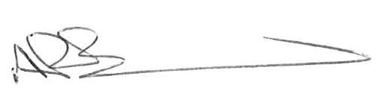
Chief Executive
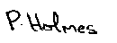
________________________________
Countersigned:

Address to which all communication should be sent:

Licensing, Public Protection, Assets & Environment,

Tamworth Borough Council, Marmion House, Lichfield Street, Tamworth, B79 7BZ

Tel 01827 709445 or Fax 01827 709434

